Cardiac Emergencies In Neonate And Young Infants
Nasib Kabbani, Hayan Altaweel*, Mohamed Kabbani*
*King Abdulaziz Medical City, National guard Hospital

Abstract:
Cardiac emergencies in children are not infrequent. Early recognition and management are essential to save life and prevent any comorbidity. The presentation of cardiac emergencies and etiologies are variable depending on the age of the child at the time of presentation and the type of cardiac lesion. Cyanotic and non-cyanotic congenital heart diseases are the main causes in neonates and infants. Acquired heart diseases and dysarhythmias are more common causes for cardiac emergencies in toddler and childhood.
In this presentation we review few cardiac emergencies with the emphasize on one case presentation of newborn with sever coarctation and markedly depressed cardiac function. The baby did not improve with prostaglandin infusion and continued to show evidence of refractory shock that required surgical emergency repair. Further more the discussion will review other causes of cardiac emergencies in neonate related to venous obstruction such as (obstructed TABVD), right side obstructive lesions, emergency brady-arrhythmia (congenital heart block). These emergencies require immediate recognition and intervention in order to save the life of the baby and insure good outcome.

Image:
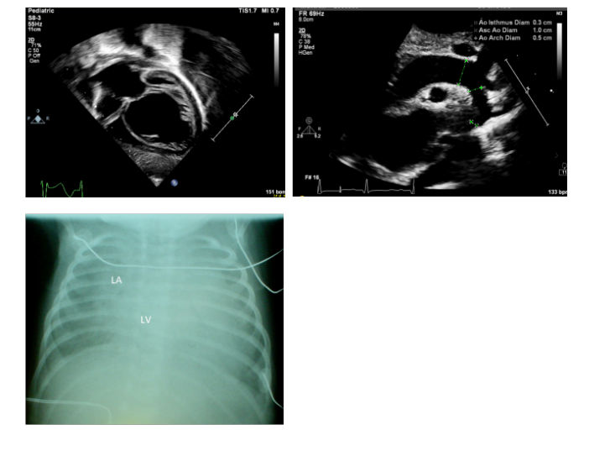

Recent publications:

1) Rosenthal E. Coarctation of the aorta from fetus to adult: curable condition or life long disease process? Heart. 2005;91:1495–1502

2) Ward KE, Pryor RW, Matson JR, Razook JD, Thompson WM, Elkins RC. Delayed detection of coarctation in infancy: implications for timing of newborn follow-up. Pediatrics.1990;86:972–976.

3) Albrecht GT. Cardiogenic shock in the neonate. Indian J Pediatr 1993; 2013:381–91.PMID:8253487


Biography:
Dr. Nasib Kabbani: is a fresh graduate from AlFaisal University.
Dr Hayan Altaweel: Associate consultant in pediatric Cardiac ICU- KAMC
Dr. Mohamed Kabbani: consultant intensives and serves as the head of the pediatric cardiac ICU from 2007-2014 in KAMC-Riyadh, Saudi Arabia. Dr. Kabbani has more than 30 publications in both pediatric and pediatric ICU

Notes/Comments:

