Sheesha smoking reduces the expressions of cancer related genes
Hoda El-katerji BDS, MSc Epidemiology University of Ottawa, Ottawa ON, Canada.

Background and objectives;
Sheesha is a new trend of smoke in western countries. It is a global health issue with more than 100 millions smokers daily. The adverse health effect of sheesha smoking has not been well addressed in the literature. Our aim is to assess the temporary effect of sheesha Massal smoking on the expression of cancer related genes in salivary cells among young sheesha smokers in Ottawa.

Methods and Results;
In this before-after comparison study, the city of Ottawa was selected to be the geographic area of study. A snowball sampling technique was adopted. The main inclusion criteria were that the individual was between the age of 18 and 25 and reported that they smoked sheesha. In total 15 volunteers were identified to be eligible for this study. After providing the saliva samples participants were asked to smoke Massal (double apple = altifahtain) for one hour and a half. Then, they were asked to provide their second saliva samples. We assessed the short term effect of sheesha Massal smoking on level of expression of xenobiotic metabolism genes and other genes known to have altered expression in tobacco related cancers, in salivary cells. RNA extracted from the saliva samples using custom-made microarray (RT-PCR) assays to measure gene expressions. All 16 genes investigated showed decreases in gene expressions with substantial differences in the magnitude of the decrease. A meta-analysis conducted to integrate the fold change of each genes across the 15 samples, between before and after smoking sheesha, showed a range of reduction in expression level between 1.7 times and 55
STAT3, PTGS2, CYP1A1 and GSTP1 show fold changes that lie within the variance of fold change of housekeeping genes
CDKN2A, NMI, BAK1, ERBB2, EGFR, CNTD1, NOS2, FAS, CCDN1, CYP1B1, GSTT1, and GSTM2 present fold changes that are outside the range of variability observed for the housekeeping genes

Images and table;
The expression of all selected genes before and after one hour and a half of sheesha smoking in two different samples;
Sample 1 Sample 2
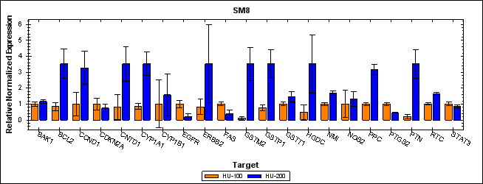
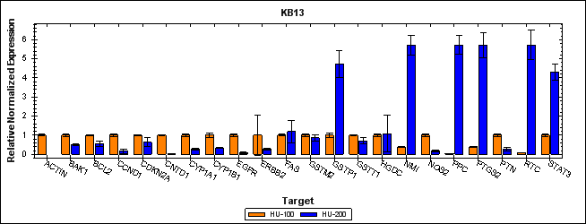
Integrated fold changes with 95%CI in gene expression for each gene across the 15 samples
Gene | Integrated-FC | Lower bound | Upper bound
PTN  CDKN2A  CCND1  NMI  STAT3  BCL2  ERBB2  EGFR  NOS2  PTGS2  FAS  BAK1  CNTD1  CYP1B1  CYP1A1  GSTP1  GSTT1  GSTM2  GAPDH  ACTB  HGDC | 0.029106252 0.022358289 0.065695067 0.115085195  0.60443164  0.174906181 0.018022191 0.019314299 0.046260736 0.576853528 0.092509546 0.063411853 0.314216134 0.147091709 0.174163004 0.213343273 0.048207976 0.101393362 0.153616945 0.739850533  0.02070046 | 0.010070523 -0.002465234 0.031230736 0.076297506 0.531890982 0.129476025 -0.01051183  0.00214128  0.021782365 0.526766668 0.063481521 0.045236428 0.080650799 0.001709402 0.102113231 0.139869896 0.034411406 0.048492258 0.137444222 0.688871356 -0.007235137 | 0.04814198  0.047181811  0.100159398  0.153872883  0.676972298  0.220336336  0.046556212  0.036487318  0.070739107  0.626940389  0.121537571  0.081587278  0.547781468  0.292474015  0.246212778  0.286816649  0.062004547  0.154294465  0.169789668  0.790829711  0.048636058

Conclusion;
Sheesha smoking has short-term effects on the expressions of genes known to be involved in tobacco-related cancers. Tobacco smoking, regardless of its mode of delivery, affects body’s susceptibility to develop cancer diseases.


Biography
Hoda El-katerji BDS, MSc Epidemiology, is researcher at University of Ottawa. Started her career as a dentist in Lebanon, Dr. El-katerji worked as a clinical instructor at Beirut Arab University and provided dental care for poor people at many charitable dental organizations, where her new vision and interest towards public health started. She moved to Ottawa and joined Dr. Daniel Krewski’s team at Mclaughlen center in 2008 to work on water fluoridation assessment and management. In 2009, Dr. El-katerji recognized the potential public health concerns of the widespread use of sheesha smoking in Canada with the lack of evidence-based science. Together with Dr. Julian Little Dr. El-katerji worked on an innovative way to assess the adverse health effects of sheesha smoking. They extrapolate readings from genetic level to set recommendation for a global public health issue.

Recent publication;
1-Waterpipe smoking and cancer: systematic review and meta-analysis 10.1136/tobaccocontrol-2015-052758

