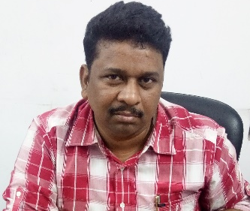
Title: Efficacy and safety of nimotuzumab with concurrent chemoradiotherapy in unresectable locally advanced squamous cell carcinoma of head and neck: Rural tertiary care hospital experience in India

Name: A. Kumar¹, K. Kunal¹, S.K. Ghosh¹, S. Chaudhari²; D.Pawar²
¹Clinical Oncology, Meherbai Tata Memorial Hospital (MTMH), Jamshedpur, India, ²Medical affairs, Biocon Limited, Bangalore, India

Background
Study was conducted to evaluate efficacy and safety of nimotuzumab with CCRT in patients with unresectable, locally advanced HNC in rural tertiary care hospital set up in India.
Methods
Hospital records of 24 patients with HNC who were treated with nimotuzumab from June 2009 till April 2017 were evaluated. One patient who underwent surgery was excluded and 23 patients of unresectable, locally advanced (stage III – IVb) HNC with histologically confirmed squamous cell carcinoma who were treated with nimotuzumab were analysed. Tumour response, overall survival (OS) and association of various dependent factors with tumour response and survival was analysed. Adverse events (AEs) were analysed by common terminology criteria for AEs v 4.0.
Results
A total of 23 patients (18 male/5 female, median ages 62 years [IQR 51, 62, 75]) were considered for the analysis. All patients were treated with nimotuzumab 200 mg weekly and CCRT. Tumour response rate at 24 weeks after completion of radiotherapy was as follows: 60.87% (14) patients had complete response, 4.35 % (1) had partial response, and 34.78% (8) had stable disease. The overall response rate was 65.22% and the clinical benefit rate was 100%. Survival rate at 1 year, 3 year & 5 year was 89.47%, 63.45%, 44.41%, respectively; and median OS was 57 months (95% CI, 32.61 - 81.39). No grade III or grade IV adverse events were observed.
Conclusions
Addition of nimotuzumab to CCRT showed incremental survival benefit in unresectable locally advanced HNC patients than that observed with historical data of conventional CCRT.

Biography
Dr.Amit Kumar has completed his MD, Radiotherapy at the age of 33 years from P.M.C.H., Patna Patna University followed by Senior Resident in Radiation Oncology at VMMC &Safdarjung Hospital,New Delhi and Specialized Training at Tata Memorial Hospital, Mumbai. Dr.Amit has also done Clinical Trial design, analysis & reporting from Biostatistics Resource & Training Centre,CMC, Vellore
Clinical Trial identification No
BIO/NIMO/001/2017

Presenting author details
Full name: Dr. Amit Kumar
Contact number: +917004749965
Twitter account:
Linked In account: docamit.kumar@gmail.com
Session name/ number:
Category: (Oral presentation/ Poster presentation)

