Breast density and its connecti0on to increased risk of breast cancer in pre-menopausal women with low BMI: risk assessment and biological impact.

Dr. Noelle L. Cutter, PhD
Interim Associate Dean, Molloy College

Abstract (300 word limit)
For women with any level of breast density, one of the major concerns is the alarming rate of false negatives that may align with cancers missed by a mammogram. Importantly, women with dense breasts have a naturally higher risk of breast cancer than women with fatty breasts, and the risk increases with increasing breast density. The main focal points of this research project cover the diagnostic study of pre-menopausal women and those with low body mass index (bet 12-22% body fat). Molloy College has a long-standing history of working in healthcare with the surrounding community. Additionally, Dr. Noelle Cutter received her graduate and post-doctoral training examining gene expression changes in breast cancer. Combined with the expertise of Dr. Robert Bard, MD, radiologist, our assembled research team has observed a significant parallel between dense breasts and women with low body fat content. The overall goals of our project include:
- Understanding the link (genetic and lifetime risk) between dense breast tissue and increased lifetime risk of developing cancer so that patients can be given better diagnosis, prevention, and treatment options.
- Advocate for alternative screening options for women with dense breast, such as the use of ultrasound in addition to a mammogram.
- We propose that physicians need to consider breast density as a key factor when determining risk-based screening approaches for individual women and hypothesize that screening ultrasound likely improves cancer detection.
Our findings will add potential value for the early detection of poor-outcome breast cancer as well as understand the link with breast density and increased risk of breast cancer in pre-menopausal women. Furthermore, it will delineate the molecular pathways involved in the development of invasive breast cancer by identifying biomarkers associated with dense breast tissue. A better understanding of the pathways will in turn lead to better diagnosis and treatment regimens for patients.

Image 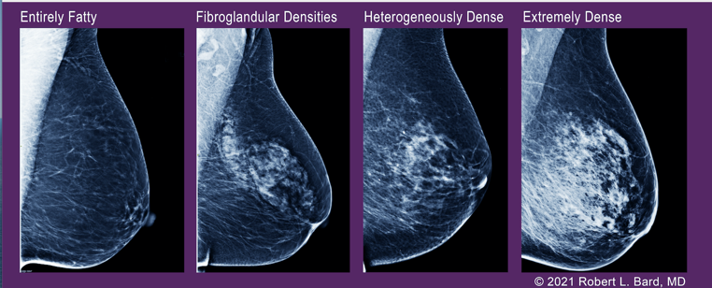

Recent Publications (minimum 5)
- Cutter, N., Chowdhury, A., Honigsfeld, B., Rubino, C. Silence of the Genome: A Role for Methylation in the Chemoresistance of Medulloblastoma. Cancer Research, October 2019
- Noelle Cutter, Emily Cruz, Frank Cristall, Kristen Lacey, Rachel Julian: Strenuous Exercise Increases the Risk of Oxidative Stress in Ironman Triathlon Participants. 08/2019; 11(1)., DOI:10.7710/2168-0620.1144
- Noelle L. Cutter, Jennifer Furman, Ryan Frank, Cassandra Greco, Matthew Lucito: Identifying Senescence as a Mode of Chemo Resistance in Ovarian Cancer. DOI:10.30845/ijast.v9n2p2
- Noelle L. Cutter, Matthew Lucito, Ryan Frank, Kimberly Doyle: The role of p53 mutational status and SOX9 suppression in chemotherapy response of ovarian cancer. Cancer Research 07/2017; 77(13 Supplement):2421-2421., DOI:10.1158/1538-7445.AM2017-2421
- Noelle L. Cutter, Tyler Walther, Kimberly H. Doyle, Ryan Frank: Abstract 4525: Hypoxia signaling pathway plays a role in ovarian cancer chemoresistance. Cancer Research 07/2017; 77(13 Supplement):4525-4525., DOI:10.1158/1538-7445.AM2017-4525

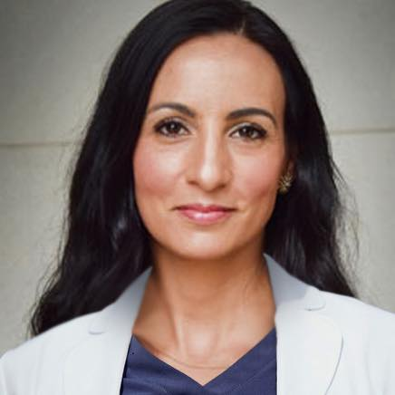 Biography (150 word limit)
Dr. Cutter is an associate professor, associate dean of arts & sciences, and director of the First Year Experience at Molloy College. By training, she is a scientist in the field of molecular biology where she has dedicated her career to studying alternative treatment options for patients diagnosed with breast cancer. During the COVID19 pandemic, Dr. Cutter worked in an antibody testing lab where she worked on designing synthetic peptides to test for the presence of SARS-Cov2 antibody is patient serum. Dr. Cutter is a graduate of Stony Brook University Medical School (Stony Brook, NY) in 2011. She achieved her post-doctoral training at Cold Spring Harbor Laboratory, working on the chemoresistance breast and ovarian cancer. She is a distinguished alumni and faculty at Molloy College, where she is known on campus for her generosity, kindness, and perseverance. Dr. Cuter has authored and co-authored several publications in critically acclaimed, peer reviewed scientific journals. She recently gave a TedX talk about taking a #GENZ global approach to curing cancer.
Email: ncutter@molloy.edu

Notes/Comments:

Philanthropy:
Dr. Cutter is an advocate for putting research first and communicating science to the general public. She is member of New York Cancer Research Alliance and Integrative Pain Management Alliance which is comprised of dedicated healthcare providers, researchers, educators, foundations and advocates who are committed to bringing community support and care to patients. She works closely with the Katie McBride Foundation of Long Island, 501©3 which helps support local families with young children battling life threatening illnesses. She was the Vice President and co-founder of the Little Louie Foundation, which helped support families of patients with pediatric brain tumors.

Awards
Dr. Cutter has received numerous awards for both her work in community service, education, and research. Most notably is her Top 30 in Healthcare on Long Island, Select Science Biologist of the Year 2020, American Association for Cancer Research Women in Science, 10-year service award to Molloy College, Molloy College Outstanding Faculty Award, Mary E. Lilly Mentorship award, 2011 Stony Brook University Renee Chasman Graduate Achievement Award and top ten spotlight award for women in cancer research for 2019.

Family First:
She is a mother to four beautiful children, Lily, Lucy, Jack and Isabel. Her work in Medulloblastoma developed because of her personal losses due to the vicious disease when she lost her nephew at only 18-months of age. She is a triathlete and marathon runner, where she is always “putting cancer on the run.”

Fun Fact
Dr. Cutter just completed in her first ever Ironman Triathlon in Lake Placid, NY. The IM consists of a 2.4 mile swim, 112 mile bike, and 26.2 mile run.

