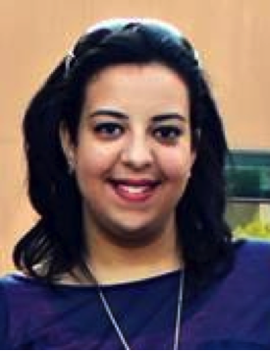
Expression Levels of hsa-miR-590-3p in Hepatocellular Carcinoma and Osteosarcoma Cell Lines and its Downstream Target Genes

Mennatallah Elfar¹, Asma Amleh ^{1,2}

¹ Biotechnology Program, The American University in Cairo, Cairo, Egypt
² Biology Department, The American University in Cairo, Cairo, Egypt

Small non-coding RNA sequences, known as mircoRNAs (miRNAs), of around 18-25 nucleotides can regulate various cellular pathways by acting on tumor suppressors, oncogenes or both. miRNAs are generally tissue-specific and can be up-regulated or down-regulated, depending on the cancer or the tissue in which they are found. In this study, we focused on hsa-miR-590-3p. hsa-miR-590-3p was found to be involved in several types of cancers and controls several downstream target genes. Several bioinformatics tools were used to identify potential downstream target genes of hsa-miR-590-3p. Using miRanda-mirSVR, Expression Atlas and The Human Protein Atlas, the following genes (SOX2, N-cadherin, E-cadherin and FOXA2) were utilized as potential downstream target genes of hsa-miR-590-3p. Various molecular techniques were carried out to further validate our in silico results using SNU449 and HepG2, hepatocellular carcinoma cell lines, and U2OS, an osteosarcoma cell line. RT-PCR and western blotting techniques were used to detect the mRNA and protein expression levels of these genes respectively. Co-localization of hsa-miR-590-3p and its potential downstream target gene, SOX2, was conducted using miRNA in situ hybridization combined with immunohistochemistry staining using anti-SOX2. An inverse correlation between hsa-miR-590-3p expression and SOX2 protein expression in SNU449 and U2OS was observed. Studying the expression of hsa-miR-590-3p downstream target genes can increase our understanding of cancer pathogenesis and how it can be utilized as a therapeutic tool.

Biography

I, Mennatallah Elfar, obtained my Master degree in Biotechnology in 2019 from The American University in Cairo and my Bachelor degree in Pharmacy and Biotechnology in 2013 from The German University in Cairo. I am currently working as a genetic counselor and a molecular lab senior in Generations Genetics Labs, a pioneer genetic diagnostic organization in Egypt.

Presenting author details
Full name: Mennatallah Mohamed Bassem Elfar
Contact number: +2 0100771993
Linked In account: Mennatallah Elfar
Session name/ number: Track 1. Cancer Cell Biology & Genetics
Category: Poster presentation

