Title: New approach for mapping of oxidative stress and redox-status of cancer cells using EPR, MRI and optical imaging
Rumiana Bakalova,^{1,2,3*} Dessislava Lazarova,³ Genoveva Zlateva,³ Zhivko Zhelev,^{4,5} Ichio Aoki^{1,2}
¹Department of Molecular Imaging and Theranostics and ²Group of Quantum-state Controlled MRI, National Institutes for Quantum and Radiological Science and Technology (QST/NIRS), Chiba, Japan
³Medical Faculty, Sofia University “St. Kl. Ohridski”, Sofia, Bulgaria
⁴Medical Faculty, Trakia University, Stara Zagora, Bulgaria
⁵Institute of Biophysics and Biomedical Engineering, Sofia, Bulgaria

Abstract
The best strategy of fighting “free radical diseases” (as cancer, neurodegeneration, atherosclerosis, etc.) is an effective early stage diagnosis. This study proposes a new concept to realize revolutionary class contrast agents to be applied as redox-sensitive probes for detection of “oxidative stress” (OxiStress) and “total reducing capacity” (TRC) during development and progression of cancer, by using optical and magnetic resonance imaging techniques.
We developed new OxiStress and TRC sensors, based on conjugation of quantum dots with nitroxide-functionalized cyclodextrin (multi-spin). The oxidation of nitroxide residues to their radical form was accompanied by strong quenching of quantum dot fluorescence and appearance of high EPR contrast (Figure 1). In opposite, the reduction of nitroxide residues in their hydroxylamine form was accompanied by rapid decay of EPR signal and appearance of strong fluorescence signal. Thus, the sensors allow evaluation of the balance between intracellular reducers/oxidizers, respectively, the level of “oxidative stress” and “total reducing capacity”.
The dimension of both sensors and their positive charge ensure enhance permeability and retention effect in cells and tissues. The sensors enter into viable cells, visualized by EPR and fluorescent imaging. They were applied for distinguishing cancer cells with different proliferative activity based on their redox-status, as well as for detection of “oxidative stress” in cell suspensions, treated by rotenone and 2-methoxyestradiol – a combination, inducing mitochondrial dysfunction, overproduction of superoxide and mild or severe oxidative damages. The physicochemical characteristics and easy cell permeability give a reason to believe that the sensors will be appropriate for in vivo imaging. Since the T₁-weigheted MRI contrast of nitroxides follows the same dynamics as their EPR contrast, the sensors are also applicable for nitroxide-enhanced MRI studies.
Acknowledgements: This study is partially supported by the Grant-in-Aid “Kakenhi-C” from the Japanese Society for the Promotion of Science (JSPS).

Biography
Rumiana Bakalova is a scientist with long experience in experimental imaging diagnostics and therapy of cancer, atherosclerosis and neurodegeneration. She has doctor’s degree (PhD) in biophysics and Doctor-of-Science (DSci) degree in biomedical sciences. Her main scientific interests are in the field of molecular imaging, molecular probe design, drug delivery systems, and nanomedicine. Recent studies are focused on redox-imaging and image-guided redox-modulation in cancer, as well as in nano-theranostics for cancer therapy (Nat. Biotechnol., 2004; Nat. Photonics, 2007; Clin. Cancer Res., 2013; Transl. Res., 2015; Redox Biol., 2018).
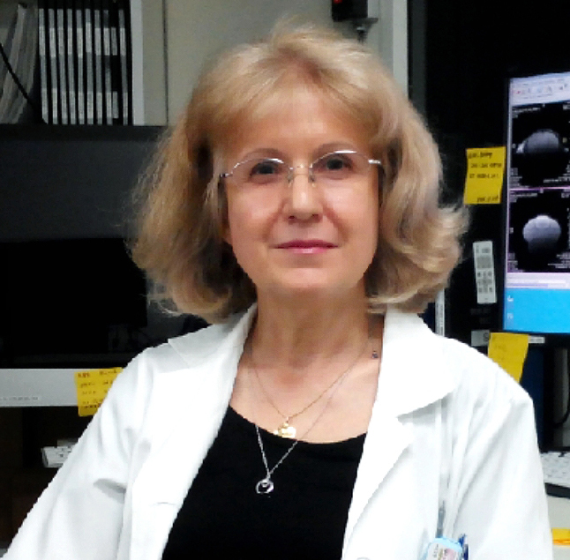

Rumiana Bakalova
Phone No: +81-08-8108-8136
Session Name/Number
Category: (Oral presentation)
Email: bakalova.rumiana@qst.go.jp

