Title: Physicians’ attitude towards cancer and cancer patients in Jose R. Reyes Memorial Medical Center

Deepak Sundar Shrestha^{1,2}, Rajendra Rijal¹, Sajani Manandhar², Corazon A Ngelangel³

AFFILIATIONS:

¹Resident-in-Training, department of internal medicine, Jose R. Reyes Memorial Medical Center, Manila, Philippines.
²Richa Bajimaya Memorial Foundation, Nepal.
³Consultant, Section of Medical Oncology, Jose R. Reyes Memorial Medical Center, Manila, Philippines.

RUNNING TITLE:

Physicians’ attitude towards cancer and cancer patients

Abstract (250-300 word limit)
Introduction:
Cancer is a global issue with a global burden. It is estimated that deaths from cancer worldwide will continue to rise. The oldest description of cancer dates back to about 3000 BC. With time, the concepts regarding cancer and its management have changed; there seems to be a shift of focus in viewing and dealing with cancer towards the curative aspects of cancer, with growing concern on the psychosocial aspects.
One of the main stakeholders concerning cancer is certainly the physician. Hence this study evaluates the attitude of physicians regarding cancer the disease and patients with cancer, which may influence the management of these patients in a certain direction allowing for recommendations for appropriate interventions.
Methods:
This is a cross-sectional study, which interviewed 251 physicians of Jose R Reyes Memorial Medical Center regarding their attitudes on cancer and cancer patients. The study also explored and identified factors associated with such attitudes. The validated modified Cancer Attitude Scale of Haley et al (1968, 1977) was used. Stata was used for descriptive statistics and logistic ordinal (proportional odds) regression.
Conclusions:

In general the overall attitude of physicians working in Jose R Reyes Memorial Medical Center towards cancer and cancer patients is positive. However the physicians are skeptical of the patient’s inner resource to cope with cancer. Expertise, years of practice (of more than 25 years), having experience with cancer patients, being active in religion, Filipino nationality and protecting oneself from carcinogens showed to be associated with positive attitude.
Recommendation:
Similar multi-center study be conducted with a larger and more representative population of the physicians for more concrete conclusions.
Keywords:
Physicians’ attitude, cancer, cancer patients, perception

Biography (100-150 word limit)
Deepak S. Shrestha received his MBBS degree from Kathmandu University School of Medical Sciences, Nepal and his residency in Internal Medicine from Jose. R. Reyes Memorial Medical Center, Philippines. It was during his residency period that the study was conducted. He is the president of Richa Bajimaya Memorial Foundation, a non-governmental organization based in Nepal with the vision of a “cancer fear-free society”- established 2007AD. He is very passionate about cancer and has been working actively in the preventive, promotive, therapeutic and palliative aspects of cancer. Professionally he is a lecturer in the department of internal medicine at Peoples Dental College and Hospital under the Tribhuwan University, Nepal.
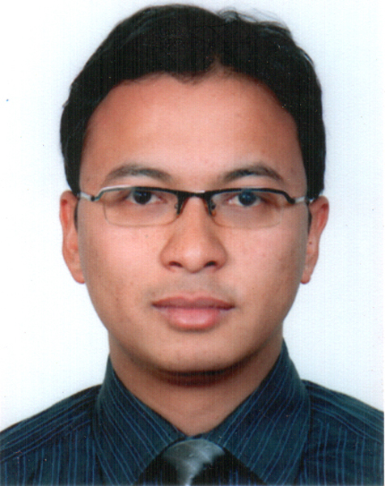

Full Name: Deepak Sundar Shrestha
Phone No: 977-1-9851175988
Session Name/Number
Category: (Oral presentation/Poster presentation)
Email: deepak@richafoundation.org.np

