Title: Frequency of BCR-ABL fusion transcript types with Chronic Myeloid Leukemia by multiplex PCR in Srinagarind hospital, Khon Kaen Thailand.

Kanokon Chaicom¹, Chitima Sirijerachai¹, Kanchana Chansung¹, Pinsuda Klangsang, Boonpeng Palaeng¹
Prajuab Chaimanee², Pimjai Ananta²
¹Department of Medicine, Medicine Faculty, Khon Kaen University
²Molecular laboratory, Central Laboratory Srinagarind Hospital, Medicine Faculty, Khon Kaen University

Abstract (300 word limit)

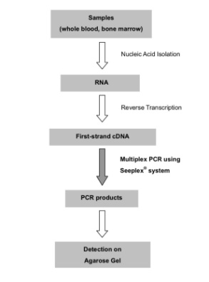
Chronic myeloid leukemia (CML) is characterized by the consistent involvement of the Philadelphia chromosome (Ph), which is derived from a reciprocal translocation between chromosome 9 and 22, the main product of the t(9;22) (q34;q11) translocation, is found in the leukemic clone of at least 95% of CML patients. There are two major forms of the BCR/ABL fusion gene, involving ABL exon 2, but including different exons of BCR gene. The transcripts b2a2 (e13a2) or b3a2 (e14a2) code for a p210 protein. Another fusion gene leads to the expression of an e1a2 transcript, which codes for a p190 protein. Other less common fusion genes are b3a3 or b2a3, which codes for a p203 protein and e19a2 (c3a2) transcript, which codes for a p230 protein. Its frequency varies in different populations. In this study we aimed to report the frequency of BCR-ABL fusion transcript types with CML by multiplex PCR in Srinagarind Hospital, Khon Kaen Thailand. Multiplex PCR for BCR-ABL was performed on 58 patients, to detect different types of BCR-ABL transcripts of the t (9; 22). All patients examined were positive for some type of BCR/ABL rearrangement. The majority of the patients (93.10%) expressed one of the p210 BCR-ABL transcripts, b3a2 and b2a2 transcripts were detected in 53.45% and 39.65% respectively. The expression of an e1a2 transcript showed 3.75%. Co-expression of p210/p230 was detected in 3.45%. Co-expression of p210/p190 was not detected. Multiplex PCR is useful, saves time and reliable in the detection of BCR-ABL transcript types. The frequency of one or other rearrangement in CML varies in different population.
Figure 1.Determination of BCR-ABL fusion transcript product obtained by Multiplex PCR in agarose gel. M: BCR/ABL Marker, Line1: e1a2, Line2: No BCR/ABL translocation, Line3: b3a2, Line4: c3a2, Line5: b2a2, Line6: No BCR/ABL translocation, Line7: b2a2 and Lane N: Distilled water as negative control.

Figure 2. Procedure Overview

Image
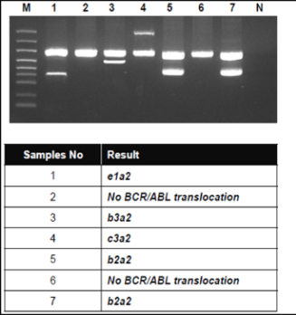



Paste your Photograph Here
Biography (150 word limit)

I am a medical technologist, department of Medicine, Medicine Faculty, Khon Kaen University. Bachelor's degree of medicine science. Master's Degree of Public Health Management. Special in laboratory diagnostic Chronic myeloie lukemia.

Email: chaicom.kanok@gmail.com

