Developing bioorthogonal smart polymers for cancer therapy
Gayathri R. Ediriweera¹, Zachary H. Houston¹, Craig A. Bell¹, Kristofer J. Thurecht¹
¹Australian Institute for Bioengineering and Nanotechnology and Centre for Advanced Imaging, University of Queensland, Brisbane, 4072, Queensland, Australia

The selective delivery and effective localisation of drugs is crucial in cancer therapy. Conventional chemotherapy is subjected to certain drawbacks, such as limitation of tumour-specific receptors that ensure efficient internalisation to enhance drug release as well as significant systemic toxicity to healthy tissues.¹ The use of bioorthogonal chemistry is a versatile and promising tool to overcome such drawbacks as it expands the scope of using non-internalising receptors as targets for cancer therapy and selective extracellular release of the drug. Importantly, this drug release stimulus is controlled only by the addition of an exogenous molecule, providing more direct control over in vivo drug release.² In this work, a ⁶⁴Cu radiolabelled tetrazine probe (tetrazine-PEG-NOTA) was synthesised, that showed rapid pharmacokinetics in healthy mice when tested in positron emission tomography/computed tomography (PET-CT). Critically, almost all of the tetrazine radioligand was cleared into the bladder within 20 minutes. Additionally, another PET-CT study conducted using a ⁶⁴Cu radiolabelled PEG-NOTA probe showed that tetrazine does not affect the clearance behaviour of the molecule from the bloodstream other than the pathway of clearance. Looking forward, a PEGylated hyperbranched polymer will be synthesised that is conjugated with bispecific antibodies as targeting ligands and trans-cyclooctene moieties bearing the anti-cancer drug doxorubicin. This will be administered to tumour-bearing mice, and following its accumulation at the tumour site, the fast clearing tetrazine probe will be administered. Selective bioorthogonal conjugation of the ⁶⁴Cu radiolabelled tetrazine probe to trans-cyclooctene through rapid inverse electron demand Diels-Alder cycloaddition will then be monitored in real-time by PET-CT. In this way, the click reaction will facilitate pro-drug activation as well as provide a means to quantify the amount of drug administered at site.



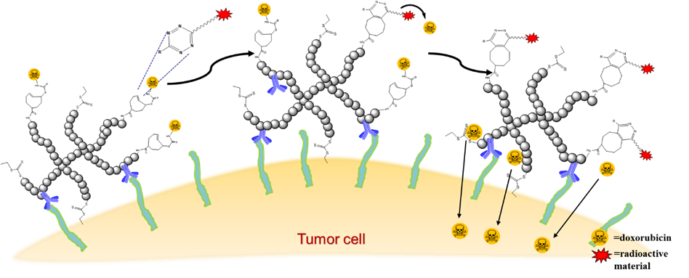
Figure 1: Hyperbranched polymer-drug conjugate activation via bioorthogonal reaction on a tumour cell

Recent Publications

1. Padumadasa, C.; Abeysekara, A. M.; Thabrew, I.; Ediriweera, A. P. G. R., Pharmacological Overview of Proanthocyanidins from the Bark of Thespesia populnea (L.) as an Antioxidant and Cytotoxic Agent. International Journal of Pharmaceutical Sciences and Research 2016, 7(1),1000-1008.

Gayathri Ediriweera is currently undertaking her PhD under the guidance of Asssociate Prof. Kristofer Thurecht in both the Centre for Advance Imaging and the Australian Institute for Bioengineering and Nanotechnology at the University of Queensland. She completed her B.Sc. (Hons) from University of Sri Jayewardenepura, Sri Lanka. She received several awards including Prof. Tuley de Silva Gold medal and Alles Memorial award for her outstanding performance in B.Sc. (Hons) degree. She started her career as an Assistant Lecturer in the University of Sri Jayewardenepura, Sri Lanka. Then she received the opportunity to peruse her Doctor of Philosophy (PhD) in the University of Queensland. Her current research interest is on developing polymeric theranostics using bioorthogonal chemistry.
.Email: a.ediriweera@uqconnect.edu.au

\

