SPATIAL ANALYSIS OF CERVICAL CANCER AND CORRRELETED FACTORS

Introduction and Background
Worldwide, cervical cancer is responsible for about 500,000 new incidence and over 250,000 deaths yearly, with 85% of the global burden of cervical cancer occurring in sub Saharan countries such as Uganda (Kesic, Poljak, & Rogovskaya, 2012). Ferlay et al., (2015), notes that cervical cancer incidence rates in on the rise in Uganda today, statistics in Uganda by the end 2015, there was an estimation of 4379 new incidence and 2511 mortality new cervical cancer incidence rates for women. Mutyaba et al.,(2006) states that cervical cancer is the commonest malignancy of women in Uganda and over 80% of the women who report to hospital are at the advanced stage of the disease where death is imminent, and this is due to majority of women not being screened.
HPV infection has been established as a necessary cause of almost all cases of cervical cancer (Nooij et al.,(2016); Hang et al.,(2016) and Almonte et al.,( 2008); Au (2004) state that only persistence HPV high risk types is the dominant factor. Castellsagué (2008) notes that most women infected with the virus become negative within 2 years, and women with persistent high-risk HPV infections are the ones at greatest risk for developing cervical cancer. Fedewa et al.,(2015) and Vinay et al., (2013) have also linked the prior HPV infection with other major risk factors such as high parity, hormonal contraceptive usage, smoking, HIV, Chlamydia among others, to increase the risk of developing cervical cancer.
There exists numerous tools to protect women from this disease such as, the use HPV vaccinations to girls under 15 years of age and not sexually active and through performing routine CxCa screening services for women who are 25 years and above, this enables the early detection and treatment of the disease (Schiffman & Solomon, 2013;Sankaranarayanan et al.,2012). Despite the efforts by Uganda’s Ministry of Health and other related health bodies in promoting nationally-supported preventive measures such as HPV vaccinations and routine cervical cancer screens, there are still high rates of cervical cancer diagnoses and deaths( Occhi et al., 2011).
This has been related to the gaps in screening that exist to ensure effective management, leading to approximately 80% of cervical cancer cases being diagnosed and presented in its late stages of the disease (Mwaka et al.,2013). The gap in late diagnosis and deaths is as a result of women who are not screened early or can’t access the services in time for treatment and prevention. The current approach to screening is based on post occurrence or outbreak of a particular disease, invitations from the locals or politicians basing on their personal interest, or it is done randomly to women who check in hospitals for other medical needs. These approaches are limited in location analysis and applicability, as a result, the actual knowledge of geographical high risk areas where the measures should be placed to target high risk groups is lacking.
The use of Geographic information systems (GIS) technology and methods are rapidly evolving, but are still in the relatively early stages of application in cancer registries and comprehensive cancer control programs (Seidman 2006). However, looking towards the future, GIS analyses may help elucidate the determinants of regional and demographic disparities of cancer and provide insights to improve health service delivery models, training for healthcare providers, and health outcomes. Palaniyandi (2012) states that, GIS combined with methods of spatial statistics provide powerful new tools for understanding the epidemiology of diseases. Kitron (1998) further elaborates that GIS offers several advantages over traditional methods of spatial analysis, that is by providing a robust approach and it’s the ability to store, manipulate, and display data linked to locations. Spatial analysis is used to extract the spatial relationship embedded between geographic locations explicitly allowing for the description and testing of spatial patterns among locations.
Rytkönen (2004) states that Geographical information system is an innovative and important component in many projects in public health and epidemiology and Cowen (1988) regards it as a tool to that has been used to resolve health related dilemmas majorly through basic mapping. Successful integration of these techniques can provide insight into the identification of causal factors driving cervical cancer transmission, through mapping risk areas, modeling factors that are more associated to cervical cancer, as well as aid in decision making and improvement of surveillance. Geographical information systems (GIS) enables the investigation of spatial patterns within data and understanding of the relationships that exist between cancer and other health, socioeconomic and environmental variables (Rytkönen 2004). Glazier et al., (2004), notes that GIS allows the integration of health data which play a major role in identifying locations where intervention is needed. Therefore, the major aim of this study is to use GIS as a tool in risk based surveillance system and health care planning, to improve the accessibility of women at risk of cervical cancer screening services through modeling the risk variables and determining the areas in Uganda at highest risk of the disease, and which the screening services in Uganda should target.

Objectives
The main aim of this study was to analyze the spatial distribution of cervical cancer, model the correlated factors to effectively target the high risk areas in Uganda thus identifying the gap of screening that exist and areas where screening should focus.
The first step involved determining the spatial distribution of cervical cancer prevalence then spatial autocorrelation was run on the prevalence to determine whether there exist a spatial process in the existence of cervical cancer
The second step involved determining the distribution of the correlated factors where the factors were modelled by converting the vector maps to raster maps, reclassifying the raster maps and an overlay of the factor maps basing on the weights from expert opinion and literature review.

Data and Methods

3.1 Research Design
The study was an ecological descriptive study that involved the use of secondary data to obtain information about the world. The study applied geo-statistical methods to identify patterns or trends that occur in the situation under study, and also the risk-modifying factors on health or other outcomes based on populations defined either geographically or temporally(Ahrens & Pigeot, 2014).

3.2 Study area
The study area is Uganda. Uganda is divided into 116 districts, grouped into four administrative regions and each district divided into counties and municipalities and each county is further divided into sub-counties. The map used for this study contained 112 out of the current 116 districts present. Omoro districts was added to Gulu district, Rubanda was added to Kabale district, Kagadi and Kakumiro was added to kibale in the analysis
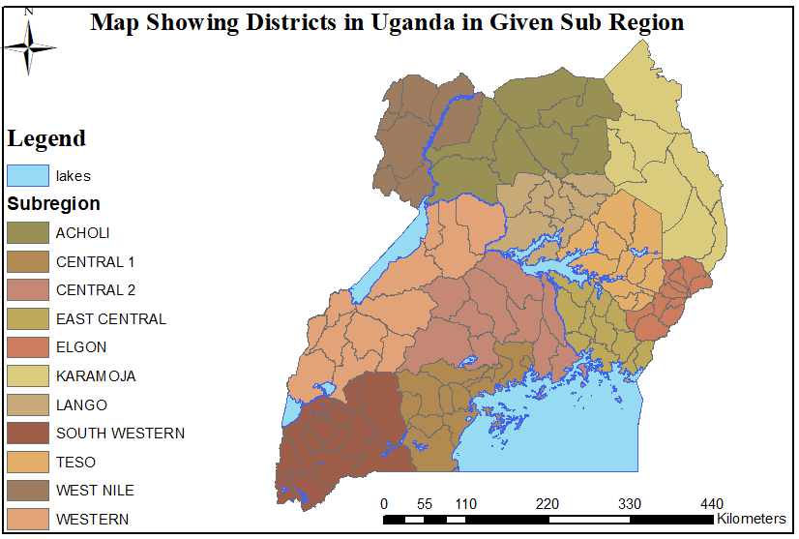
Figure 3:1Map of Uganda

3.3 Methodology Flow
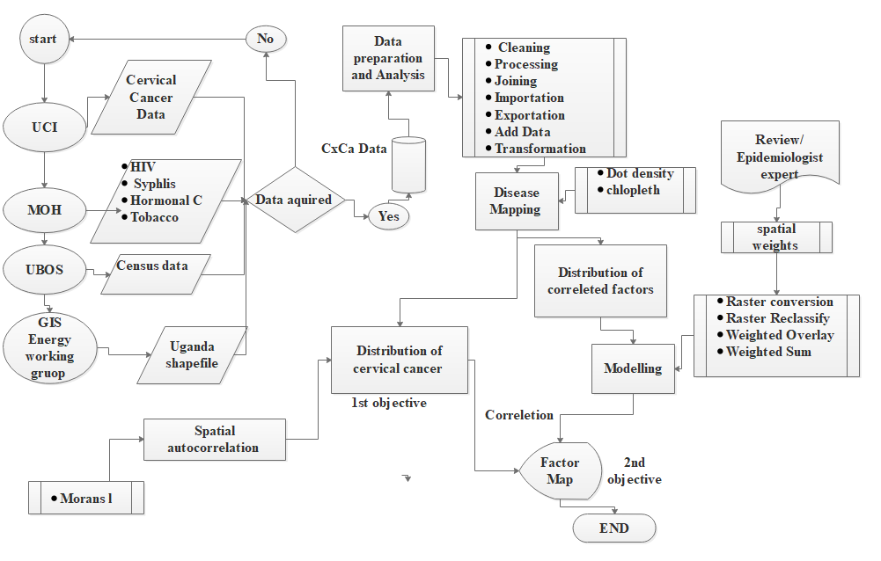
Figure 3:2 Methodology Flow

Data collection and source
Table 3:1 Data Collection and Source
Variable | Source | Level | Time
Cervical Cancer | MOH | District | 2015-2016
HIV | MOH | District | 2014
Uganda shapefile | UBOS | District | 2014
Women Population | UBOS | District | 2015
Hormonal Contraceptive | MOH | District | 2016
Syphilis | MOH | District | 2016
Tobacco usage | MOH | District | 2016
Fertility | DHS | sub regional | 2016
Multiple Partners | DHS | sub regional | 2016
Socio Economic Variable | UBOS | sub regional | 2015

3.5 Data Preparation
The various data collected were cleaned, edited and checked for inconsistency and completeness. The Data on cervical cancer, tobacco usage, hormonal contraceptive, syphilis and HIV required adjustment through various age as the denominators that was extracted from census data as described below
The prevalence of cervical cancer data was adjusted using the population of women between 30 to 59 age groups which was used as the denominator for the study.
Equation 3:1: Cxca
$$\frac{prevalance }{women population 30-59 years} x100,000$$

Hormonal contraceptive containing variables such as Oral Others, Ovrett another pop, oral lo-feminal, Oral microgynon and Injectable was age adjusted using women population in 20-45 years as a denominator of the study
Equation 3:2: Hormonal Contraceptive
$$\frac{hormonal contraceptive use}{women population 20-45 years} x100$$
HIV was age adjusted using Male and Female population between age 18 to 69 as the denominator for the study against the total persons living with the disease.
Equation 3:3: HIV

$$\frac{PLHIV}{Men and women population 18-69 years} x100$$
Tobacco usage data in 2016 was age adjusted using the population of male and female aged between 20-49 years.
$$\frac{\left(Tobacco Usage\right)}{Men and women population 20-49 years} x100$$
Equation 3:4: Tobacco

Syphilis proportion in this case was derived from the positive syphilis test in 2015 and 2016 against the total number of women tested in 2015 and 2016 by districts. The formulae 3.5 was applied to all districts in Uganda
Equation 3:5: Syphilis

$$\frac{syphilis infection 2015-2016 }{total tested 2015-2016} x100$$
After the completion of the adjustments, all the required data was then cleaned to ensure consistent entry. The high and extreme values not matching were corrected basing on neighborhood averages. The various data for analysis was then consolidated entered in a single database file after the completion of cleaning. The consolidated data was then imported into ArcGIS 10.3 environment as a Comma Separated Values (CSV) file. The CSV file was then joined with Uganda shapefile basing on district names, validated and exported to a shapefile named cervical cancer which was projected, transformed and used for analysis.

3.6 Data Analysis
This process involved the transformation and modeling of data for purposes of discovering useful information, making conclusions, and supporting decision-making through using methods and tools to achieve the objectives of the study.

3.6.1 Disease Mapping
Cervical cancer data was mapped using dot density map to show the distribution. The interpretation of the dot density map on the legend was one dot representing 50 cervical cancer cases per 100000 women. The correlated factors data and were also mapped using choropleth maps. These maps were created from symbology under quantities and classified basing on natural breaks (jenks) into 6 classes to represents the various factor maps.

3.6.2 Spatial Autocorrelation
Using spatial analyst tools Morans l was run on cervical cancer data. Moran’s l was run to determine whether there is existence in spatial process within the data. The Moran’s l evaluates whether the pattern expressed is clustered, dispersed, or random and it returns five values, the Moran's I Index, Expected Index, Variance, z-score, and p-value.

3.6.3 Modeling Correlated Factors
The correlated factors were automated in the model builder, this process chains together sequences of processes and geo processing tools, using the output of one process as the input to another process. The input feature class was the cervical cancer shapefile and the attributes included were HIV, syphilis, illiteracy, poor women, average monthly income, tobacco, multiple partners and fertility levels.

Table 3:2 Description of tools and methods
Tool/Method | Description
Conversion | The vector maps were converted to raster layers using the polygon to raster conversion
Reclassification | This involved replacing original input cell values to alternative new values that were assigned. The values assigned constitutes of 1 to 5 with 1 being low and 5 high.
Weighted overlay | Weighted overlay was applied to SES variables due to the input variables being integers
Weighted Sum | This method overlays several raster by multiplying each by their given weight. The factor maps that were multiplied by a given weigh as in table 4.2 and summing them together to come up with a factor hotspot.

3.6.4 Weighting Correlated Factors
The correlated factors were weighted basing on pair wise comparison that stems from the Analytic Hierarchy Process (AHP). The factors were ranked based on importance with index values from 1 – 9, where 1 is equally important and 9 extremely important. The rank values were summed up and divided by weight of the rank and the individual criteria weight was multiplied by 100 to get the percentage of influence(Barzilai & Golany, 1990) . Illiteracy, poor women and average monthly income had a negative relationship to cervical cancer and were ranked separately basing on their importance and the layers created from this were later overlaid to form a single layer surface called socio economic variables. The factors were ranked basing on literature review, Cxca specialist and through expert opinions in particular Dr. Fred Okuku an oncologist and a research investigator at the UCI/Hutchinson Center Cancer

Results and discussion
The spatial distribution of cervical cancer was analyzed using a dot density map where 1 dot represents 50 cases per 100,000 women.
The highest number of cases 13 % (n= 15/112) of the districts where over 500 cases per 100,000 women, were distributed in all regions of Uganda. The Northern region had five of the 15 districts which included Nebbi, Gulu, Kitugum, Amolatar and lira. The western region had 5 of the 15 districts which included Ibanda, Mbarara, Bushenyi, Kabale, and Kiryadongo. The Eastern region had three of the 15 districts, these were Mbale, Amuria and Katakwi. The central region had 2 of the 15 districts which were Kampala and Mpigi. However Mbale districts in the Eastern region and Gulu districts in the northern region were the stand out districts with over 6,000 cases per 100,000 women. The Northern and Western regions had the highest number of districts with the highest recorded cervical cancer cases.
The lowest number of cases 33 %( n=37/112) of the districts had less than 50 cases per 100,000 women, this cases were evenly distributed across the regions. The Eastern region had 14 of the 37 which had the highest number of districts which recorded low number of cases, the Northern region had nine of the 37 districts, the Central region had eight of the 37 districts and the Western region had six of the 37 districts. The majority of the districts, 54% (n=60/112) had between 51 to 499 cases per 100,000 women. This was also distributed evenly throughout the regions. The Northern region had the highest number of districts in this category with 16 of the 60 districts. The Eastern and Western regions had equal number of districts with 15 of the 60 districts each. The Central region had 14 of the 60 districts with majority of cases recorded.
The high number of cases recorded might be attributed due to high hormonal contraceptive usage in regions such as the Eastern and Western regions which had over 30 % of hormonal contraceptive usage (figure 4.4). The long term usage of hormonal contraceptive has been documented as one of the factors which increase the development of precancerous cells (Gierisch et al., (2013;Moreno et al., 2002). The Eastern region was identified to having high fertility rates among the women with around 7 live births per woman (figure 4.12) and, a high number of women with multiple sexual partners(figure 4.5) (DHS 2016). This might also explain the high number of cases in these areas since sexual activity expose women to HPV infections and other related STDS which lead to fast development of pre-cancerous cell as well as developing the disease (Liu et al., 2015;Chan et al., 2003).The high fertility among women also increase the risk of developing cervical cancer since child birth increases the risk (Foliaki & Pearce, 2016) (figure 4. and figure 4.12). The high HIV rates witnessed in the Northern and Central regions, with over 13% of the infection is likely to explain the high number of cervical cancer reported cases in these areas (figure 4.6). HIV infection weakens human body by compromises the immune systems making the body prone to other infections (Ononogbu et al., 2013; Holmes et al., 2009).
The low number of cases mainly in Karamoja sub region (Northern region) with 4 out of 9 districts and the Eastern region might be explained by SES as seen in (figures 4.9 to 4.11). The areas of low SES are expected to have high rates of the disease due to CxCa being a poverty disease, however this is not the case here as these areas in Uganda have recorded very low cases of the disease. This might be due to inadequate and no screening for the disease in this areas. The areas of low SES areas are characterized with high illiteracy and poverty rates where there is inability to understand essential information leading to limitation in awareness, low self-esteem making health seeking behavior not a priority yet screening is normally done randomly to women who visit hospitals, misconceptions and negative attitude towards screening, all these factors among others increase individual and community susceptibility to diseases (Santos et al., 2016; Mwaka et al., 2014). The women in these areas are also faced with challenge of accessibility to the screening services, with limitation in movement due to low income levels. These area have also been identified to having low service coverage where the few existing skilled personnel are located majorly in urban areas such as Kampala (Ndejjo et al., 2016; Ogilvie et al., 2013).
The ease of accessibility to the screening service by women in high to medium SES have been characterized to seeking medical attention and this might explain high cervical cancer cases recorded in major towns such as Kampala in Central region Ibanda, Bushenyi and Mbarara in Western region and Mbale in Eastern Uganda . The existence of special projects/awareness program that exist in areas such as Gulu (Northern Uganda), Kampala UCI (Central region) and Mbale (Eastern region) might explain the high cervical cancer cases recorded in these regions. Such programs encourage screening, provide access to these services, educate the women, raise awareness and urgency to screen hence, greater number of cases might be captured as compared to areas without these programs. This programs also lead to women from neighboring districts seeking the services as well (Waiswa et al.,2017; Mukama et al.,2017; New Vision 2015; Rain-Uganda 2015.
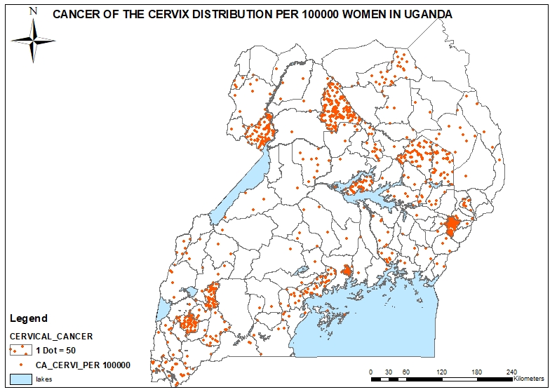
Figure 4:1 Cervical Cancer distribution in Uganda

4.1 Spatial autocorrelation
The results from the S.A report shows a P value of 0.22, a Z score of -1.23 and a Moran’s index of -0.07 (Figure 4.2).The null hypothesis of this context is that CxCa is randomly distributed therefore basing on this result, the occurrence of CxCa occurs by chance with accepts the hypothesis. The negative SA of cervical cancer that was detected represents a dispersed random occurrence of the disease. This value suggests that high values is associated with low values (Esri, 2015), as seen in figure 4.1 CxCa distribution. This distribution probably portrays under screening of women in most districts in Uganda leading to a missed or low recording cases of the disease.

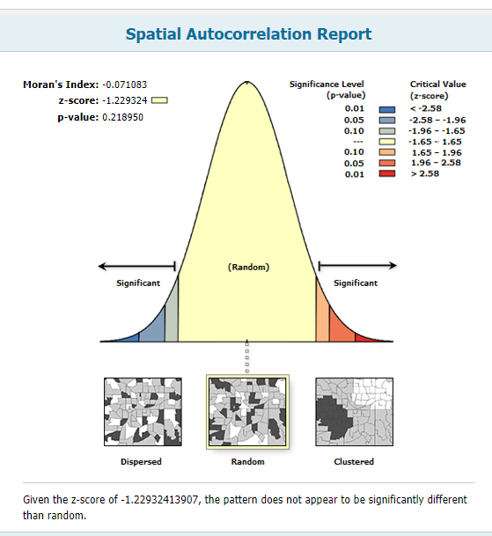
Figure 4:2 Spatial Autocorrelation Report

4.2 Analyzing the distribution of cervical cancer correlated factors
This process involved the mapping of the correlated factors that increase the risk of developing cervical cancer and were identified as tobacco, hormonal contraceptive, women with multiple partners, HIV, syphilis proportion, illiteracy, poor women, average monthly income of women, women age and fertility levels.
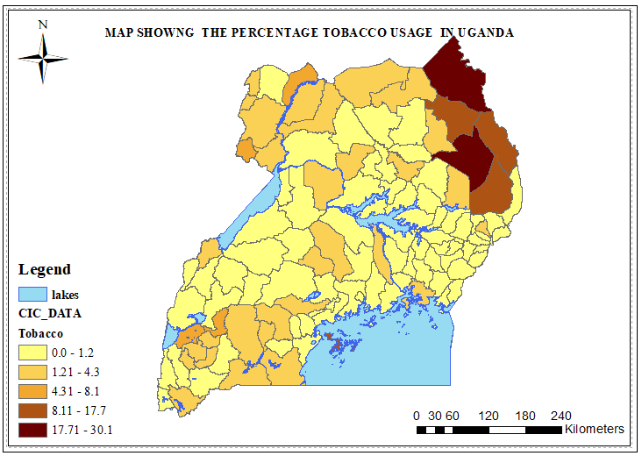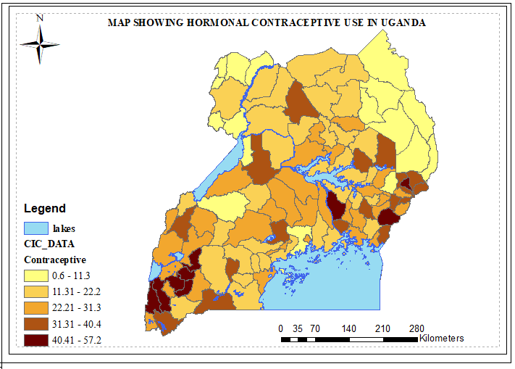
Figure 4:3: Tobacco usage Figure 4:4: Hormonal contraceptive usage
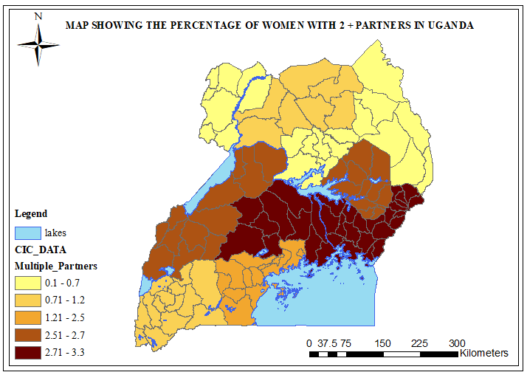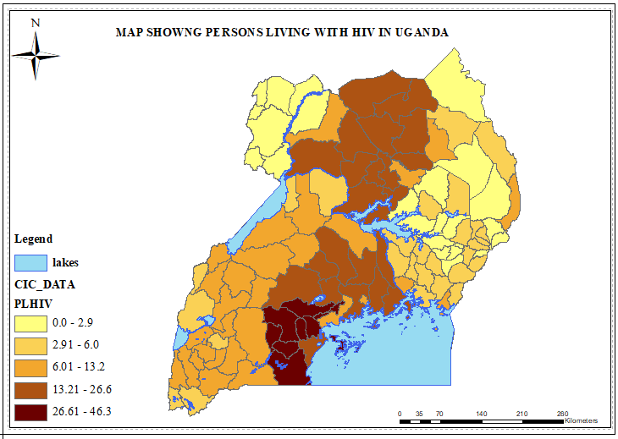
Figure 4:5: Multiple partners Figure 4:6: HIV distribution

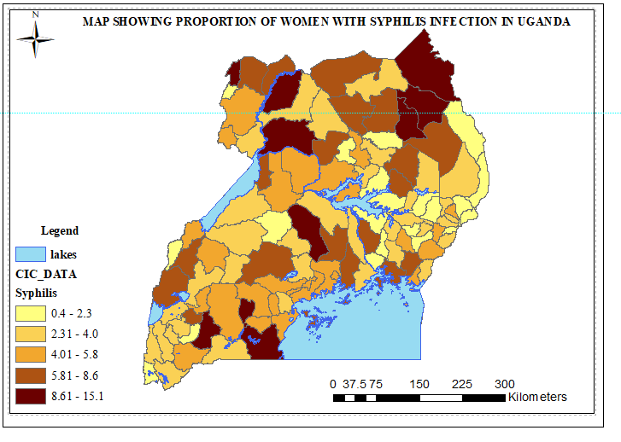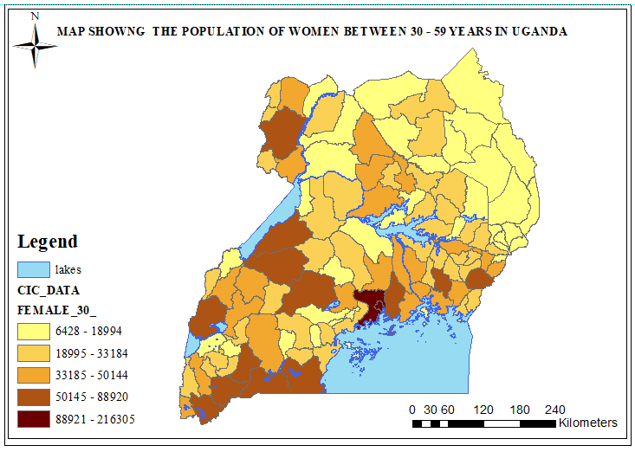
Figure 4:7: syphilis proportion Figure 4:8: Women population 30-59 years

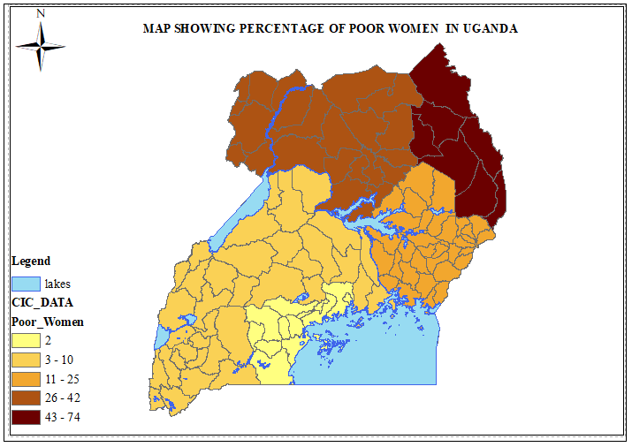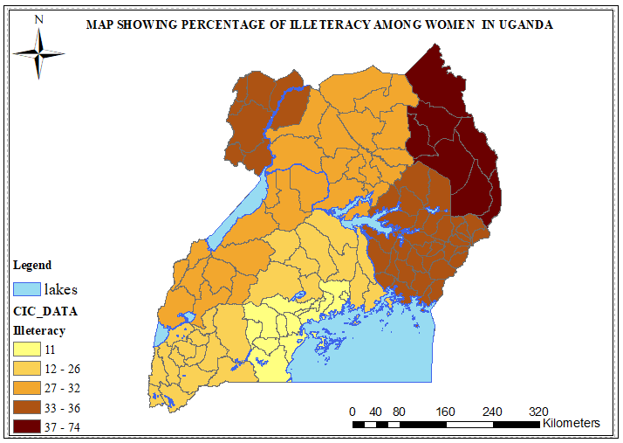
Figure 4:9: Percentage of poor women Figure 4:10: Percentage distribution of illiteracy
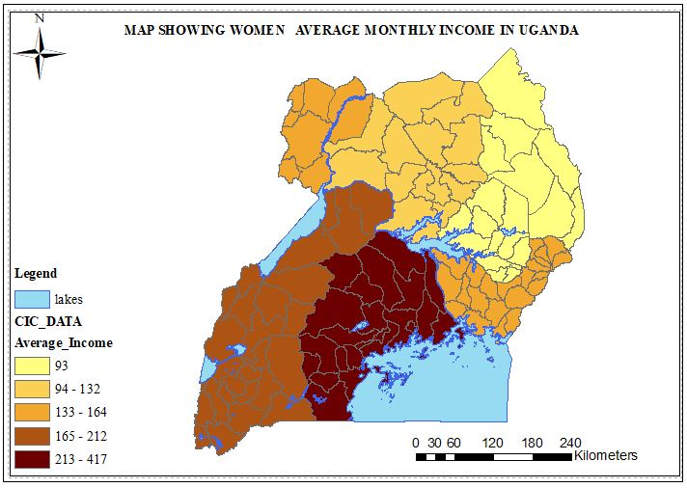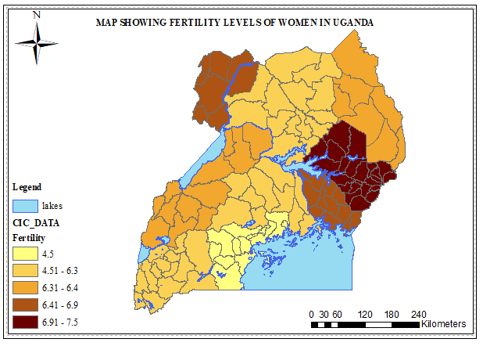
Figure 4:11: Average monthly income of women Figure 4:12: Fertility levels in women

4.2.1 Weighted factors
A spatial analyst overlay tool was applied to the factors maps and weighted basing on the tables below to produce a factor hotspot map.
Table 4:1 Ranking Socio Economic Variables
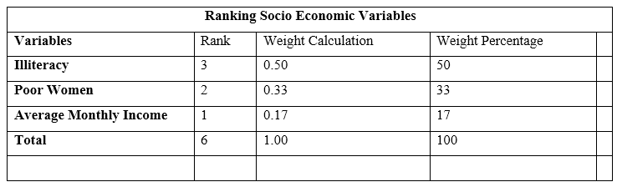
Table 4:2 Ranking Correlated Factors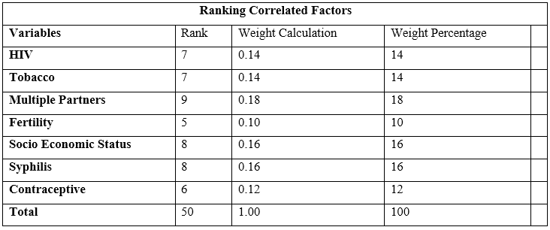

4.2.2 Cervical Cancer Correlated Factor Hotspot Map
The correlated hotspot map identified 21 percent (n=23/112) of the districts in Uganda represented with maroon color as very high cervical cancer risk areas, which were distributed throughout the country. The Central region had the highest number of districts in the very high risk zone with 12 of the 23 districts namely Kayunga, Nakaseke, Mityana, Mubende, Ssembabule, Gomba, Butambala, Lyantonde, Masaka, Bukomanisimba, Kalangala, Rakai. The Western region had seven of the 23 districts namely Kabalore, Ibanda, Buhweju, Bushenyi, Sheema, Rukingiri, Kanungu. The Eastern region had three of the 23 districts namely Kapchorwa, Tororo, Kamuli, while the Northern region had only one district, Gulu out of the 23 districts.
The very low risk areas represented by yellow color were identified by 13 percent (n=14/112) of the districts. The Northern region had the highest number of districts in low risk areas with nine of the 14, six of these districts were from the West Nile sub region. The district in Northern region included, Yumbe, Maracha, Arua, Zombo, Nebbi, Koboko, Moroto, Amudat and Nakapiripiti. The Eastern region had 3 of the 14 districts which included Serere, Buyede, and Bukedea. The Western region had 2 of the 14 districts namely Bullisa and Kibale. The Central region had no districts in low risk areas.
The majority of the districts in Uganda, 61% (n=68/112) represented by maroon to brown color were identified as high to very high risk districts, these were evenly distributed throughout the country. The Central region had the highest number of districts in high to very high risk with 21 of the 68 districts, the Western and Eastern regions both had 16 of the 68 districts in high to very high risk areas, and the Northern region had 15 districts in high to very high risk areas.
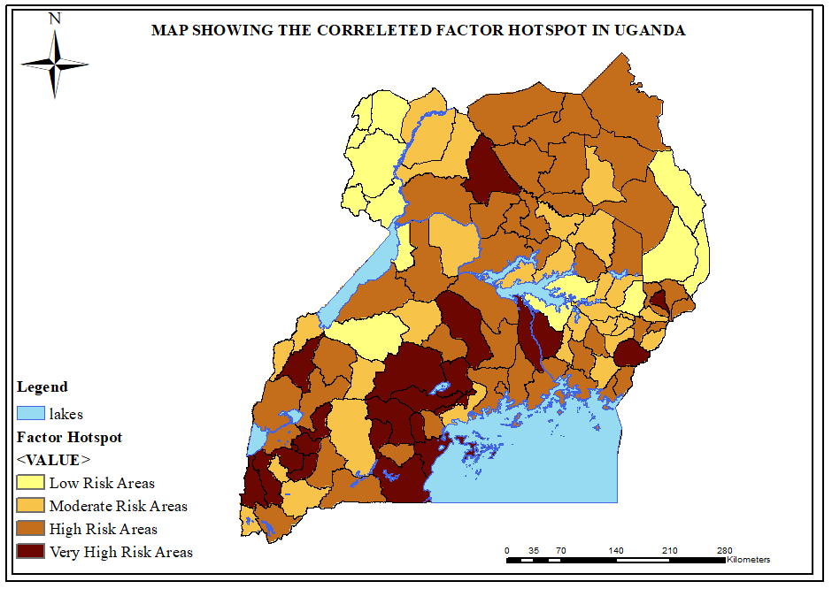
Figure 4:13 Correlated Factor Hotspot in Uganda
The factor hotspot map in figure 4.13 does not correlate to the prevalence of cervical cancer in Uganda in figure 4.1. The factor hotspot map in figure 4.13 presents clustering of cases as compared to the random Cxca prevalence in figure 4.1 and the SA report in figure 4.2. However, the factor map was successful in identifying Gulu in Northern region, Ibanda and Bushenyi in Western region as very high risk which was consistent with the Cxca prevalence in figure 4.1, the factor map identified the remaining very high risk districts from the CxCa prevalence as high risk areas.
The factor map presented a wide distribution of CxCa risk in Uganda, with a majority of districts being high to very high risk areas as compared to the distribution CxCa prevalence in Uganda. This probably might explain the gaps in screening that exist in Uganda and the reason why the 80 % of women with late presentation and high mortality of the disease (Waiswa et al., 2017; Mwaka et al., 2016; Mwaka et al.,2013; Katahoire et al., 2008). This distribution might signify the differences in screening of women, as a result of concentration of screening in certain areas such as Gulu in Northern region, Mbale in Eastern region and Kampala in Central region than other areas leading to a high numbers of missed cases in figure 4.1 as we are seeing in figure 4.13 where women at high risk areas are probably not being attended to (Waiswa et al., 2017;Mukamaet al., 2017; Mwaka et al., 2016;Twinomujuni et al, 2015; Nakibuule 2014; Ogilvie & Mitchell, 2013; Ogilvie et al., 2013; Ssenyonjo 2013 Mwaka et al.,2013)
Uganda being a low resource country is faced by limitation in accessibility and personnel to carry out the screening services, this might probably explain the difference between the factor hotspot map and the prevalence where majority of districts in Uganda, where women are currently not being screened leading to low reported cases in majority of districts which are of high risk (Okwi et al., 2007). The majority of low socio economic areas in figures 4.9 to 4.11 have also been affected greatly by low screening of women in these areas due to the wrong perception to screening, low awareness, low income levels to afford the screening services and this probably might also explain the difference in the correlated hotspot map and the prevalence of CxCa (Mukama et al., 2016;Santos et al., 2016; Mwaka et al., 2014;Ali et al.,2012). Therefore the screening service in Uganda should focus on other high risk areas. The map predicts the areas in Uganda where women are at high risk of the disease and the areas that require urgent intervention strategies to target women who might be at risk, thus reducing the burden of the disease before outbreak, this can also help in the surveillance of the disease (Mukama et al., 2016).

Conclusion and Recommendations
This study identified the existence of gaps in screening, where there is a lot of under screening of CxCa among the women in Uganda, this has led to missed screening in Uganda and thus there is urgent need of the health bodies in Uganda to place nationwide distribution of screening and treatment services so as to capture high number of women who are not being screened or else there will be continued missed cases, late presentation of the disease and high death resulting from this preventable disease. The study also affirmed that screening services are random and screening is not considerate of the high risk thus need to improve the surveillance and raising awareness of this disease to the women by communicating the risk they likely to face incase initiatives to preventions are not put in place. These initiatives need to start from the individual to community up to the national level perspective. Emphasis should be put to improve health seeking behaviors among the women, educating women about risk they face and due to high levels of illiteracy, poverty, these particularly make them more susceptible to diseases. The level of awareness among the women need to also be improved in order change their mindsets towards screening and treatment.
The development of a health national spatial data infrastructure can be paramount for future analysis of health related phenomena. This development will enhance further spatial epidemiology research, which is currently limited in Uganda and through the sharing, collecting accurate geospatial data and making it readily available, better analysis can be performed to manage disease effectively and efficiently. Therefore the integration of GIS research in Uganda health system will to improve on the analysis, which will improve on the spatial knowledge and aspects into disease studies.
There is need for community participation and general distribution of information through introducing community programs to target the low participation of women towards screening and enable tackle the rigidities in communities that limits screening. This can be done through training health workers to provide adequate information. There is need to improve the accessibility and coverage of screening services in the communities, through training more health workers to carry out the services.
There is need to distribute and increase screening and treatment services for women throughout the country, through financial investment into this disease, further research, improving policies that might help reduce the rates, determining issues that hinder communities from accessing the services, national wide campaigns to combat the disease through education and raising the awareness levels.

Limitation of the Study
The major limitation to this study was failure to get data mainly, HPV data which has been identified as the main factor to developing cervical cancer, this was due to HPV test not being available in Uganda. This lead to key variables missing in the study as shown by the model.
The data on socio economic status, multiple partners and fertility were collected in the sub regional levels and this data was generalized therefore might have brought ecological fallacy, bias and severe model problem when using the data on the software
The data from the ministry of health (HMIS) and (DHS) has a lot of errors which needed a lot of cleaning thus it wasn’t so reliable. The available data had only records for 2015 and 2016 thus study on patterns through the various years was impossible
The study did not address the spatial accessibility of women to screening services and the coverage of screening centers, this is an open field where future research could focus.

Conflict of interest
There is no conflict of interest in the study
Bibliography
Ahrens, W., & Pigeot, I. (2014). Handbook of epidemiology: Second edition. Handbook of Epidemiology: Second Edition. https://doi.org/10.1007/978-0-387-09834-0
Ali, F., Wassie, B., & Kuelker, R. (2012). Understanding cervical cancer in the context of developing countries. Annals of Tropical Medicine and Public Health, 5(1), 3. https://doi.org/10.4103/1755-6783.92871
Almonte, M., Albero, G., Molano, M., Carcamo, C., García, P. J., & Pérez, G. (2008). Risk factors for Human Papillomavirus Exposure and Co-factors for Cervical Cancer in Latin America and the Caribbean. Vaccine, 26(SUPPL. 11). https://doi.org/10.1016/j.vaccine.2008.06.008
Au, W. W. (2004). Life style, environmental and genetic susceptibility to cervical cancer. In Toxicology (Vol. 198, pp. 117–120). https://doi.org/10.1016/j.tox.2004.01.022
Barzilai, J., & Golany, B. (1990). Deriving weights from pairwise comparison matrices: The additive case. Operations Research Letters, 9(6), 407–410. https://doi.org/10.1016/0167-6377(90)90062-A
Castellsagué, X. (2008). Natural history and epidemiology of HPV infection and cervical cancer. Gynecologic Oncology, 110(3 SUPPL.2), 4–7. https://doi.org/10.1016/j.ygyno.2008.07.045
Chan, J., Monk, B., Brewer, C., Keefe, K., Osann, K., McMeekin, S., … Berman, M. (2003). HPV infection and number of lifetime sexual partners are strong predictors for ‘natural’ regression of CIN 2 and 3. British Journal of Cancer, 89(6), 1062–6. https://doi.org/10.1038/sj.bjc.6601196
Cowen, D. J. (1988). GIS versus CAD versus DBMS : What Are the Differences ?, 54(11), 1551–1555.
Esri. (2015). How GIS Works.
Fedewa, S. A., Sauer, A. G., Siegel, R. L., & Jemal, A. (2015). Prevalence of Major Risk Factors and Use of Screening Tests for Cancer in the United States. Cancer Epidemiology and Prevention Biomarkers, 24(4).
Ferlay J, Soerjomataram I, Ervik M, Dikshit R, Eser S, Mathers C, Rebelo M, Parkin DM, Forman D, Bray, F. (2015). No Title. GLOBOCAN 2012 v1.0, Cancer Incidence and Mortality Worldwide: IARC CancerBase No. 11 Lyon, France: International Agency for Research on Cancer; 2013, (http://globocan.iarc.fr, accessed on 25/december/2015).
Foliaki, S., & Pearce, N. (2016). Publisher main menu Prevalence of HPV infection and other risk factors in a Fijian population, (Ci), 1–11. https://doi.org/10.1186/1750
Gierisch, J. M., Coeytaux, R. R., Urrutia, R. P., Havrilesky, L. J., Moorman, P. G., Lowery, W. J., … Myers, E. R. (2013). Oral contraceptive use and risk of breast, cervical, colorectal, and endometrial cancers: a systematic review. Cancer Epidemiology, Biomarkers & Prevention : A Publication of the American Association for Cancer Research, Cosponsored by the American Society of Preventive Oncology, 22(11), 1931–43. https://doi.org/10.1158/1055-9965.EPI-13-0298
Glazier, R. H., Creatore, M. I., Gozdyra, P., Matheson, F. I., Steele, L. S., Boyle, E., … Kathuria, N. (2004). Geographic methods for understanding and responding to disparities in mammography use in Toronto, Canada. Journal of General Internal Medicine, 19(9), 952–961. https://doi.org/10.1111/j.1525-1497.2004.30270.x
Hang, D., Yin, Y., Han, J., Jiang, J., Ma, H., Xie, S., … Li, N. (2016). Analysis of human papillomavirus 16 variants and risk for cervical cancer in Chinese population. Virology, 488, 156–161. https://doi.org/10.1016/j.virol.2015.11.016
Holmes, R. S., Hawes, S. E., Touré, P., Dem, A., Feng, Q., Weiss, N. S., & Kiviat, N. B. (2009). HIV infection as a risk factor for cervical cancer and cervical intraepithelial neoplasia in Senegal. Cancer Epidemiology, Biomarkers & Prevention : A Publication of the American Association for Cancer Research, Cosponsored by the American Society of Preventive Oncology, 18(9), 2442–6. https://doi.org/10.1158/1055-9965.EPI-08-0956
Kesic, V., Poljak, M., & Rogovskaya, S. (2012). Cervical cancer burden and prevention activities in Europe. Cancer Epidemiology Biomarkers and Prevention. https://doi.org/10.1158/1055-9965.EPI-12-0181
Kitron, U. (1998). Landscape ecology and epidemiology of vector-borne diseases: tools for spatial analysis. Journal of Medical Entomology.
Liu, Z.-C., Liu, W.-D., Liu, Y.-H., Ye, X.-H., & Chen, S.-D. (2015). Multiple Sexual Partners as a Potential Independent Risk Factor for Cervical Cancer: a Meta-analysis of Epidemiological Studies. Asian Pacific Journal of Cancer Prevention : APJCP, 16(9), 3893–900.
Moreno, V., Bosch, F. X., Muñoz, N., Meijer, C. J. L. M., Shah, K. V, Walboomers, J. M. M., & Herrero, R. (2002). Effect of oral contraceptives on risk of cervical cancer in women with human papillomavirus infection : the IARC multicentric case- control study, 359, 1085–1092.
Mukama, T., Ndejjo, R., Musabyimana, A., Halage, A. A., & Musoke, D. (2017). Women’s knowledge and attitudes towards cervical cancer prevention: a cross sectional study in Eastern Uganda. BMC Women’s Health, 17(1), 9. https://doi.org/10.1186/s12905-017-0365-3
Mutyaba, T., Mmiro, F. A. F., & Weiderpass, E. (2006). Knowledge, attitudes and practices on cervical cancer screening among the medical workers of Mulago Hospital, Uganda. BMC Medical Education, 6, 13.
Mwaka, A. D., Okello, E. S., Kiguli, J., & Rutebemberwa, E. (2014). Understanding cervical cancer: an exploration of lay perceptions, beliefs and knowledge about cervical cancer among the Acholi in northern Uganda. BMC Women’s Health, 14(1), 84. https://doi.org/10.1186/1472-6874-14-84
Mwaka, A., Wabinga, H., & Mayanja-Kizza, H. (2013). Mind the gaps: a qualitative study of perceptions of healthcare professionals on challenges and proposed remedies for cervical cancer help-seeking in post conflict northern Uganda. BMC Family Practice, 14, 193.
Ndejjo, R., Mukama, T., Musabyimana, A., & Musoke, D. (2016). Uptake of cervical cancer screening and associated factors among women in rural Uganda: A cross sectional study. PLoS ONE, 11(2), 1–13. https://doi.org/10.1371/journal.pone.0149696
New Vision. (2015). Gulu Hospital To Get Cancer Institute. Retrieved 13 October 2017, from https://www.newvision.co.ug/new_vision/news/1410615/gulu-hospital-cancer-institute
Nooij, L. S., Brand, F. A. M., Gaarenstroom, K. N., Creutzberg, C. L., de Hullu, J. A., & van Poelgeest, M. I. E. (2016). Risk factors and treatment for recurrent vulvar squamous cell carcinoma. Critical Reviews in Oncology/Hematology, 106, 1–13. https://doi.org/10.1016/j.critrevonc.2016.07.007
Occhi, F., Okong, P., Bovani, I., Aloi, F., & Pozzi, M. (2011). Cervical and breast cancer in Uganda: A descriptive analysis of a screening campaign in rural and Urban Areas. International Journal of Gynecological Cancer. https://doi.org/http://dx.doi.org/10.1097/IGC.0b013e318235bd21
Ogilvie, G. G. S., Mitchell, S., Sekikubo, M., Biryabarema, C., Byamugisha, J., Jeronimo, J., … Money, D. M. (2013). Results of a community-based cervical cancer screening pilot project using human papillomavirus self-sampling in Kampala, Uganda. International Journal of GYNAECOLOGY AND OBSTETRICS, 122(2), 118–23. https://doi.org/10.1016/j.ijgo.2013.03.019
Okwi, A. L. a*, Othieno, E. a, W.a, B., Okoth, A. D. b, Ocaido, M., Okoth, A. D., & Wandabwa, J. (2007). Attitudes and knowledge gaps of the communities about cervical carcinoma and it’s detection in four selected districts of Uganda.
Ononogbu, U., Almujtaba, M., Modibbo, F., Lawal, I., Offiong, R., Olaniyan, O., … Adebamowo, C. (2013). Cervical cancer risk factors among HIV-infected Nigerian women. BMC Public Health, 13. https://doi.org/10.1186/1471-2458-13-582
Palaniyandi, M. (2012). The role of Remote Sensing and GIS for spatial prediction of vector-borne diseases transmission: A systematic review. J Vector Borne Dis, 49, 197–204.
Proma, P., Winkler, J. L., Bartolini, R. M., Penny, M. E., Huong, T. T., Nga, L. T., … Jeronimo, J. (2013). Screen-and-treat approach to cervical cancer prevention using visual inspection with acetic acid and cryotherapy: experiences, perceptions, and beliefs from demonstration projects in Peru, Uganda, and Vietnam. The Oncologist, 18(12), 1278–84. https://doi.org/10.1634/theoncologist.2013-0253
Rain-Uganda. (2015). CERVICAL CANCER SCREENING IN EASTERN UGANDA. Retrieved 13 October 2017, from https://www.indiegogo.com/projects/cervical-cancer-screening-in-eastern-uganda#/
Rytkönen, M. J. P. (2004). NOT ALL MAPS ARE EQUAL : GIS AND SPATIAL ANALYSIS IN EPIDEMIOLOGY, 9–24.
Sankaranarayanan, R., Nessa, A., Esmy, P. O., & Dangou, J.-M. (2012). Visual inspection methods for cervical cancer prevention. Best Practice & Research Clinical Obstetrics & Gynaecology, 26(2), 221–232. https://doi.org/10.1016/j.bpobgyn.2011.08.003
Santos, S., Caetano, E., Melo, P., & Santos, K. M. (2016). Spatial analysis of the indicators agreed for screening cervix cancer in Brazil El análisis espacial de los indicadores acordados para, 1–7.
Schiffman, M., & Solomon, D. (2013). Cervical-Cancer Screening with Human Papillomavirus and Cytologic Cotesting. New England Journal of Medicine, 369(24), 2324–2331. https://doi.org/10.1056/NEJMcp1210379
Seidman, C. S. (2006). An Introduction to Prostate Cancer and Geographic Information Systems, 30, 1–2. https://doi.org/10.1016/j.amepre.2005.10.019
Vinay Kumar, R., & Bhasker, S. (2013). Potential opportunities to reduce cervical cancer by addressing risk factors other than HPV. Journal of Gynecologic Oncology, 24(4), 295–297. https://doi.org/10.3802/jgo.2013.24.4.295
Waiswa, A., Nsubuga, R., Muwasi, M., Kimera, I., Ndikabona, G., Tusingwire, P. D., … Akera, P. (2017). Knowledge and Attitude towards Cervical Cancer Screening among Females Attending out Patient Department in Health Centre IIIs in Oyam District. Open Journal of Preventive Medicine, 7(4), 55–62. https://doi.org/10.4236/ojpm.2017.74005

