

THE POSSIBILTY OF EMPLOY THE MICRONUCLEUS TEST FOR THE DIAGNOSIS OF THE DOUBT CASES IN THE SCREENING FOR THE DETERMINATION OF BREAST CANCER
MENICAGLI LAURA * MENICAGLI ROBERTO**
*IRSCC POLICLINICO SAN DONATO UNIVERSITY MILAN
** BIOMED RESARCH LAB MEDIGLIA
Preliminary, and positive results, propose the use of test of the micronucleus , in saliva, for the diagnosis of the cases doubts, detected in screening for breast malignancy
THE CASE DOUBTS – BIRADS 3. PROBABLY BENIGN
BI-RADS ,is a scheme for putting the findings from mammogram screening ,(for breast cancer diagnosis), into a small number of well-defined categories. Although BIRADS started out for use with breast screening mammography, it was later adapted for use with Magnetic Resonance Imaging (MRI) and breast ultrasound (US) as well.
THE BIRADS CASSIFLICATION : 0- incomplete ; 1-negative ;2-benign findings ;3-PROBABLY BENIGN ;4-suspicious abnormality ;5-highly suspicious of malignancy ;6-known biopsy with proven
BIRADS 3 is rarely used nowadays, because BIRADS 4 and 5 are categories that lead to biopsies, and breast biopsy to give a definitive diagnosis. BIRADS 3 often indicates the need for a 6-month follow-up mammogram. THIS CAN CAUSE WORRY AND ANXIETY FOR EVERYONE FOR THOSE 6 MONTHS DUE TO THE UNCERTAINTY OF THE SITUATION. BOTH RADIOLOGISTS AND PATIENTS PREFER FAST ANSWERS RATHER THAN HAVING TO WAIT FOR 6 MONTHS
Category 3. Probably Benign
With BI-RADS category 3, a follow-up of 6 months is usually recommended. On the breast cancer screening mammogram there may be a finding of some kind, but the lesion is non-palpable Findings typical of this category include: 1-Clusters of tiny calcifications – round or oval 2-Non-calcified solid nodules (no size limitation but non palpable on physical examination), round, ovoid and well-defined. 3-Selected focal asymmetrical areas of fibroglandular densities (not palpable): This might include concave-outward defined margins, interspersed with fat and without central increased fibular density on two projections. 4-Miscellaneous focal findings, such as a dilated duct or post biopsy architectural distortion without central density 5-Generalized distribution in both breasts. For example, multiple similar lesions with tiny calcifications or nodules distributed randomly In some scenarios a percutaneous biopsy (usually core-needle biopsy) might be considered even for BIRADS category 3. For example, extreme patient anxiety or plans for pregnancy, plans for breast augmentation or reduction surgery, or if synchronous carcinoma is present. POSITIVE NEGATIVE
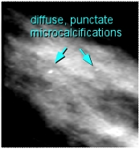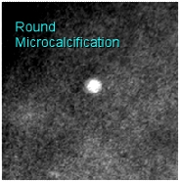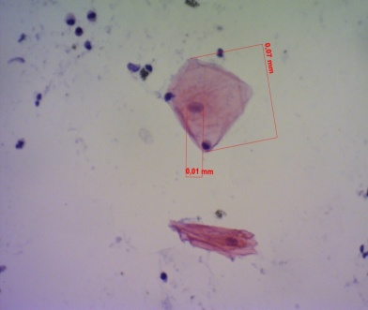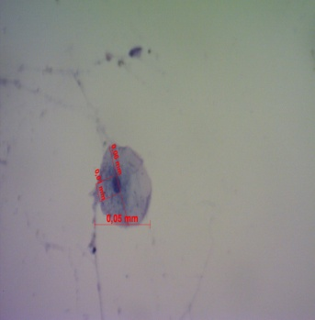
These tiny specs are diffuse This microcalcification is round, MICRONUCLEUS not MICRONUCLEI
Punctuate microcalcifications but the edges are not sharply MICRONUCLEUS
defined (indeminate birads 3)
biography MENICAGLI LAURA

2003 -Degree in Medicine and Surgery, University of Milan, Milan, IT
2007
Specialization in Radiodiagnostics, University of Milan, Milan, IT

PROFESSIONAL EXPERIENCES
From 2008 reader for the mammographic screening service organized by the ASL Milano2 (Certified Diploma in senology issued by ISPO, Florence, 2006

PUBLICATION Collaboration on the research activities of the Radiology Unit of the IRCCS Policlinic San Donato , with 8 articles published in PubMed indexed journals with impact factor.

FULL NAME. MENICAGLI LAURA
039290661201
Menicagliòlibero.it
POSTER PRESENTATION

,

