MENICAGLI ROBERTO*- MAROTTA ORTENSIO**
*SENIOR RESEARCH ROMABIOMED RESEARCH .LAB ;DIR UOC SANT’ANNA HOSPITAL CASERTA
THE DIABETES IN THE PROMOTION OF ORAL AND LARYNGEAL CANCER
RISK FACTORS ( SMOKE , HPV, ALCOHOL, AGE, SEX)
MUCOUS NOT ALTERATE LAYER
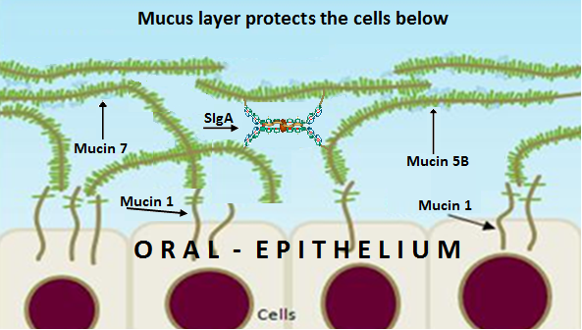
NO PROMOTION OF ORAL AND LARYNGEAL CANCER
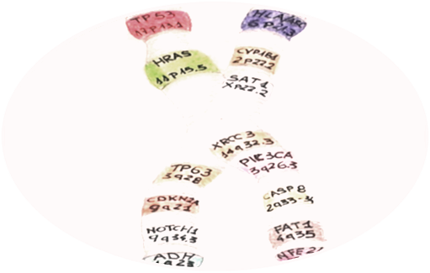 MICRONUCLEUS ≥ IN DIABETES
GENE MUTATION

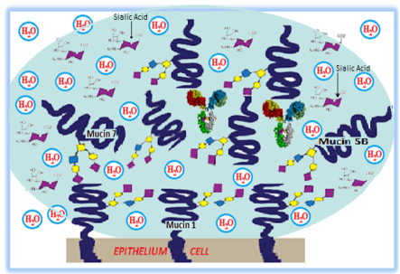 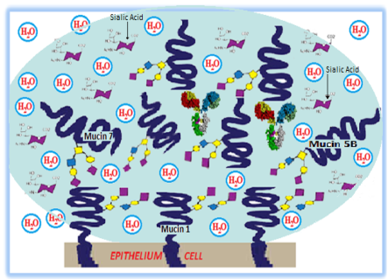------MUCOUS ALTERATE LAYER -------------------------------------------------RISK FACTORS-----------------------------------DIABETES -FREE RADICALS-
Laryngeal cancer and oral cancer are not always correlated with genetic mutations, HPV infection, smoking, and alcohol abuse. In the absence of these risk factors, there is an epidemiological increase on these cancers with a parallel increase of diabetes The possible explanations is that in diabetes increases, the free radicals production, the micronucleus formation, and the concentration of salivary mucins with a alteration of mucin layer ,even more reduced, and so completely ineffective in protecting the mucosa. Diabetes is also a risk factor, p= 0.0445 ,for laryngectomees male vs control group
BIOGRAPHY
Roberto Menicagli has completed his PhD at the age of 25 years from Milan University .Postdoctoral studies in biochemistry and molecular genetics, at the faculty of biology at Milan University. He is the director of Roma Biomed Research Lab a Private Medical Service Organization. Has published more than 20 papers in reputed journals ,some also with impact factor ; is also the principal author of 4 international patent ,in the field of the environment, and biomarkers , and has been serving as an editorial board member of two magazine concerning the medical sciences.

