Successful Anesthetic Management for a Medialization Thyroplasty in a Case of Vagus Nerve Damage from Breast Cancer Recurrence;
Zanot A, Alnatour O, Williams UU, Zavala AM, Van Meter A, Kapoor R, Mirza A, Bellard B, Owusu-Agyemang P
The University of Texas MD Anderson Cancer Center, Department of Anesthesia and Perioperative Medicine
Introduction
Medialization thyroplasty is a procedure for voice palliation secondary to vagus nerve damage (1). An intraoperative voice assessment may be necessary to evaluate the success of the procedure, and anesthetic management should not impair the ability of the patient to follow instructions. We present the case of a patient with unilateral vocal cord paralysis presenting for thyroplasty where the use of local anesthesia provided significant benefits.
Case Report
A 58 year-old female with left unilateral vocal cord paralysis presented for a medialization left thyroplasty with Gore-Tex graft. Two milligrams of midazolam was administered in the preoperative holding area. In the operating room, a propofol infusion was initiated at 75 mcg/kg/min and discontinued after a local anesthetic injection of the surgical site (1% lidocaine with 1:100,000 epinephrine) had been performed by the surgeon. Phenylephrine and oxymetazoline were also administered intranasally. A left thyroid cartilage window was created to enter the periosteum, perichondrium, and the inner perichondrium. A speech pathologist used a nasal fiberoptic scope to inspect the larynx. Under direct visualization, the Gore-Tex was placed behind the vocalis muscle, pushing it medially. Intraoperative voice assessment verified correct placement of the graft. The patient maintained spontaneous ventilation and the procedure was completed without complications.
Discussion
The use of local anesthesia with minimal sedation proved to be successful for many reasons in this case. This modality allowed for real time intraoperative voice assessment and proper placement of the Gore-Tex graft, potentially leading to improved surgical outcomes. Additionally, the use of local anesthesia avoided possible complications of laryngeal mask airway (LMA) insertion. While some studies have performed thyroplasty using an LMA, this modality increases the pharyngeal space and decreases exposure to the surgical field (4), potentially interfering with vocal cord medialization. Sedatives such as dexmedetomidine may also be administered with local anesthesia to inhibit laryngeal motion and reflexes without impairing respiration, thus allowing for a quiet surgical field and safe intraoperative voice assessment (2). Performing a thyroplasty while the patient is awake can potentially lead to better surgical outcomes, decreased surgical/anesthesia complications, a more cost and time effective treatment (3), and better tolerated treatment for patients with significant sensitivity to anesthetics.
References
1. Lam PK, Ho WK, Ng ML, Wei WI. Medialization thyroplasty for cancer-related unilateral vocal fold paralysis. Otolaryngol Head Neck Surg 2007; 136 (3) 440-444.
2. Kukida, A., Fujimoto, Y., Shimoyama, K., Nakamoto, A., Yoshikawa, N., Ohira, N., & Tatekawa, S. [Dexmedetomidine is useful for sedation during laryngoplasty with voice monitoring]. Masui. 2014;63(4), 431-434.
3. Kanazawa, T., Watanabe, Y., Komazawa, D. et al, Phonological outcome of laryngeal framework surgery by different anesthesia protocols: a single-surgeon experience. Acta Otolaryngol. 2014;134:193–200.
4. Tokashiki R, Hiramatsu H, Tsukahara K, Kanebayashi H, Nakamura M, Motohashi R et al. A “fenestration approach” for arytenoid adduction through the thyroid ala combined with type I thyroplasty. Laryngoscope 2007;117:1882–7.

Figure 1: CT soft tissue of neck with contrast
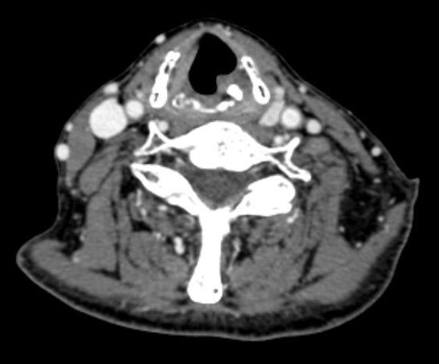
Left vocal cord paralysis

Figure 2: Right vocal cord closed
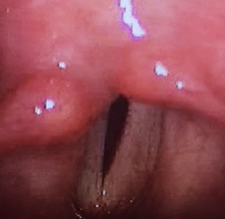
Left cord paralysis
Right cord adducted

Figure 3: Right vocal cord open
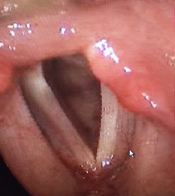
Left cord paralysis
Right cord abducted

