ABSTRACT
Lingual Space of Maximum Size as an Electromagnetic Field of the Human Body: Health and Disease - Biotechnological Factors
The importance of functional lingual space for human health and quality of life was first emphasized by Willem Balters (German doctor MD, in 1962), when he concluded that the reduction of the buccal space and glossoptosis (tongue drop down) can compromise the individual's physiological, physical, biochemical and emotional balance. This correlation has been highlighted by several journals (articles, books, etc) in Europe, South America, North America and especially in Brazil. According to the latest advances in biotechnology, it is now possible to evaluate and quantify, in human saliva, several inflammatory markers and the main hormones that control all metabolism. This work has provided dentists, doctors (MD) and other related professionals with better possibilities for the diagnosis and treatment of a number of chronic diseases that also present an important oral component, which is still forgotten. Therefore, this work aims to highlight the importance of maximum size buccal space and the functional influence of this powerful electromagnetic field, acting as a box of physiological hormonal rossonance for the individual's cellular metabolism according to the concepts of quantum and energetic medicine.
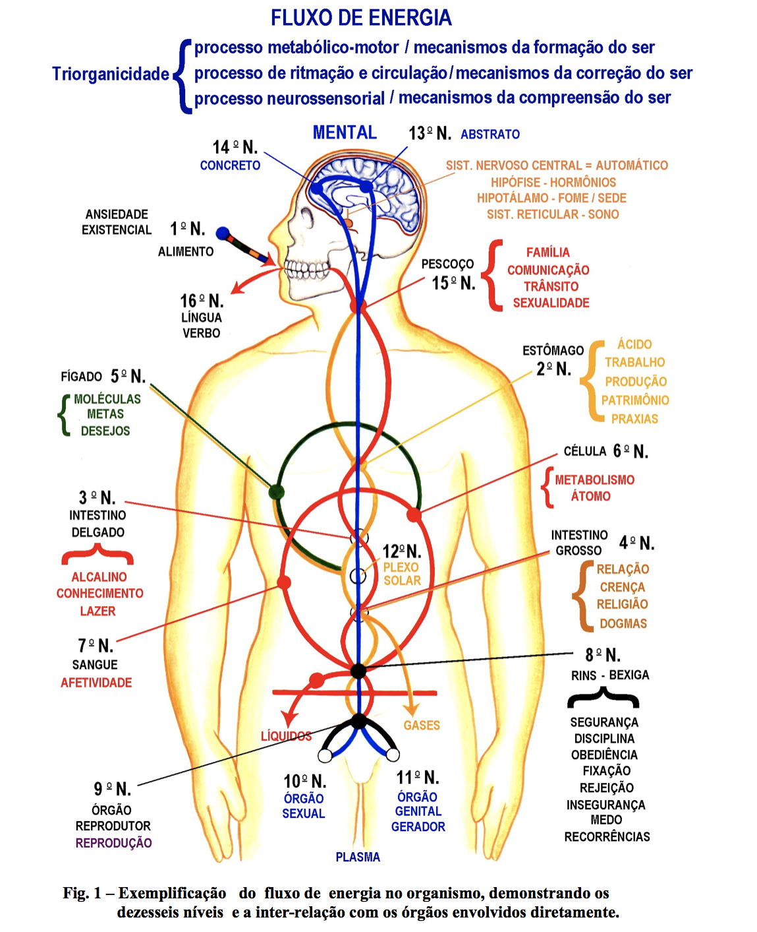
Key words: lingual space, electromagnetic field, health, disease.
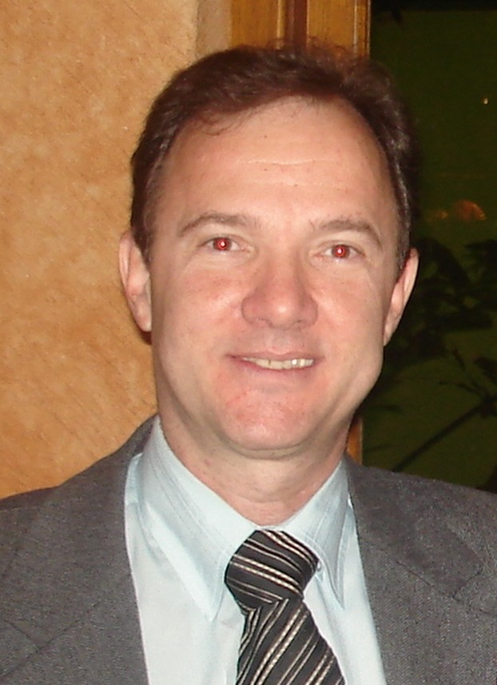

Biography

Dr. Helio Gomes da Silva, Doctor in Dentistry (PHD, MSD, DDS), author of 03 books and numerous scientific articles which correlates the deformation of the shape and volume of functional lingual space with different physical, chemical and emotional changes of human beings, who participating in a context of chronic disease; developed and HGS-RA system (intra-oral devices for the treatment of snoring and sleep apnea); researcher since 1990 on the symptoms of TMJ, dysfunction, relating to the occlusal disharmony with repercussions in the spine, CTA Research Center of the Brazilian Air Force in São José dos Campos, Brazil; Researcher UNITAU- (University of Taubaté- Sao Paulo State, where he completed a survey of the daily performance and psychosocial conditions of young adults undergoing orthodontic treatment; currently, teacher graduate program coordinator in dentistry in orthodontics Faculty IMED (RS- Brazil) and College IPENO (SC-Brazil)
Name - HELIO GOMES DA SILVA
EMAIL - consultoriohgs@gmail.com
Mobile Number 55 12 988640511
Facebook - Helio Gomes da Silva
Category - Oral Presentation
Date of Birth - 30/mai/1956
Postal Adress - J. K. Av 580/12 - Guaratinguetá- SP - Brazil

