Title: Enhancing Potentials of under-utilized Legume (Mucuna utilis) by Fermentation with Hybrid Rhizopus strain Produced by Protoplast Fusion of Parent Cells

- Balogun, Olanrewaju Ifejesu, PhD.
Department of Food Technology, Yaba College of Technology,
Yaba, Lagos. Nigeria.

Abstract (300 word limit)
Statement of the Problem: United Nations has projected likelihood of inability to supply food adequately to entire world population by 2020 when world population is expected to have multiplied. Coupling this fact is problem of inadequate harvest of crops in developing nations, where farmers leave good percentage of harvests on farms for lack of adequate transportation and storage facilities. Velvet bean (Mucuna utilis) is an underutilized legume though embedded with bundles of nutritional potentials; reason identified for its abandonment is presence of toxic compounds in the seed. Research efforts have concentrated on detoxifying velvet bean with practices like roasting, boiling, soaking and combined efforts of soaking with boiling in soak water for long period of time. Methods like these have not produced samples with increased nutritional quality; rather leaching of nutrients occurs with high energy demand making such treatments non-economical. Methodology & Theoretical Orientation: Fermentation technique, using the hybrid Rhizopus strain and its respective parent cells is known to keep nutrients as intact and bring about increases in nutritional values through pathways that result into advantageous bio-molecular transformations. Findings: Different enzyme concentrations yielded significant differences in number of free protoplasts released by parent cells, with optimum enzyme activity at 4.0 x 10³ U/g mycelia. R. oryzae appeared most promising in all enzymatic activities. Morphologically, the hybrid resembled R. oligosporus. Hybrid species was most effective in reducing anti-nutrients in samples with a reduction of over 90% of L-DOPA content in samples fermented with R. oryzae and hybrid. Conclusion & Significance: The study was successful at producing a hybrid from R. oligosporus and R. oryzae by protoplasmic fusion with better performance than either of parent strains with a practical and visible potential of detoxifying Mucuna utilis by fermentation with hybrid organism, thereby enhancing the bean as a viable food commodity. Recommendations are made that hybrid cells should be further employed in Tempeh production.

Image
a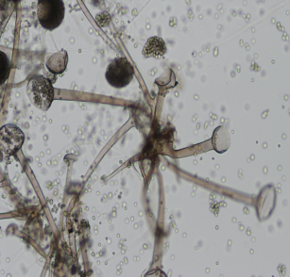 b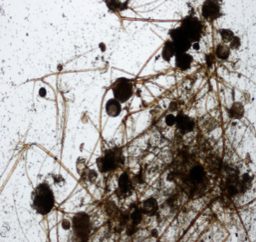

c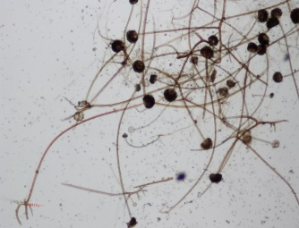

Plate 1a: Layout of mycelia network: R.oligosporus. Magnification: x 40
Plate 1b: Layout of mycelia network: R.oryzae. Magnification: x 40
Plate 1c: Layout of mycelia network: Hybrid Magnification: x 40

Recent Publications (minimum 5)
- Food and Agricultural Organization (2014). The state of Food Insecurity in the world. www.fao.org/publications.sofi.
- Grajek W., Anna O. and Anna S., (2005). Probiotics, prebiotics and antioxidants as functional foods; Acta Biochimica Polonica, 52 (3): 665–671.
- Medical Toxicology, (Google book search) books.googles.com (2004). ISBN 978-0-7817-2845-4.
- Sikandar, H. and Christos, C. (2010). Isolation and Fusion of protoplasts from the Phytopathogenic Fungus Sclerotium rolfsii (sacc.) Brazilian Journal of Microbiology, 41: 253-263.
- Balogun, I.O, Otunola, E.T, Olatidoye, O.P and Adebayo-Oyetoro, A.O (2011). Effect of fermentation with Rhizopus species on some physic-chemical properties of starch extracts from velvet bean (Mucuna utilis). Book of Abstracts, International Food Conference, Faculty of Agricultural Technology, Widya Mandala Catholic University, Surabaya, Indonesia.
- Gurumoorthi .P., Janardhanan.K., Kalvathy .G. (2013). Improving nutritional value of velvet bean; Mucuna pruriens (L) DC.var utilis (wall.ex.wight) L.H Bailey; an underutilized pulse using microwave technology; Indian Journal Traditional Knowledge. 12 (4): 677-681.

 Biography (150 word limit)
BALOGUN Olanrewaju Ifejesu is an academic and researcher presently based in Nigeria. His research area is based on Food Biotechnology with major interest in fermentation and sprouting Technology to combat challenges arising from food insecurity in order to ensure food safety, adequate processing and development. He has maintained a focused research on detoxification or removal/reduction of toxic, anti-nutritional principles of under-utilized legumes such as Mucuna sp. He also majors on Rhizopus strain development through hybridization using protoplast fusion technique; a technique he successfully employed to develop a novel hybrid Rhizopus strain from R. oligosporus and R. oryzae, which was successfully applied in his fermentation research with an enormous result. He works with both local and international collaborators; especially with researchers in Indonesia in product development of Tempeh, a fermented food from soy-bean.

Email:folabalog@gmail.com

- Full Name: BALOGUN, Olanrewaju Ifejesu
- Personal Email: folabalog@gmail.com
- Mobile Number: +2348027243969, +2349081142538
- Linked In:
- Facebook: Lanre Balogun
- Session Name/ number:
- Category: (Oral presentation/ Poster presentation)
- Date of Birth: November 17, 1966
- Postal Address: Department of Food Technology,
Yaba College of Technology,
Yaba, Lagos.
Nigeria.

Notes or Comments:

