Ultra-fast analysis of nucleic acids in human serum by bioorthogonal hybridization assays.

Jesper Uhd,¹ Laura Miotke,² Hanlee P. Ji², Marina Dunaeva,³ Ger J. M. Pruijn,³ Christian Damsgaard Joergensen,⁴ and Kira Astakhova¹, PhD, Associate Professor in Chemistry
1. Department of Chemistry, Technical University of Denmark, 207 Kemitorvet, 2800 Kgs. Lyngby, Denmark
2. Stanford Genome Technology Center, Stanford University, 3165 Porter Drive, Palo Alto, California 94304, United States
3. Department of Biomolecular Chemistry, Institute for Molecules and Materials, Radboud University, Geert Grooteplein Zuid 26 28, 6525 GA Nijmegen, The Netherlands
4. Department of Mathematics and Computer Science, University of Southern Denmark, Campusvej 55, 5230 Odense, Denmark

Abstract
Point-of-care (POC) diagnostic tools used for e.g. cancer and rheumatoid arthritis (RA) provided today, does not show high enough sensitivity and specificity. Current POC diagnostic tools for detection of nucleic acid biomarkers are not reliable enough and new more accurate tools are needed. Bioorthogonal hybridization assays will get rid of amplification-related bias, as no enzymes are used for this, and is also time efficient as no heavy workload is performed. The main targets for the enzyme-free assay chosen here are microRNA (miRNA) and circulating tumor DNA (ctDNA), respectively, from human blood serum. miRNAs are a group of regulatory molecules, which can be used as potential biomarkers for diagnostics of RA. Studies of miRNA have shown a dysregulation in specific miRNAs that relates to rheumatic diseases as RA. The detection of dysregulated miRNA serve to give specific detection but also to simplify the workflow in RA diagnostic. ctDNA mutations caused by cancer is actively being explored for the detection of specific tumor tissue as these are released to the blood stream by dying tumors. ctDNA mutations vary for each patient which can be used for a diagnostic purpose. Detection of mutations is done through single-nucleotide polymorphisms (SNPs) as to give information of genetic variation found in the human genome. Reliable detection of SNPs is both important in clinical- and research science. Bio-recognition can be performed through bioorothogonal hybridization assays which uses synthetic oligonucleotides as these allows for detection of miRNA’s in RA patients and SNPs in cancer associated ctDNA. The bioorthohonal assay still needs more work to be able to replace existing diagnostic assays but gives important knowledge for current and future work in this field.

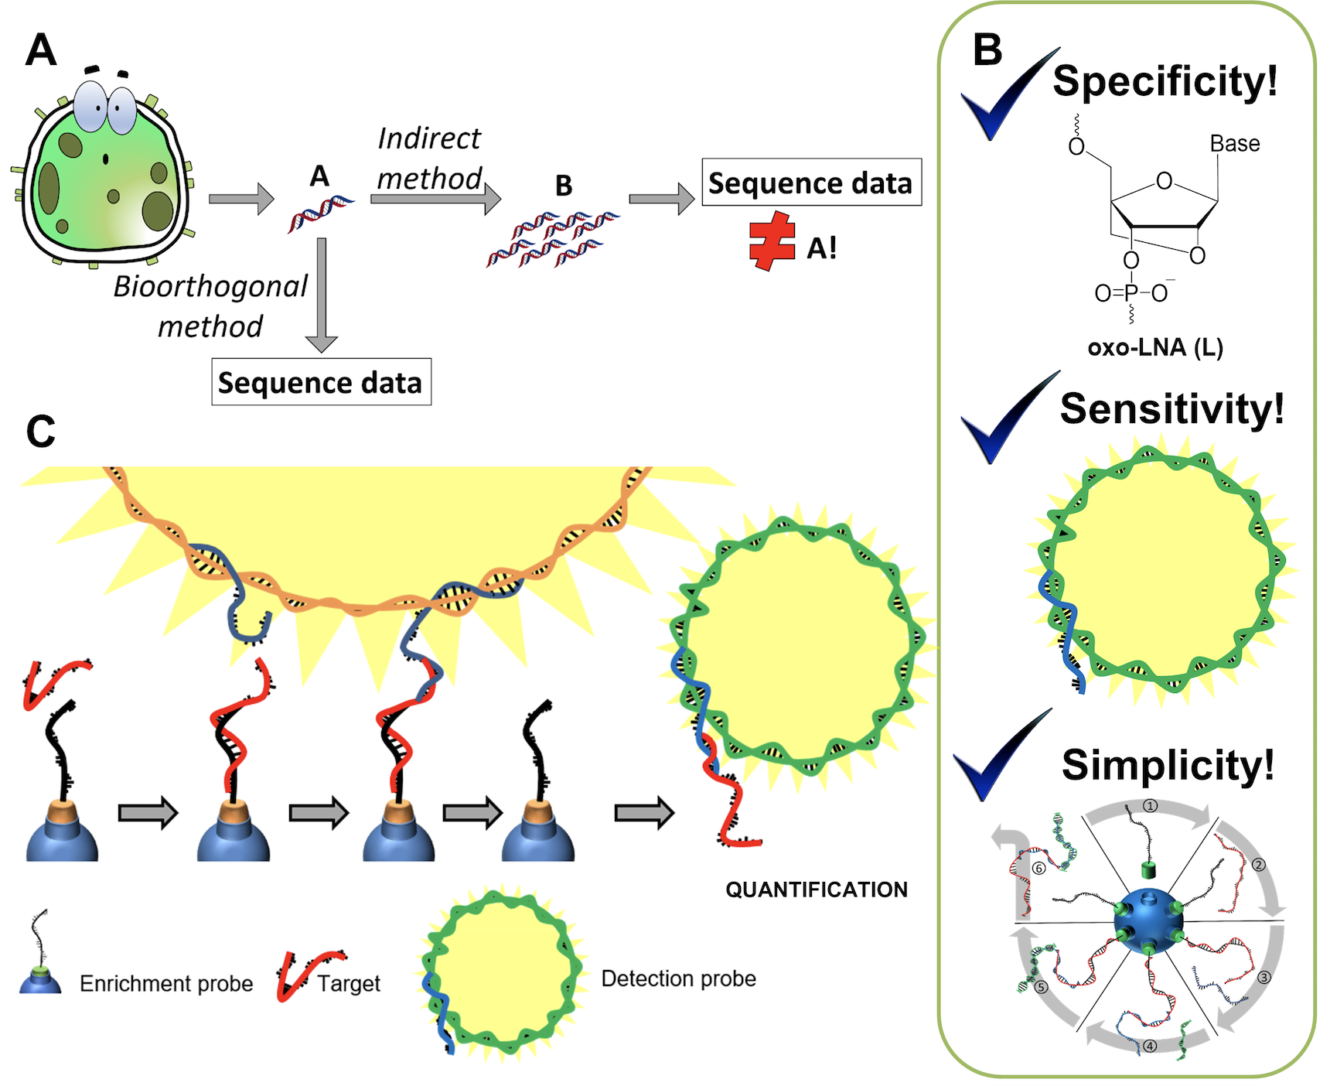
Recent Publications
- Maria Taskova, Jesper Uhd, Laura Miotke, Matthew Kubit, John Bell, Hanlee P. Ji, and Kira Astakhova (2017) Tandem Oligonucleotide Probe Annealing and Elongation To Discriminate Viral Sequence. Anal. Chem. 2017, 89:4363–4366.
- Ivana Domljanovic, Annika Carstens, Anders Okholm, Jørgen Kjems, Christoffer Tandrup Nielsen, Niels H. H. Heegaard and Kira Astakhova (2017). Complexes of DNA with fluorescent dyes are effective reagents for detection of autoimmune antibodies. Scientific Reports 7:1925.
- Kira Astakhova, Vladimir Korshun, et al. (2017) 2'-O-Me RNA probes modified with pyrene fluorophores: Attachment point matters. Tetrahedron 73:3220-3230.
- Maria Taskova, Maria Carla Barducci and Kira Astakhova (2017) Environmentally sensitive molecular probes reveal mutations and epigenetic 5-methyl cytosine in human oncogenes. Org Biomol Chem 2017:5680-5684.

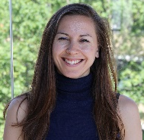Biography
Kira Astakhova is an Associate Professor in the Department of Chemistry at the Technical University of Denmark where she has been a faculty member since August 2017. She holds PhD in Bioorganic Chemistry from the Russian Institute of Bioorganic Chemistry, received in the group of Prof. Korshun in 2009. Dr. Astakhova completed her undergraduate studies at Higher Chemical Colledge of Russian Academy of Sciences. In 2012-2017 Dr. Astakhova has been appointed at the Nucleic Acid Center, University of Southern Denmark. Her current research interests lie in the area of nucleic acid chemistry and biotechnology. Currently Astakhova group has 11 members. In January 2018, Dr. Astakhova initiated a high tech company IBIO TECH ApS, that works on autoimmune research and therapy (https://ias982.wixsite.com/ibiotechnol). The research group and start us are supported by several industrial and research grants, including Villum Foundation and National Institutes of Health, USA.

Email: kiraas@kemi.dtu.dk

