Mutation Breeding in Malaysia

Sobri Bin Hussein¹, Abdul Rahim Bin Harun¹, Shakinah Binti Salleh¹, Sakinah A¹, Zaiton A¹. Khairuddin Bin Abdul Rahim¹, Faiz Bin Ahmad¹, Mustapha A¹.,Phua Choo Kwai Hoe¹, Zahid A¹, Maznah M¹., Ahmad Nazrul A.W¹, Latiffah Binti Nordin¹, Atsushi Tanaka², Anna Ling Pick Kiong³, Mohd Rafii Bin Yusop⁴, Kogeethavani R⁵.

Abstract (300 word limit)
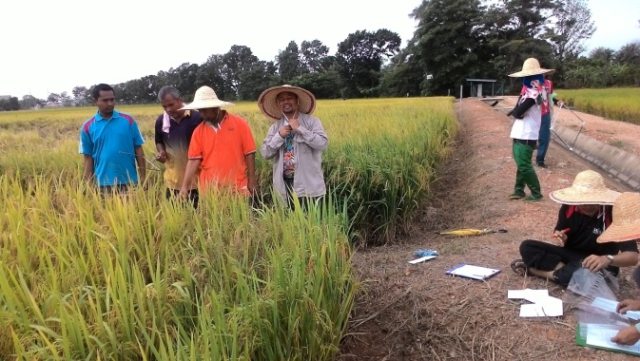
In Malaysia, the development of mutation induction technology has progressed well, from the phases of capacity building and infrastructure upgrading to research applications in many crops including ornamental plants, which ultimately lead to the generation of new and beneficial mutant lines and varieties. Currently, most of the mutation breeding projects are funded by grants from Ministry of Science, Technology and Innovation (MOSTI) viz. ScienceFund, TechnoFund, Community Innovation Fund (CIF), MOSTI Social Innovation (MSI), Fundamental Research Grant Scheme (FRGS) from Ministry of Higher Education (MoHE) and International Atomic Energy Agency (IAEA). These projects are mainly collaborative efforts involving various government departments and agencies, research institutes and institutions of higher learning. In agriculture and life sciences, Malaysian Nuclear Agency (Nuclear Malaysia) conducts research and development (R&D) using nuclear technology for the improvement of food and industrial crops and ornamental plants, management of agro-ecosystems for productivity enhancement as well as development of radiation based bioproducts and bioprocesses. Rice industry has always been a priority based on strategic importance of rice as a staple food commodity. Although the production of rice is increasing towards population increase, Malaysia still depends on imported rice to fulfill consumer’s demand. Malaysia managed to achieve 72% self-sufficiency level in rice with the current average rice yield of 4.1t/ha/season. In this situation, about 28% of the local demand will have to depend on rice imports. In Peninsula Malaysia, rice production depends largely on the irrigated lowland production system. Through ten years of R&D, Nuclear Malaysia succeeded in generating five potential rice mutant lines through ion beam (irradiated at TARRI, formerly known as AVF-Cyclotron, Japan Atomic Energy Research Institute) and gamma rays radiation. Of these, 3 mutant lines (ML3, ML10 & ML30) were produced through ion beam radiation while another 2 mutant lines (NMR151 and NM152) were derived from gamma radiation.

Recent Publications (minimum 5)

- Hussein, S, Halmi, M.I.E, and Ling, A.P.K, 2016. Modelling the growth kinetics of the callus cultures from the seedling of Jatropha curcas L. according to the modified gompertz model. Journal of Biochemistry, Microbiology and Biotechnology. JOBIMB 2016, Vol 4, No 1, 16-19.

Image

Field trial at farmer’s plot

- Ling, A.P.K, Halmi, M.I.E, Hussein, S, and Ong S.L. 2016. Modelling the Effect of 2-4, D on the Growth Kinetics of Cell Suspension Cultures of Ficus deltoidea L. Journal of Biochemistry, Microbiology and Biotechnology. JOBIMB 2016, Vol 3, No 2, 1-5.

- Erna, Laere, Anna P. K. L, Ying P. W, Rhun, Y. K, Mohd Azmi M. L, and Sobri, H, 2016. Plant-Based Vaccines: Production and Challenges. Journal of Botany. Vol 2016, Article ID 4928637. 1-11.

- Ling, A.P.K, Halmi, M.I.E, Hussein, S, and Ong S.L. 2016. Modelling the effect of picloram on the growth kinetics of cell suspension culture of Ficus deltoidea L. Journal of Biochemistry, Microbiology and Biotechnology. JOBIMB, 2016, Vol 4, No 1, 16-20.
- Shaiful A.M., Mat Rasol., Rusli I., Choong Y. K., Mohd Y. H., Rosnani A. R., Sobri H., Khairuddin A. R., Fauzi D., Aidil A. H. & Wan Mohtar W. Y. Production of Endopolysaccharides from Malaysia's local mushrooms in Air-lift Bioreactor. Advances in Bioscience and Biotechnology, 2015, 6, 456-462. Published Online July 2015 in SciRes. http://www.scirp.org/journal/abb



Biography (150 word limit)
Dr. Sobri has a wide experience in the area of mutation breeding and advanced air-lift bioreactor system for plant propagation. During the past few years, Dr Sobri and his research team manage to produce many potential mutant lines that can benefit many farmer's in his country. Apart from he also manage to publish many research papers in the area of plant biotechnology and plant breeding.

Email: sobri@nm.gov.my

Notes/Comments:

I would like to request an invitation letter from the organizing committee in order to proceed with my application

