Multi-drug resistance Profile of Bacteria Isolated from Blood Stream Infection at Tikur Anbessa Specialized Hospital, Addis Ababa, Ethiopia
Seneshat Eshetu¹ Adane Bitew²*, Tigist Getachew^{2,} Dessie Abera^{2,} Solomoan Gizaw³

Abstract
Background: Hospital acquired bloodstream infections are major cause of mortality and morbidity. Objective: To asses bacteria implicated in causing blood stream infections and their multidrug resistance profile.
Method: A single institutional cross-sectional study was conducted at Tikur Anbessa Specialized Hospital from September 1/2016 to October 30/2017. A total of 422 blood samples were collected and cultured on blood agar bottles and bacteria were isolated and characterized by conventional methods. Drug susceptibility testing was carried by Kirby Bauer disc diffusion technique.
Results: out of a total of 422 samples processed, bacterial pathogens were isolated from 64(15.2%) samples. Among the isolates, 29 were Gram- positive and 35 were Gram negative bacteria. Staphylococcus aureus and Klebsiella pneumoniae were dominant isolates. Penicillin (86.7%) was the least effective drug against Gram-positive bacteria while ampicillin (85.7%) and amoxicillin clavulanic acid (77.14%) were the least effective drugs against Gram-negative bacteria. Clindamycin (80%) and amikacin (97.1%) were the most effective drugs against Gram positive and Gram-negative bacteria, respectively. Out of 29 isolate of Gram-positive bacteria, 16 (55.2 %%) were multidrug resistant of which 11 (35.9.3%) were extensively drug resistant and 2 (6.9%) were pandrug resistant. Out of 35 isolates of Gram- negative bacteria, 26(74.3%) were multidrug resistant of which 18 (54.4%) were extensively drug resistant.
Conclusions: The magnitude of blood stream bacterial infection was high. This study added to the knowledge of the epidemiology of the isolates with high rates of multidrug resistance. Continuous investigations of bacteria implicated in causing blood stream infection and evaluation of their antibiotic susceptibility profile in large scale is essential to decrease the occurrence of bloodstream infections and multi drug resistant strains.
Key words:- Bacterial blood stream infection, multidrug resistant, nosocomial infections, extensively drug resistant, pandrug resistant Ethiopia, 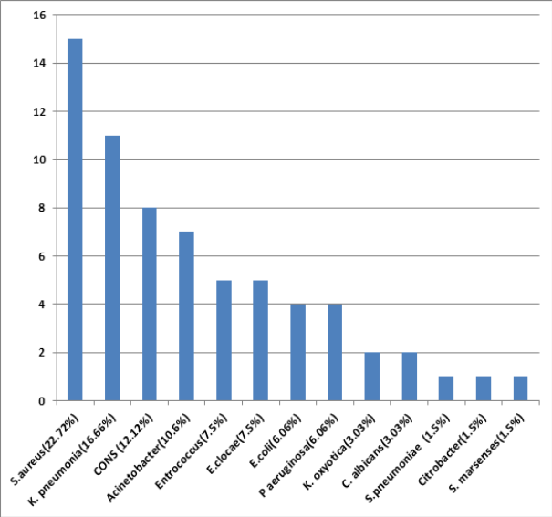
Figure 1: Frequency and types of bacterial isolates from blood cultures

Publication
- Adane Bitew1*, Mulu Hassen1, Tigist Getachew1, Surafel Fentaw2. Prevalence of Crytpococcal Infection in Patients Clinically Diagnosed to Have Meningitis in Ethiopia. Clinical Medicine Research, 2016; 5(4): 73-76; http://www.sciencepublishinggroup.com/j/cmr
- Seneshat Eshetu1 Adane Bitew2*, Tigist Getachew2, Dessie Abera2, Solomoan Gizaw3 Multi-Drug Resistance Profile of Bacteria Isolated from Blood Stream Infection at Tikur Anbessa Specialized Hospital, Addis Ababa, Ethiopia. Journal of EC Microbiology 14.3 (2018): 119-126.
- Adane Bitew1; Mesele Admassie; Tigist Getachew; Meseret chanie. Spectrum and Drug Susceptibility Profile of Bacteria Recovered from Patients with wound Infection Referred to Arsho Advanced Medical Laboratory Accepted and will be published on 3/2018 at Clinical Medicine Research.

Biography
My name is Tigist Getachew Tadesse, I have BSc in Aplied Biolohy and MSc in Biotechnology. Currently am chief expert health professional working as technical assistance in the Department of Medical Laboratory Science, Addis Ababa University, Addis Ababa, Ethiopia. Am executive board member of Ethiopian Medical Laboratory Association.
tigist.getachew @aau.edu.et

