Mannosylerythritol lipids production by Pseudozyma aphidis UFMG-Y3468: A process optimization approach.
Glaucia M Pastore, PhD, University of Campinas, Brazil
Bruno N Paulino, PhD student, University of Campinas, Brazil
Carlos A Rosa, PhD, Federal University of Minas Gerais

Abstract (300 word limit)
Statement of the Problem: Yeasts from Ustilaginaceae family have been highlighted in the last years as a promising source of industrial interesting compounds, including enzymes, sugars, lipids, organic acids and glycolipids biosurfactants. Among the biosurfactants produced by these yeasts, the mannosylerythritol lipids (MELs) have been attracted the attention of the scientific community in recent years due to its potential applications in several fields including medical, cosmetics and food. Considering the high costs associated with the production of biosurfactants, this work focused on the use of response surface methodology (RSM) to optimize the carbon and nitrogen sources in the medium for production of MELs by a Pseudozyma aphidis strain isolated from Brazilian water sample. Methodology & Theoretical Orientation: After a screening study, one strain of yeast belonging the Pseudozyma genus showed able to produce MEL in mineral medium with glucose. A central composite design (2⁴), 28 experiments, was used for optimization of glucose, soybean oil, yeast extract and sodium nitrate concentrations in mineral medium applied for production of MELs by P. aphidis UFMG-Y3468. The process was carried in controlled incubator at 30°C and 200 rpm for 10 days. Findings: The production of crude MEL extract ranged of 5,87 g/L to 27,25 g/L and the mathematical model obtained with significative parameters (soybean oil, glucose and yeast extract) showed good results after analysis of variance. In addition, after the chemical characterization using high-resolution mass spectrometry and Nuclear Magnetic Resonance was observed the presence of MEL-A, MEL-B, MEL-C. Conclusion & Significance: The use of RSM for optimization of MEL production can be considered an important tool to reduce of costs of medium composition applied in the biotechnological processes. This approach can be considered promising since it allowed to find the optimum concentration levels of the substrates used for MEL production.

Image
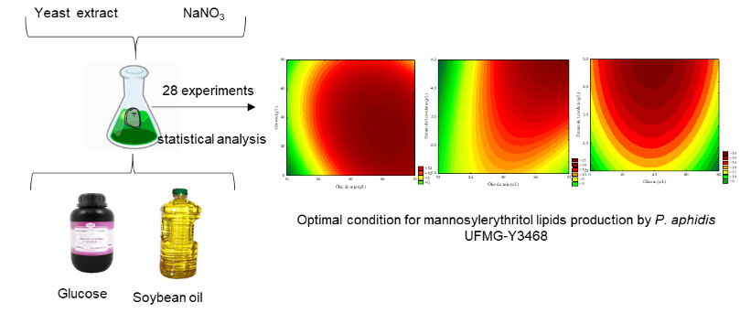
Figure 1. Schematic steps of the optimization process and contour curves showing the optimum concentrations of glucose, soybean oil and yeast extract for MELs production by P. aphidis UFMG-Y3468.
Recent Publications (minimum 5)
- Paulino BN, Pessoa MG, Molina G, Kaupert Neto AA, Oliveira JVC, Mano MCR, Pastore GM (2017) Biotechnological production of value-added compounds by ustilaginomycetous yeasts. Applied Microbiology and Biotechnology 101:7789-7890.
- Paulino BN, Pessoa MG, Mano MCR, Molina G, Neri-Numa IA, Pastore GM (2016) Current status in biotechnological production and applications of glycolipid biosurfactants. Applied Microbiology and Biotechnology 100:10265-10293.
- Fai AEC, Simiqueli APR, Andrade CJ, Ghiselli G, Pastore, GM (2015) Optimized production of biosurfactant from Pseudozyma tsukubaensis using cassava wastewater and consecutive production of galactooligosaccharides: An integrated process. Biocatalysis and Agricultural Biotechnology 4:535-542.
- Andrade CJ, Andrade LM, Rocco AS, Sforça ML, Pastore GM, Jauregi P (2017) A novel approach for the production and purification of mannosylerythritol lipids (MEL) by Pseudozyma tsukubaensis using cassava wastewater as susbtrate. Separation and Purification Technology 180:157-167.
5. Néri-Numa IA, Paulino BN, Pessôa MG, Abrahão MRE, Bution ML, Molina G, Pastore GM (2016) Industrial additives obtained through microbial biotechnology: biosurfactants and prebiotic carbohydrates. In: Gupta VK, Sharma GD, Tuohy MG, Gaur R (eds) The handbook of microbial bioresources, 1ed. CABI Publishing, Boston, pp 528–548.

 Biography (150 word limit)
Full Professor, Department of Food Science, Faculty of Food Engineering, Campinas University,
UNICABachelor of Biological Science, Catholic University of Campinas (1976)
M.S. in Food Science, Campinas University-Unicamp (1982)
Enzyme Technology Course Osaka Technical Institute Japan (1985)
Ph.D. in Food Biochemistry, Campinas State University-Unicamp (1991)
Post-doctorate: Ohio State University USA, 1993.

Responsible for graduate and undergraduate courses in Food Biochemistry and PrincipIes of Food Biotechnology, Biotransformation of Agriculture wastes.
Author of several chapters in international and national books, more than 100 research papers in international journals.

Deanna Mulvihill has her expertise in evaluation and passion in improving the health and wellbeing. Her open and contextual evaluation model based on responsive constructivists creates new pathways for improving healthcare. She has built this model after years of experience in research, evaluation, teaching and administration both in hospital and education institutions. The foundation is based on fourth generation evaluation (Guba& Lincoln, 1989) which is a methodology that utilizes the previous generations of evaluation: measurement, description and judgment. It allows for value-pluralism. This approach is responsive to all stakeholders and has a different way of focusing.
Email: drXXgXXXXX@xxxmail.com
glaupast@fea.unicamp.br
Notes/Comments:

