Improving the nutritional quality of cherry tomato fruits by LED lighting
Simon Miranda, M. Sc., INTA, Universidad de Chile, Chile
Talia del Pozo, Ph.D., INTA, Universidad de Chile, Chile.

Abstract

Statement of the problem: Fruits and vegetables account for an important part of the human diet, whose benefits are strongly related to their nutritional quality. In the last few decades, this concept has emerged as an important agricultural trait, due to the increasing demands of consumers who look for healthier commodities. Within this context, LED (light-emitting diode) lighting is emerging as a promising and sustainable technology used in greenhouse cultivation and in food production. For growing plants, the advantage of this kind of lighting is the possibility to optimize the selection of the light spectrum at physiologically relevant wavelengths in order to regulate specific processes in plants. Despite of LED lights benefits, the relationship between lighting conditions and nutritional quality has not been deeply addressed. Methodology: Therefore, in this work we studied the effect of light stress doses and/or light regimens with different spectral quality on the accumulation of several nutrients (vitamin C, vitamin E and lycopene) in fruits of cherry tomato (Solanum lycopersicum cv. cerasiforme). Findings and Conclusions: By regulating the lighting conditions, we found that the accumulation of the compounds analyzed was significantly altered. Furthermore, these metabolite changes were correlated with the expression of several genes involved in the main pathways related to the biosynthesis of vitamin C, E and lycopene. Thus, correlations are discussed in terms of the metabolic pathways involved. Experiments for further optimization are underway, which will allow us to increase the nutritional quality of plant crops by a customized selection of spectral quality, but also will provide insights into the complex metabolic network that is responsible for the antioxidant metabolism in fruits.

Acknowledgments: Fondecyt 11160899 and FONDAP 15090007.

Image
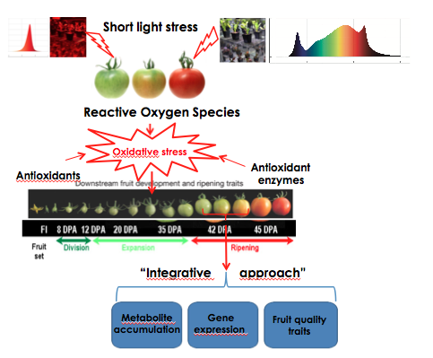
Recent Publications
- D'Souza, C., Yuk, H.-G., Khoo, G. H. and Zhou, W. (2015), Application of Light-Emitting Diodes in Food Production, Postharvest Preservation, and Microbiological Food Safety. Comprehensive reviews in food science and food safety, 14: 719–740. doi:10.1111/1541-4337.12155.
- Zhang, G., Shen, S., Takagaki, M., Kozai, T., and Yamori, W. (2015). Supplemental upward lighting from underneath to obtain higher marketable lettuce (Lactuca sativa) leaf fresh weight by retarding senescence of outer leaves. Frontiers in Plant Science. 6:1110. doi: 10.3389/fpls.2015.01110
- Rabara R.C., Behrman G., Timbol T., Rushton P.J. (2017). Effect of Spectral Quality of Monochromatic LED Lights on the Growth of Artichoke Seedlings. Frontiers in Plant Science. 10.3389/fpls.2017.00190.
- Bantis F, Ouzonis T and Radoglou K. (2016). Artificial LED lighting enhances growth characteristics and total phenolic content of Ocimum basilicum, but variably affects transplant success. Scientia Horticulturae 198: 277-283.
- Taulavuori, E., Taulavuori, K., Holopainen, J.K., Julkunen-Tiitto, R., Acar, C. and Dincer, I. (), Targeted use of LEDs in improvement of production efficiency through phytochemical enrichment. Journal of the Science of Food and Agriculture. Accepted Author Manuscript. doi:10.1002/jsfa.8492.


Biography

Simon Miranda is a biologist and master in Biological Sciences of the University of Chile, whose main interests are within the field of plant molecular biology and nutrition. During his master thesis, he has acquired ample skills in plant molecular biology, phenotyping and in vitro transformation and regeneration of genetically - modified plants, for studying the metabolism of antioxidant compounds related to human health. Therefore, he is currently working, along with Talia del Pozo (PI), in a research project for addressing diverse questions related to biofortification of fruits, with the aim of applying available genomic and biotechnological tools for obtaining plants enriched in bioactive compounds.
Email: simon.miranda@inta.uchile.cl

