Photo-Curable Natural Polymer Derivatives for Bio-Medical Application

Jae-Won Kim¹;Eun-Hye Kim¹; Seung-Hyun Noh¹;Shin-Woong Kim¹; Yoshihiro Ito^{2,3}; Tae-il Son^{1*}

¹Department of Systems Biotechnology, Chung-Ang University, Anseong-si, Gyeonggi-do 456-756, Republic of Korea
²Nano Medical Engineering Laboratory, RIKEN, 2-1 Hirosawa, Wako, Saitama 351-0198, Japan
³Department of Computational Intelligence and systems Science, Interdisciplinary Graduate School of Science and Engineering Tokyo Institute of Technology, 4259 nagatsuda-cho, Midori-ku, Yokohama, 226-9501, Japan

Abstract
To be biomedical applications, these materials require properties such as biocompatibility, biodegradability, and low-toxicity. Chitosan is a natural polymer with these properties. In addition, chitosan has anti-bacterial activity. For this reason, chitosan is suitable as a biomaterial.
Growth factors are biomolecules, mainly proteins. Growth factors such as epidermal growth factor, transforming growth factor-β and bone morphogenetic protein-2 play an important role in the physiological activity process. Although growth factors affect their diverse physiological activities in biological processes, their biomedical applications are very limited. Because growth factors have a half-life that causes to rapidly decrease the physiological activity in the body.
Protein immobilization methods are a way to solve these problems. Various immobilization methods have been developed. However, methods using chemical agents may form by-products that can potentially cause denaturation of immobilized protein. It is also difficult to immobilize them in the same chemical method because the residue of each amino acid is different.
To solve these problems, our research team have developed a photo immobilization method for immobilizing proteins using UV and visible light photo-reactive chitosan derivatives. The additional advantages of this method are relatively simple process, low cost, easy scale-up, and low toxicity. Photo immobilization methods will be used to immobilize various biomolecules. Our research team report the preparation of photo-reactive chitosan derivatives that can be used for the immobilization of various biomolecules via photo-immobilization method.

Image
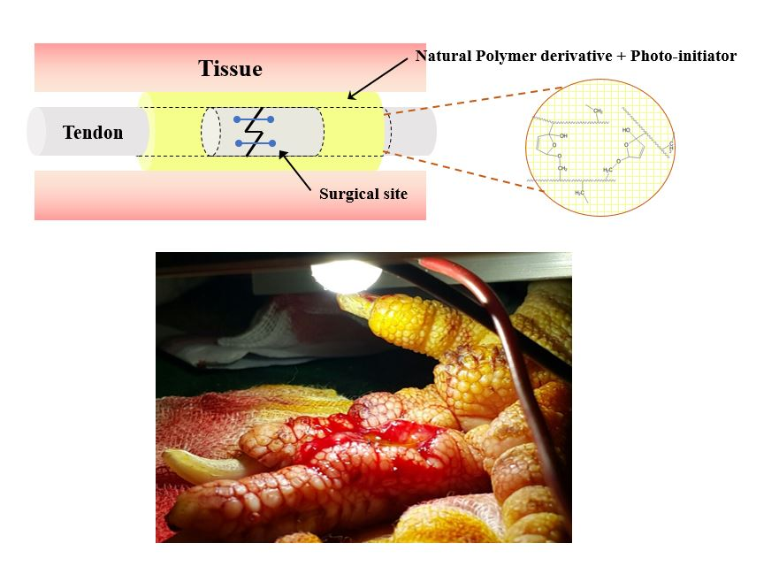

Recent Publications
- Kim EH, Park SH, Chi SY, Woo HD, Heo Y, Ito Y, Han DK, Nah JW, Son TI (2016) Enhancement Effect of Cell Adhesion on Titanium Surface Using Phosphonated Low-Molecular-Weight Chitosan Derivative. Macromolecular Research 24:99-103
- Park SH, Kim EH, Lee HJ, Heo Y, Cho YM, Seo SY, Kim TY, Suh HW, Kim MK, Ito Y, Nah JW, Son TI (2016) Wound Healing Effect of Visible Light-Curable Chitosan with Encapsulated EGF. Macromolecular Research 24:336-341
- Kim KI, Han GD, Kim EH, Jeong JH, Lee JW, Kim MK, Ito Y, Son TI (2016) Controllable Mouse Epidermal Growth Factor (mEGF) Release by Photo-Encapsulation Using Azidophenyl Chitosan Derivative and Its Wound Healing Effect. Macromolecular Research 24:862-867
- Jeong JH, Kim EH, Han GD, Nah JW, Ito Y, Son TI (2016) BMP-2 immobilization by phosphonated UV-curable low-molecular-weight chitosan derivative on the surface of titanium. Journal of Industrial and Engineering Chemistry 34:33-40
- Heo Y, Kim EH, Kobatake E, Nah JW, Ito Y, Son TI (2016) Preparation of phosphonated gelatin-coated titanium containing rhBMP-2 by UV irradiation for improved osteoinduction and function. Journal of Industrial and Engineering Chemistry 34:66-73
- Ham DW, Jang EC, Son TI, Lee TJ, Song KS (2016) Photo-immobilization of bone morphogenetic protein-2 using azidophenyl gelatin on a collagen sheet enhances osteogenesis in a rat calvarial defect model. Journal of Industrial and Engineering Chemistry 40:177-184
- Woo HD, Park KT, Kim EH, Yun Heo Y, Jeong JH, Pyun DG, Choi CS, Lee JG, Han DK, Nah JW, Son TI (2015) Preparation of UV-curable gelatin derivatives for drug immobilization on polyurethane foam: Development of wound dressing foam. Macromolecular Research 23:994-1003

Acknowledgement
This research was supported by Basic Science Research Program through the National Research Foundation of Korea(NRF) funded by the Ministry of Education (No. NRF-2017R1D1A1B03028877).

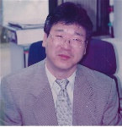Biography
Tae-Il son was awarded the degree of PhD by Tokyo Institute of Technology, Japan in 1989. He is a Professor in the Department of Systems Biotechnology, Chung-Ang University, Republic of Korea and the president of Biomaterial Field in The Korean Society of Industrial and Engineering Chemistry (KSEC). He has published more than 80 papers in reputed journals.
Email: tisohn@cau.ac.kr

Notes/Comments:

