Effect of synthesis process variables on morphological and mechanical properties of vitreous carbon scaffolds for tissue engineering applications
Natalia Terán-Acuña, MSc Student, Universidad Industrial de Santander, Colombia
Viviana Güiza-Argüello, PhD, Universidad Industrial de Santander, Colombia
Elcy Córdoba-Tuta, PhD, Universidad Industrial de Santander, Colombia

Abstract
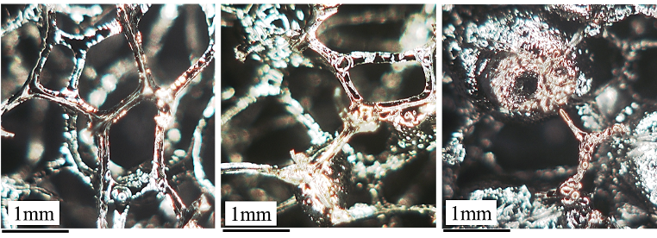
Vitreous carbon foams have been shown to promote bone cell adhesion, mineralization and proliferation. However, their low mechanical resistance as well as their high manufacturing cost restrict their utilization in the biomedical area. The purpose of this study was to develop bone tissue engineering scaffolds from vitreous carbon foams, which were fabricated through the template route using an economical and renewable precursor. Towards this, cellulose sponges were impregnated with a sucrose-based resin and then carbonized under inert atmosphere. The effect of the concentration of the components of the resin (HNO₃ and sucrose) on the mechanical and morphological properties of the resulting foams was determined. Moreover, the ability of the synthesized foams to promote cell adhesion was evaluated in vitro using human osteoblasts. Our results show that it was possible to produce vitreous carbon foams with highly interconnected polyhedral cells (cell size ~1000 μm). Scaffold morphology was strongly affected by the concentration of the catalyst in the resin (HNO₃) due to its foaming effect, which lead to porous and irregular surfaces on the carbonaceous materials. Also, increasing the concentration of sucrose in the precursor resin favored the mechanical resistance of the resulting foams, reaching values close to the commercial foams. In conclusion, vitreous carbon foams with trabecular bone-like morphology were obtained from a non-toxic and renewable precursor. The fabricated foams were shown to be highly cytocompatible and to promote human osteoblast adhesion. Although the compressive strength of the foams is much lower than that of native bone, their high porosity will allow their reinforcement using an additional biocompatible phase (coating/filler). Therefore, the vitreous foams synthesized here could be used as the porous component of a composite biomaterial system for the treatment of bone defects.
Figure 1. Morphology of vitreous carbon foams fabricated using (a) 0:1, (b) 1:16, and (c) 1:1 acid:sucrose molar ratios.
Image

Recent Publications
- Inagaki M, Qui J, Guo Q. (2015) Carbon foam : Preparation and application. Carbon. 87:128–152.
- Jana P, Fierro V, Celzard A. (2013) Ultralow cost reticulated carbon foams from household cleaning pad wastes. Carbon. 62:517–20.
- Letellier M, Delgado-sanchez C, Khelifa M, Fierro V, Celzard A. (2017) Mechanical properties of model vitreous carbon foams. Carbon. 116:562–571.
- Narasimman R, Vijayan S, Prabhakaran K. (2014) Carbon particle induced foaming of molten sucrose for thepreparation of carbon foams. Materials Science and Engineering B. 189:82-89.
- Walsh FC, Arenas LF, Ponce de León C, Reade GW, Whyte I, Mellor BG. (2016) The continued development of reticulated vitreous carbon as a versatile electrode material: Structure, properties and applications. Electrochimica Acta.215:566–91.


Biography
Natalia Terán Acuña received her degree in Chemical Engineering from Universidad Industrial de Santanter (Colombia) in 2008, currently is student researcher in the master in materials engineering at the same university. Her research interests include the development of composite scaffolds for bone regeneration and the decontamination of industrial waste water.
Email: natalia.teran@correo.uis.edu.co

