Production of extra jam from indigenous grape varieties
Vlasta Pilizota, PhD, University of J.J. Strossmayer, Faculty of Food Technology Osijek, Croatia
Ante Loncaric, PhD, University of J.J. Strossmayer, Faculty of Food Technology Osijek, Croatia

Abstract

Noah, Othello and Isabelle are grape varieties introduced in Europe in the 19th century due to their natural resistance to Phylloxera (Batur and Aigner, 2016). Since these varieties were directly planted in winegrowers’ fields they were called “direct producers” or “direct producer wines”. The term came to cover native American species (Vitis aestivalis, V. labrusca, V. riparia, V. rupestris) and hybrids obtained from interspecific crossings, either with each other, or with the European common species Vitis vinifera (Batur and Aigner, 2016). Due to EU Regulation No. 1308/2013, and Croatian Law on Wine (NN 14/14), it is forbidden to produce wine from these grape variates. In this research we investigated the possibility of exploitation of these grape variates for production of jams in order to encourage local producers to preserve these grape cultivars.

The results of investigation showed that the highest soluble solids content had white Noah followed by red Noah, Isabelle and Othello, 22; 21; 19; 18 °Brix, respectively. Othello and white Noah had the highest total acid content (1 g/100 g), while Isabelle had the greatest polyphenol content (2.04 mg/mL), and antioxidant activity (2073.93 µmol trolox/100 mL). The main polyphenols in white grape variate were gallic acid, epicatechin, quercetin and caffeic acid, while in red variates additional anthocyanins were identified (cyanidine-3-glucoside, cyanidine-3-rutinoside, malvidin-3-glucoside and delphinidin-3-glucoside).

The soluble solids content of extra jams was set on 60-62%, which is according to the National (Croatian) Law (NN 46/07, 55/11), and directives for production of extra jams. Jam production caused decrease in AOA for 25; 31; 42 and 47% in black Noah, white Noah, Othello and Isabelle, respectively. The amounts of individual polyphenols were lower in jams compared to unprocessed grapes. The smallest change of color, caused by jam production, was measured in Othello (2.22) and Isabelle (2.75) grape varieties.

Image
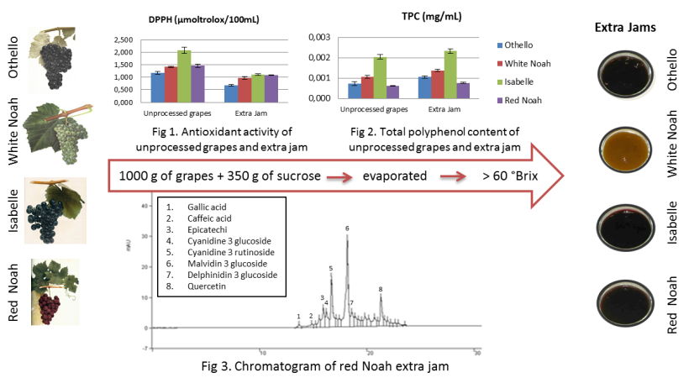
Recent Publications
- Batur F, Aigner K (2016) Forbidden Fruits: The fabulous destiny of Noah, Othello, Isabelle, Jacquez, Clinton and Herbemont. ARCHE NOAH, Brussels and Vienna, April 2016*
- Regulation (EU) No 1308/2013 of the European Parliament And of the Council. Establishing a common organisation of the markets in agricultural products and repealing Council. Regulations (EEC) No 922/72, (EEC) No 234/79, (EC) No 1037/2001 and (EC) No 1234/2007
- Zakon o vinu Narodne novine 96/03, 25/09, 22/11, 55/11, 82/13, 14/14
- Zakon o hrani, Narodne novine, broj 46/07, 55/11. Pravilnik o voćnim džemovima, želeima, marmeladama, pekmezu te zaslađenom kesten pireu

 Biography
Vlasta PilizotaLhas her exhpertise divided into the basic research of structure and composition of food (and/or food model systems) such as aroma composition of
different food, thermophysical and rheological properties of foodstuffs, inhibition of browning of fruits and vegetables, safety of minimally processed fruits and vegetables,
improving the process for processing and preservation of foods, and the applied research for food processing – industry.

Email: Vlasta.Pilizota@ptfos.hr


 Biography
Ante Loncaric has his expertise in detection and quantification of polyphenols in food by using advanced analytical tools such as HPLC, LC-MS/MS, and NMR. His focus is evaluation of polyphenols from the food waste and stability of polyphenols in food. His work on polyphenol stability showed that some polyphenols could be stabilized in presence of sugars and/or other polyphenols. He gains his experience through professional trainings and working as a researcher on two national projects.
Email: ante.loncaric@ptfos.hr

Notes/Comments:

