Bacterial cellulose as matrix to functionalize macromolecules
Cesar Augusto Tischer
Universidade Estadual de Londrina
Departamento de Bioquímica e Biotecnologia
Rodovia Celso Garcia Cid | Pr 445 Km 380 | Campus Universitário
Cx. Postal 10.011 | CEP 86.057-970 | Londrina - PR

Abstract (300 word limit)
Statement of the Problem: Cellulose corresponds to the most abundant biopolymer on earth, constituting all plant cells walls, exceeds the biological significance and play and important role as industrial product. The cellulose is biocompatible and the interest for biomedical purposes has grown recently being studied as scaffold for tissue regeneration as well the nanocellulose is, and for these reason a plenty of studies can be found testing cellulose pure, blended or chemically modified on in vitro models. Nanocelluloses are the highly ordered α-(14) glucan chains produced naturally or by chemical processes and that are in nanometric size in at least one dimension. Methodology & Theoretical Orientation: Different strategies for functionalization of bacterial cellulose could be used, covalently linked or not, directly on the hydroxyl group, or in more steps. Weak forces as hydrogen linkages or ionic forces could trap small or bigger molecules as proteins as aggregates to membranes. Less labile option is introducing a linker as the succinic acid between cellulose chain and the functional compound, that give steric freedom for the last to act. Different technics could reach it with the advantage that the coupling product results in a pendant carboxylic acid, which provides a site for further chemical reactions. Findings: Proteins and enzymes could be immobilized in nanocelulose, his activity remains or are improved taking advantage of the persistent suspension formed by nanofiber. Conclusion & Significance: bacterial cellulose is a versatile material that is being reinvented by physical and chemical ways creating very attractive new materials.

Image
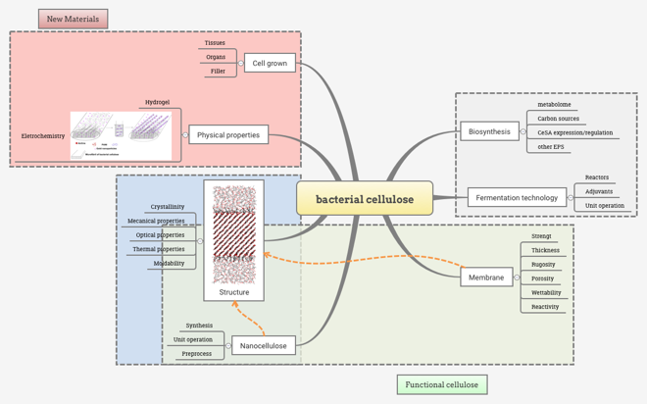
Figure 1. Main fields for bacterial cellulose research
Recent Publications (minimum 5)
1. Grein, Aline; Da Silva, Bruno C.; Wendel, Cinthia F.; Tischer, Cesar A.; et al. (2013). Structural characterization and emulsifying properties of polysaccharides of Acacia mearnsii de Wild gum In Carbohydrate Polymers. 92:312-320.

2. De Oliveira, Sabrina Alves; Da Silva, Bruno Campos; Riegel-Vidotti, Izabel Cristina; et al, (2017). Production and characterization of bacterial cellulose membranes with hyaluronic acid from chicken comb In International Journal of Biological Macromolecules. 97:642-653.

3. De Oliveira, Admilton G.; Spago, Flavia R.; Simionato, Ane S.; et al, (2016).
Bioactive Organocopper Compound from Pseudomonas aeruginosa Inhibits the Growth of Xanthomonas citri subsp. citri In Frontiers in Microbiology (Online). 7:1-12

4. Ribeiro-Viana, Renato M.; Faria-Tischer, Paula C.S.; Tischer, Cesar A.. 2016. Preparation of succinylated cellulose membranes for functionalization purposes In Carbohydrate Polymers. 148:21-28

5. RIBEIRO-VIANA, RENATO M.; BUTERA, ANNA P.; SANTOS, ELIZIANE S.; et al, (2016). Revealing the Binding Process of New 3-Alkylpyridine Marine Alkaloid Analogue Antimalarials and the Heme Group: An Experimental and Theoretical Investigation In Journal of Chemical Information and Modeling. 56:571-579

Biography
Cesar A. Tischer work as Professor at Biochemistry and Biotechnology Department of State University of Paraná. Professor Tischer has finished his doctorate in 2002 in Biochemistry, in the field of structural analysis of glycoconjugates. Leader of the research group called Biotechnology and Glycoconjugates (CNPq certified, CNPq - National Council for Scientific and Technological Development), with founds approved in course on research councils operating in Brazil, CNPq in projects for cellulose modification, CAPES/Araucária foundation, with changes on cellulose for your use as sun blocker activity, both with industry collaboration. He works to develop functionalized nanocellulose with proteins or aggregated with charged polysaccharides as Hyaluronic acid.

.
.
Email: cesar.tischer@me.com

Notes/Comments:

