A dry method to preserve tear sample
Weiwei Qin, Linpei Zhang, Youhe Gao
Department of Biochemistry and Molecular Biology, Beijing Normal University, Beijing, China

Abstract (300 word limit)
The tears overlay the epithelial cells of cornea and conjunctiva surface. It provides lubrication, protection and nutrition to the ocular surface. Tears is an important bio-fluid containing thousands of molecules, including proteins, lipids, metabolites, nucleic acids, and electrolytes. Tear fluid can be easily and noninvasively accessed, and it has become a useful resource for biomarker research of ocular and systemic diseases. According to a recent review, hundreds of potential specific molecular biomarkers in tears had been detected to associate with ocular diseases, such as, dry eye disease, keratoconus, Graves’ orbitopathy. Other reports showed that tear can also reflect the states of breast cancer, prostate cancer and multiple sclerosis.
Ideally tear samples should be stored by a simple, low-cost and efficient method along with the patient’s medical record. The primary methods for collecting tears are using the Schirmer's strip and glass capillary tube, followed by flash-freezing at −80°C. But cryopreservation of tears cannot absolutely prevent the degradation of proteins, as the samples contain various enzymes and hydrolases. Additionally, use of the required cold chain during sample transportation is challenging and costly.
Here, we developed a novel Schirmer’s strip based dry method which allows storage of tear samples in vacuum bags at room temperature. Using this method tear protein pattern can be faithfully preserved. LC-MS/MS analysis of proteins recovered from our dry method and from traditional wet method, indicating that there is no significant difference. This dry method facilitates sample transportation and makes it possible to store tear samples at large scale, which in turn increases the research pace of tear related diseases.

Image

Recent Publications (minimum 5)
- Gao Y H. Urine—an untapped goldmine for biomarker discovery? Sci China Life Sci, 2013, 56: 1145–1146
- Gao, Y Opinion: Roadmap to the Urine Biomarker Era MOJ Proteomics Bioinform 2014 1(1): 00005
- Jia LL, Liu XJ, Liu L, Li MX, Gao YH. （2014）Urimem, a membrane that can store urinary proteins simply and economically, makes the large-scale storage of clinical samples possible. Sci China Life Sci, March 2014 ,57(3): 336–339
- Lisi Zhu, Menglin Li, Lilong Wei, Xuejiao Liu, Jianrui Yin and Youhe Gao Fast fixing and comprehensive identification to help improve real-time ligands discovery based on formaldehyde crosslinking, immunoprecipitation and SDS-PAGE separation Proteome Science 2014, 12:6
- Menglin Li, Mindi Zhao and Youhe Gao Changes of proteins induced by anticoagulants can be more sensitively detected in urine rather than plasma. Sci China Life Sci, 2014, 57(7): 649-656.
- Zhang F, Cheng X, Yuan Y, Wu J, Gao Y. Urinary microRNA can be concentrated, dried on membranes and stored at room temperature in vacuum bags. PeerJ. 2015 Jul 14;3:e1082.
- Yuan Yuan , Fanshuang Zhang, Jianqiang Wu, Chen Shao, Youhe Gao (2015) Urinary candidate biomarker discovery in a rat unilateral ureteral obstruction model Sci Rep. 2015 Mar 20;5:9314.
- Mindi Zhao, Menglin Li, Xundou Li, Chen Shao, Jianrui Yin and Youhe Gao （2014）Dynamic changes of urinary proteins in a focal segmental glomerulosclerosis rat model Proteome Science 12:42 doi:10.1186/1477-5956-12-42

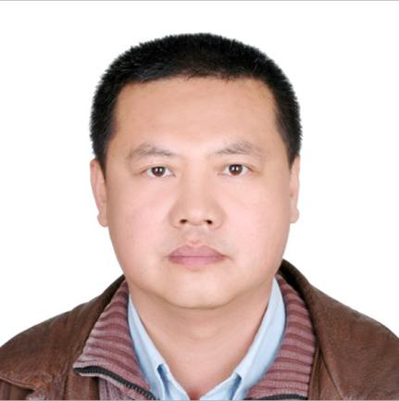 Biography (150 word limit)
Youhe Gao Professor Beijing Normal University. He received his MD from Peking Union Medical College, his Ph.D from University of Connecticut and postdoctoral training from Beth Israel Deaconess Medical Center, Harvard Medical School. He was the professor of Department of Pathophysiology, Institute of Basic Medical Sciences, Chinese Academy of Medical Sciences/ Peking Union Medical College from 2001-2014. His research interests include biomarker discovery in urine, urine biobanking, protein interaction methods and related bioinformatics.
Email: gaoyouhe@bnu.edu.cn

Notes/Comments:

