Contribution of AlSAP Domains “A20/AN1” in Salt and Drought Stresses
Omar M Azab, MSc, King Saud University, Riyadh, KSA
Rania Ben Saad, PhD, Centre of Biotechnology of Sfax, Tunisia
Walid Ben Ramdhan, King Saud University, Riyadh, KSA
Emmanuel Guiderdoni, PhD, CIRAD, Montpellier, France
Afif Hassairi, PhD, King Saud University, Riyadh, KSA

Abstract (300 word limit)
Overexpression of AlSAP in transgenic tobacco, rice and wheat plants conferred tolerance to various abiotic stresses under both green house and open field conditions. Stress associated proteins (SAPs), encoding proteins containing A20/AN1 zinc-ﬁnger domains with N-terminal A20 and/or C-terminal AN1 domain. In previous work we deciphered the role of AlSAP in enhancing abiotic stress tolerance. We generated two mutations AlSAP∆AN1 (AlSAP minus AN1 domain), and AlSAP∆A20/AN1 (AlSAP minus A20 and AN1 domains) beside full length gene AlSAP, and studied the contribution of each domain to the enhanced tolerance of the full length gene. The integration and expression of AlSAP was ascertained by PCR and RT-PCR respectively. T1 seeds were obtained, and statistical analysis of segregation model was done using the χ2 test in which observed values were compared to theoretical values corresponding to the integration of one or more copies of the transgene. A three T2 homozygote plants from each construct were selected for evaluation of their tolerance to salt and osmotic stresses. Here we found that overexpression of A20 domain has a good contribution to the enhanced tolerance to salt and osmotic stresses, as the generated AlSAP∆AN1 lines showed the same level of tolerance to the full length lines.

Image
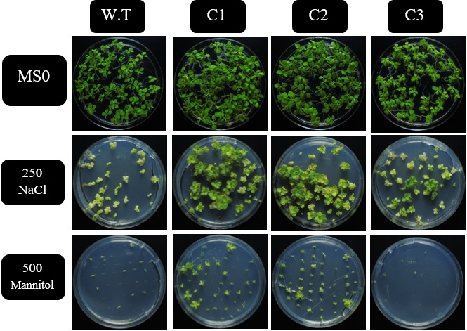

 Biography (150 word limit)
Omar Moustafa Azab has his expertise in plant molecular biology and transformation through his work with a collaborative team from France, Tunisia, Saudi Arabia and Egypt. He is working on plant Abiotic stress tolerance through AlSAP gene isolated by Afif Hassairi, and studied function of the gene. Mr. Omar finished his MSc in King Saud University on this topic, and he is continuing evaluating this lines in the open field and greenhouse. Omar starting working his PhD on gene expression of drought stress genes in bread wheat.
Email: oazab@ksu.edu.sa

