Commercial Polyester Fabric Repair of Abdominal
Defects and Hernias

M.Shokry

Hernias are common surgical affections of human and animals and their treatments may vary from simple herniorrhaphy to hernioplasty with prosthetic materials. This work was designed to study the feasibility of using commercial polyester fabric (CPF) as a prosthetic mesh for reconstruction of abdominal hernias and defects in experimental and clinically affected animals.
The subjects of the experimental work were 12 dogs, 3 goats and 3 donkeys. Following anesthesia, an artificial abdominal defect, measured 5X12 cm in dogs and goats and 12X20cm in the donkeys, was produced by resection of a piece of abdominal muscle in 3 different abdominal regions, such as the epigastrium (3 cases), the mesogastrium (12 cases) and the hypogastrium (3 cases). An appropriate piece of sterilized CPF was implanted either in 2 layers in small animals or in 4 layers (folded) in large animals in the abdominal defects. The techniques of implantation used, were reteroperitoneal (6 cases) in which the CPF was implanted between the internal rectus sheath and peritoneum, intra-peritoneal implantation either with (3 cases) or without (3 cases) omentalisation; and double sandwish (3 cases) using 2 layers. Morphological and histo-pathological examinations were carried out on full thickness sections after euthanasia at 1, 2 ,3 ,4, 5 & 6 months postoperatively. The Clinically affected cases comprised different species of animals at different locations. Gross examination of the abdominal wall at the experimental implantation site at monthly intervals for 6 months showed the unaltered integrity of the CPF and uniform infiltration of the prosthetic material with a layer of white connective tissue of variable thickness (4 to 10 cm). Histological features correlated well with the gross examination. Complications related to herniorrhaphy in the clinical cases have been rarely serious. In conclusion, CPF has excellent biocompatibility and no adverse histological changes. Low cost CPF therefore offers a worthwhile alternative prosthesis for mesh herniorrhaphy.
Publications
Shokry M, El-Keiey M, Hamouda M, Gadallah S (1997) Commercial polyester fabric repair of abdominal hernias and defects. Vet. Record 140: 606-607.

Image
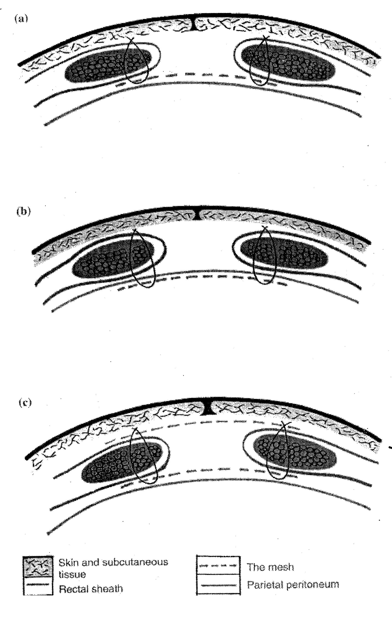

Technique used for implantation of CPF mesh (a) retroperitoneal, (b) intraperitoneal,
( c ) double sandwich



Professor Emeritus, Dept. of Vet Surgery, Faculty of Veterinary Medicine, Cairo University
http://scholar.cu.edu.eg/mshokry
mshokry@cu.edu.eg

Email: mshokry@cu.edu.eg

Notes/Comments:

