ROM-AGROBIOFERTIL NP- biological fertilizer for a sustainable agriculture
Nicolae Levandovschi, MSc, Romvac Co., Romania Constantin Chiurciu, PhD student, Romvac Co., Romania
Paul Chitonu, MSc, Romvac Co., Romania

Abstract
Statement of the Problem: Evolution of modern agriculture has led to extensive use of agricultural chemicals which have degraded the soil fertility, soil profile and rendered the soil unsuitable for plant growth. Biofertilizers are being recognized as an essential component for increasing the sustainable agricultural productivity and maintaining long term soil fertility in an eco-friendly manner. ROM-AGROBIOFERTIL NP is a biological fertilizer based on three bacteria belonging to Azospirillium lipoferum, Azotobacter chroococcum and Bacillus megaterium species. ROM-AGROBIOFERTIL NP contains living microorganism which, when applied to seed, plant surfaces, or soil, colonizes the rhizosphere and the interior of the plant and promotes growth by increasing the supply or availability of primary nutrients to the host plant. Methodology & Theoretical Orientation: the product was applied to tomatoes (Prekos F1), cucumbers (Mirabelle F1) and cauliflower (Cornell F1), both in the seedling phase and after planting, as an aqueous solution sprayed on soil. Two treatments were applied on seedlings: 4 days before sowing and 15 days after emergence. During vegetation period were performed three applications, using 15 l/ha. Plant height, number of leaves and the length of the roots as well as the obtained yield were determined and recorded. Findings: In tomato, cucumber and cauliflower seedlings the application of ROM-AGROBIOFERTIL NP has improved plant height (5.6 -17.9%), number of leaves (> with 20.0-29.6%), number of roots (19.5 – 40.8%) and the length of the roots (21.2 -33.1%). In tomato, cucumber and cauliflower crops, the effect has been reflected both in the growth and development of plants and in the obtained yield higher with 2.3% on tomatoes, 3.7% on cucumbers and 2.4% on cauliflower. Conclusion & Significance: Additional obtained yield was significant in comparison with untreated controls, in all three vegetable crops.

Image
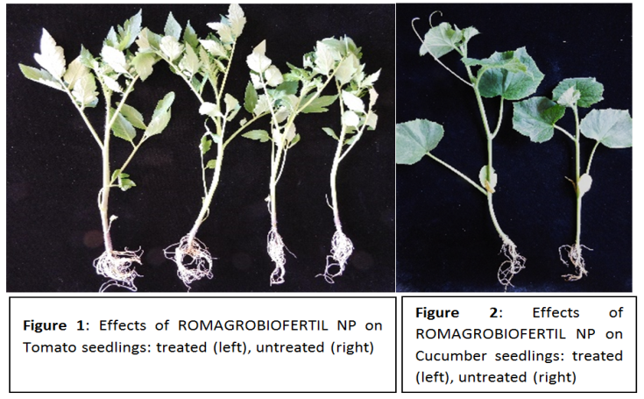
Recent Publications
- Steenhoudt, O. and Vanderleyden, J. (2000), Azospirillum, a free-living nitrogen-fixing bacterium closely associated with grasses: genetic, biochemical and ecological aspects. FEMS Microbiology Reviews, 24: 487–506.
- Bashan Y, Holguin G, and Bashan LE (2004) Azospirillum-plant relationships: physiological, molecular, agricultural, and environmental advances Can. J. Microbiol. 50:521–577.
- Wani SA, Chand S, Ali T (2013) Potential Use of Azotobacter chroococcum in Crop Production: An Overview. Curr Agri Res 2013;1(1):35-38.
- Gothandapani S, Soundarapandian S and Padaria J (2017) Azotobacter chroococcum: Utilization and potential use for agricultural crop production: An overview. Int. J. Adv. Res. Biol. Sci. 4(3): 35-42.
- Stefanescu IA (2011) Impact of Bacillus megaterium on fertilization with phosphogypsum Journal of Engineering Studies and Research – Volume 17 (2011)3:93-97.

Biography
Nicolae Levandovschi dedicated last years in learning and discovering how bacteria works best. His major concern was to ensure the optimal composition of culture media, the right range of both temperature and pH and the exact moment of harvesting the bacterial culture. He applied this model to all the bacteria he was responsible for, as chief of department of living or inactivated vaccines. "The newer the project, the harder the challenge" seems to be the pathway for improving range of products of Romanian company ROMVAC, in order to meet the requirements of Ph. Eur., GMP or EMA. As part of an experienced team, Levandovschi included in ROMVAC CO portfolio ROM-AGROBIOFERTIL NP, a top product for good health of soil and rich crops in agriculture.
Email: pchitonu@gmail.com

Notes/Comments:

