Screening and Characterization of agarolytic bacteria from different sources
Dinesh Labade, Ravi Ghule, Minal Wani
Dr. D. Y. Patil Biotechnology and Bioinformatics Institute, Dr. D. Y. Patil Vidyapeeth, Pune, Maharashtra, India

Abstract
Statement of the Problem: Agar, a complex polysaccharide produced by marine red algae, is used throughout the world in a variety of laboratory and industrial applications, owing to its jellifying properties. In India more than 100 plant tissue culture laboratories (PTCL) are engaged in plant propagation programme and ~25 are in Maharashtra state. Once the plants are transferred to soil, the residual agar with low nutrient contents thus becomes waste agar. Around 1500 kg waste agar is generated per day in a medium sized PTCL which poses a problem of disposal, as it is dumped in pits and takes months for decomposition. Agarolytic microorganisms produce agarases, which catalyze the hydrolysis of agar. Most agarolytic bacteria described have been isolated from marine sources, though there are few reports from other sources as well. Methodology & Theoretical Orientation: The aim of the present study is to isolate bacteria which is effective in degradation of agar. Collection of samples for screening of microbes through different sources including river water, spinach field soil and compost has been done. Pure bacterial isolates obtained from enrichment technique followed by repeated sub-culturing were screened for agar-degrading ability by streaking on agar media. Isolates were characterized by using biochemical and molecular methods. Bacterial genomic DNA isolation was carried out using CTAB method. 16S r-RNA of isolates were studied. Findings: Total 7 strains were selected as the candidates that hydrolyze agar around colony, among which three each from river water and spinach soil and one from compost sample. Three strains of Pseudomonas, Enterobacter and Aeromonas were identified and characterized using 16S rRNA. Conclusion & Significance: Investigation on the efficiency of these isolates from non-marine sources may yield useful information and their usage for accelerated degradation of waste agar from PTCL and thus would be valuable for the industry.

Image
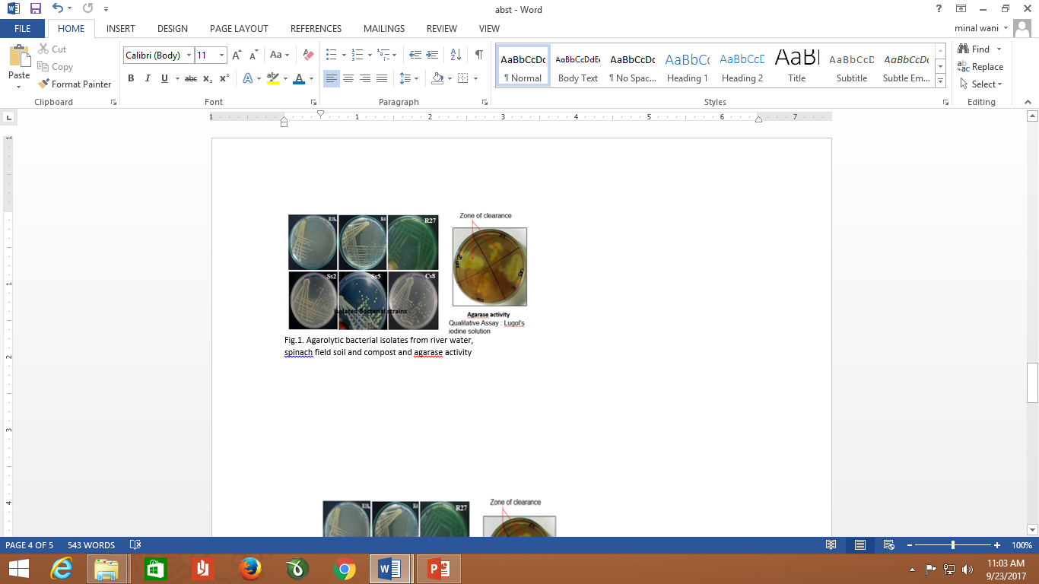
Recent Publications
- Feng Z, Li M (2013). Purification and characterization of agarose from Rhodococcus sp. Q5, a novel agarolytic bacterium isolated from printing and dyeing wastewater. Aquaculture 372:74–79
- Hosada A, Sakai M, Kanazawa S (2003). Isolation and characterization of Aagrdegrading Paenibacillus spp. associated with the Rhizosphere of Spinach. Biosci Biotechnol Biochem 67:1048–55.
- Hu, B.-K. Lin, Y. Xu, M.Q. Zhong and G.-M. Liu,2008. Production and purification of agarase from a marine agarolytic bacterium Agarivorans sp. HZ105, Journal of Applied Microbiology ISSN 1364-5072
- Tao Song, Weijia Zhang, Congchong Wei, Tengfei Jiang, Hui Xu, Yi Cao, Yu Cao, Dairong Qiao (2015). Isolation and Characterization of Agar-Degrading Endophytic Bacteria from Plants. Curr Microbiol 70:275–281.
- Vijayaraghavan R, Rajendran S (2011). Studies on agar degrading Salegentibacter sp. and characterization of its agarase. Int J Bioscience 1(5):56-64.

 Biography
Minal Paresh Wani, pursued her Post graduation in Botany and doctorate with specialization in Plant Physiology. Currently Minal Wani is Associate Professor with Dr. D. Y. Patil Vidyapeeth, Pune India and actively involved in teaching and evaluation, research and administrative activities. Research interest include plant and environmental Biotechnology. She is having more than 25 publications in National and International journals and guiding seven Ph. D candidates.
Email: minal.wani@dpu.edu.in
DOB: 05-30-1970
Contact Number: 91-9373332012

