Evaluation of activities of Miconia cuspidata extracts on gelatinases and HeLa cell lines

Lucas S Azevedo, UFSJ-CCO, Brazil
Natália A Ribeiro, Msc, UFSJ-CCO, Brazil
Rosy I M A Ribeiro, PhD, HCB-CPOM, Brazil

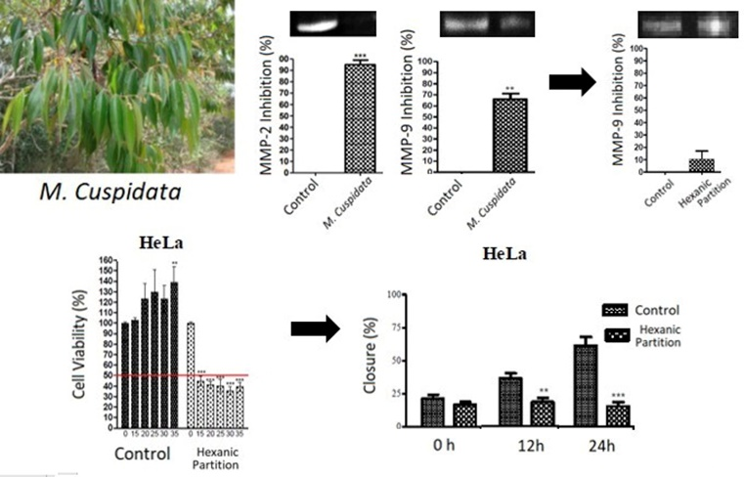
Introduction: Statement of the Problem: According to National Cancer Institute (INCA), in 2016, 12.7 million cases of neoplasms were diagnosed worldwide, of which 7.6 million died. In Brazil, 500 thousand new cases are estimated in 2017, which 61 thousand cases of prostate and 58 of breast cancer. The treatments available have many side effects and, depending on the region affected, provide a poor prognosis, mainly because of metastatic capacity that does not have viable treatments. Thus, it is extremely important to develop more effective and specific treatments of this disease. Methodology & Theoretical Orientation: There were verified the presence of secondary compounds by phytochemical study analyses. In parallel, zymograms were made with gelatin as a substrate to evaluate the inhibitory capacity against Matrix Metalloproteinases (MMPs). Subsequently, the extracts activity on HeLa (human cervical neoplasia) cell lines were evaluated by cell viability assay. Finally, inhibitory capacity was evaluated by migration assay. Findings: Hexanic partition exhibited the presence of steroids/triterpenoids, flavonoids, saponins, alkaloids, tannins and coumarins. It also inhibited approximately 50 percent of MMP-9 activities. The IC50 was achieved with 7.38µg/mL on HeLa. This extract decreased closure by 20 percent in compared to control in both 24 and 48 hours. Conclusion & Significance: It is suggested that Miconia cuspidata hexanic partition has antitumor potential owing to its secondary compounds.

Figure 1 – Treatment’s scheme with Miconia cuspidata by the activity of its compounds in metalloproteinases 2 and 9 and Hela cell lines.

References

LAURI E, A; SHUMAM, MOSS; JENSEN-TAUBMAN, SANDRA; STETLER-STEVENSON, WILLIAN. Matrix Metalloproteinases, Changing Roles in Tumor Progression and Metastasis. The American Journal of Pathology. v. 181, n. 6, 2012.

Inca, Ministry of Health (Brazil), National Cancer Institute in Brazil. Brasília: MS/INCA, 2017.

KERKELÄ, E.; SAARIALHO-KERE, U. Matrix metalloproteinases in tumor progression: focus on basal and squamous cell skin cancer. Nature Reviews. v. 12, n. 2, p. 109-25, 2003.

RIBEIRO, R. I. M. A. Expression of matrix metalloproteinases and their tissue inhibitors in basal cell carcinoma. Bras Patol Med Lab. V. 44, n. 2, p. 115-121, 2008.

ROOMI, M. W. Monterrey JC, Kalinovsky T, Niedzwiecki A and Rath M: Inhibition of invasion and MMPs by a nutrient mixture in human cancer cell lines: a correlation study. Exp Oncol. n.32, p.243–248, 2010.

Acknowledgment: CNPQ, FAPEMIG, UFSJ.



Lucas Santos Azevedo is a biochemistry student at Federal University of São João del-Rei (UFSJ). He develops research in Experimental Pathology Laboratory (LAPATEX), which focuses on activities evaluation of cerrado plants in neoplasic cells, being guided for Dra. Rosy Iara Maciel de Azambuja Ribeiro.
Email:
azevedolucas@outlook.com

