Screening of extracts of the Cerrado in human glioblastoma tumoral cell line

Patrik S Vital, UFSJ-CCO, Brazil
Ana G Silva, Msc, UFSJ-CCO, Brazil
Alisson R Rezende, Msc, UEMG, Brazil
Renato J S Oliveira, PhD, HCB–CPOM, Brazil
Rui M V Reis, PhD, HCB–CPOM, Brazil
Rosy I M A Ribeiro, PhD, HCB –CPOM, Brazil

Introduction: The Cerrado is the second biome among the five largest ones located in Brazil, with a vast variety of species that were still not studied regarding their biological properties. For that reason, the investigation of the potential cytotoxic activities in cancer of these species seems very promising. Glioblastoma, for instance, a central nervous system’s tumor, is presented as an of the most aggressive types of cancer, with a poor prognostic and high mortality rate. Thus, this work had as objective the screening of six Cerrado’s species in human glioblastoma tumoral cell line.

Results and discussion: Among the six vegetal extracts evaluated, three species (EB01, EB02 e EB03) presented high cytotoxicity in U251 cell line, having IC₅₀ value lowest that 40µg/mL at 24 hours of treatment - 38,93µg/mL; 12,08µg/mL and 14,27µg/mL, respectively (Figure 1). The current chemotherapeutic used to treat that type of tumor, Temozolomide, presents an IC₅₀ value of 129,8 µg/mL at 72 hours of treatment. These findings are interesting because, when compared with the currently used chemotherapeutic, these extracts have a much lower cytotoxic concentration.

Conclusion: The early screening allowed to find three potential antitumoral extracts in glioblastoma cell line since they were cytotoxic at very lowest concentration than the currently used chemotherapeutic.

Figure 1: Cytotoxicity of six vegetable extracts in U251 glioblastoma cell line after 24 hours of treatment.

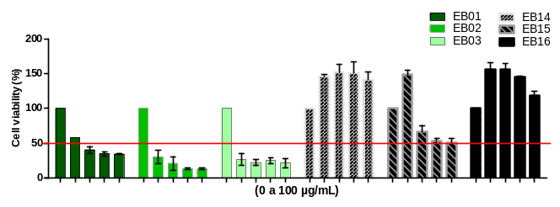

Figure 2: Temozolomide chemotherapeutic cytotoxicity in U251 glioblastoma cell line after 72 hours of treatment.

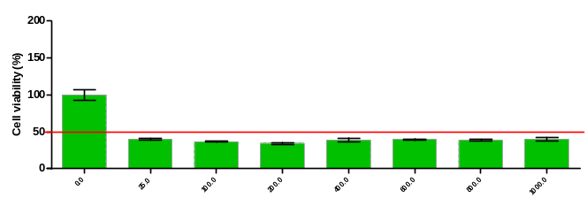

References:

ZHANG, J; FG STEVENS, M; D BRADSHAW, T. Temozolomide: mechanisms of action, repair and resistance. Current molecular pharmacology, v. 5, n. 1, p. 102-114, 2012. ISSN 1874-4672.

NEWMAN, DJ; CRAGG, GM. Natural products as sources of new drugs over the 30 years from 1981 to 2010. Journal of natural products, v. 75, n. 3, p. 311-335, 2012. ISSN 0163-3864.

de MESQUITA ML, de PAULA JE, PESSOA C, de MORAES MO, COSTA-LOTUFO LV, GROUGNET R, et al. Cytotoxic activity of Brazilian Cerrado plants used in traditional medicine against cancercell lines. J Ethnopharmacol. 2009;123(3):439-45.

OMURO, A.; DEANGELIS, LM. Glioblastoma and other malignant gliomas: a clinical review. Jama, v. 310, n. 17, p. 1842-1850, 2013. ISSN 0098-7484.

RIBEIRO DA, OLIVEIRA LG, MACEDO DG, MENEZES IR, COSTA JG, SILVA MA, et al. Promising medicinal plants for bioprospection in a Cerrado area of Chapada do Araripe, Northeastern Brazil. JEthnopharmacol. 2014;155(3):1522-33.

Acknowledgment: CNPQ, FAPEMIG, UFSJ.


Biochemistry Student by Federal University of São João del-Rei, Campus Centro-Oeste Dona Lindu (UFSJ-CCO); Industrial Automation Technician by Conceição Ferreira Nunes college (CECON), Divinópolis-MG, Technician Buildings by Serviço Nacional de Aprendizagem Industrial college (SENAI), Divinópolis-MG and Scientific Initiation Student in the Laboratory of Experimental Pathology (LAPATEX), UFSJ-CCO.
Email:
patrikdasilvavital@gmail.com

