Evaluation of the antineoplastic potential of new natural compounds in glioblastoma lines.
Lorena R Sousa, Msc student, UFSJ-CCO, Brazil
Ana G Silva, Msc, UFSJ-CCO, Brazil
Vanessa G P Severino, PhD, UFG, Brazil
João G M Junqueira, Msc, UFG, Brazil
Renato J S Oliveira, PhD, CPOM-Barretos, Brazil
Rui M V Reis, PhD, CPOM-Barretos, Brazil
Rosy I M A Ribeiro, PhD, UFSJ-CCO, Brazil

Nowadays cancer is one of the diseases with the highest number of deaths worldwide. Glioblastomas are one of the most aggressive tumors of the central nervous system in adults. The average survival rate of patients diagnosed with this disease is only 3% in five years. The available treatments are only palliative, justifying the need of studies aimed at screening new compounds more effective for clinical use. The present study aimed to evaluate the antitumor potential of plant extracts of Annona coreacea in two human glioma lines, GAMG and U251. Cell viability was quantified by the reduction of MTT ([3-(4,5-dimethylthiazol-2yl)-2,5-diphenyltetrazolium bromide) to formazan, its metabolization being proportional to the number of viable cells. The absorbance was measured by the spectrophotometer at wavelength 570nm after 2 hours and 30 minutes incubation with MTT (2.5mg/mL). The IC₅₀ of all compounds was elucidated by a 24 hours dilution curve with concentrations (1µg/mL, 7µg/mL, 15µg/mL and 25µg/mL). AcL3 was the most promising partition for U251, with IC₅₀ equal to 1.355µg/mL, and for GAMG AcL1 partition shown the best result, IC₅₀ equal to 3.355µg/mL (Figure 1). Migration assay was performed using the "wound-healing" methodology and aimed to evaluate the potential inhibition on cell migration of the partitions against U251 cell lines. Cells were treated with the IC₅₀, pre-determined by MTT assay. Relative migration was estimated by the formula: % wound-healing percentage: (%) = 100 (AB)/A, where A is the width of the wounds before treatment, and B is the width of the wounds after treatment. The images were obtained at times 0, 12, 24 and 72 hours after treatment for measurements. AcL3 and AcL4 (Figure 2) shown to be the best compounds when analyzed the inhibitory potential of the extracts on cell migration.
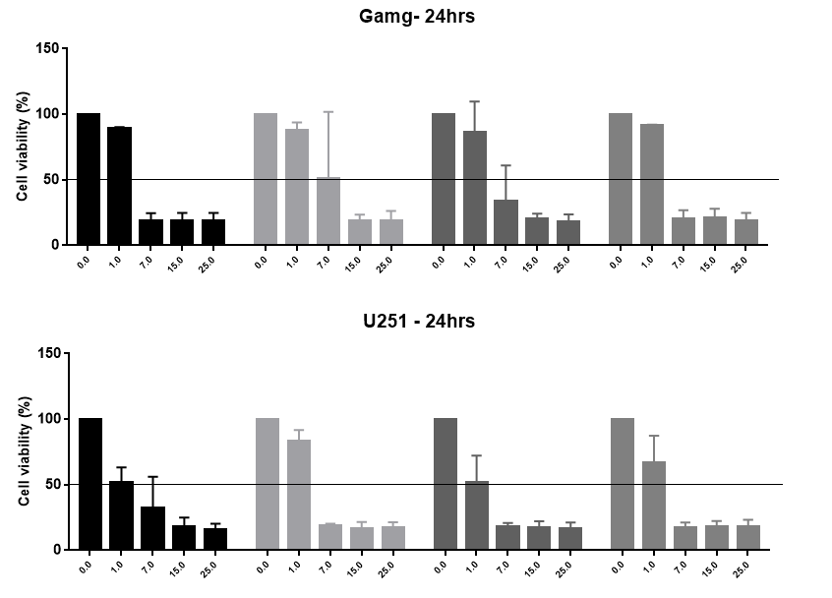

Figure 1. Viability assay

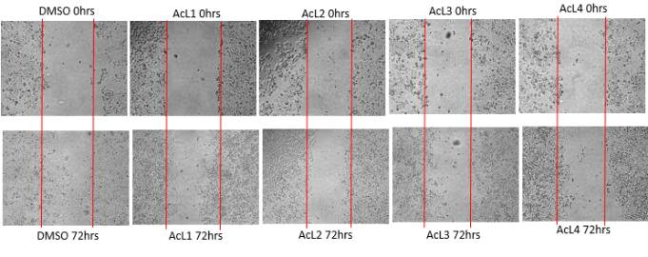
Figure 2. Visual analysis of wound-healing assay. Statistical analysis is not shown.
- GOSS, Paul E.; et al. Planning cancer control in Latin America and the Caribbean. The Lancet. Oncology PMID: 23628188, v. 14, n. 5, p. 391–436 , abr. 2013.
- SHAHAR, Tal et al. The impact of enrollment in clinical trials on survival of patients with glioblastoma. Journal of Clinical Neuroscience: Official Journal of the Neurosurgical Society of Australasia PMID: 22989795, v. 19, n. 11, p. 1530–1534 , nov. 2012.
- FORMAGIO, AS; VIEIRA, MC; VOLOBUFF, CR; SILVA, MS; MATOS, AI; CARDOSO, CA. In vitro biological screening of the anticholinesterase and antiproliferative activities of medicinal plants belonging to Annonaceae. Braz J Med Biol Res. 2015;48:308–15.
- HANAHAN, Douglas; WEINBERG, Robert A. Hallmarks of cancer: the next generation. Cell PMID: 21376230, v. 144, n. 5, p. 646–674 , 4 mar. 2011.
- INCA -INSTITUTO NACIONAL DO CÂNCER, 2015. Estimativa 2016: incidência de câncer no Brasil. Disponível em < http://www.inca.gov.br/estimativa/2016/estimativa-2016-v11.pdf> Acesso em: 31 mar. 2017.

Acknowledgment: CNPQ, FAPEMIG, UFSJ.



Lorena Raspante de Sousa has formed in biology in 2015 on University Federal of Pampa located in SG, RS. Nowadays is mastering student on Biochemistry and Molecular Biology on University Federal of São Joao Del Rey located in Divinopolis, MG. Actually, she works with glioblastomas cell lines, an aggressive tumor of the nervous central system of adults. In the past she worked with some others diseases such as Alzheimer's and Parkinson, using Drosophila melanogaster as an alternative model organism.
Email:lorena_raspanti@hotmail.com

