Activity of derived extracts from Annona coriacea Mart. on head and neck tumor lines
Aline T M Coelho, UFSJ-CCO, Brazil
Rodolfo E M Ribeiro, UFSJ-CCO, Brazil
Ana G Silva, Ms, UFSJ-CCO,Brazil
Gilvânia A R Cordeiro, UFSJ-CCO, Brazil
João G M Junqueira, Ms, UFG, Brazil
Vanessa G P Severino, PhD, UFG, Brazil
Renato J S Oliveira, PhD, HCB-CPOM, Brazil
Rui M V Reis, PhD, HCB-CPOM, Brazil
Rosy I M A Ribeiro, PhD, UFSJ-CCO, Brazil

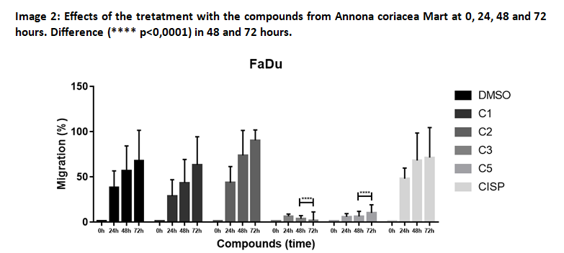
Abstract
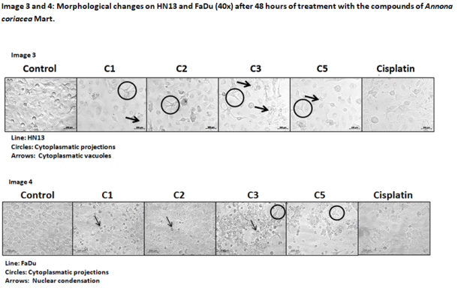
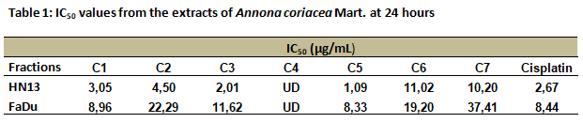
Introduction: Head and neck squamous cell carcinoma (HNSCC) makes up about 90% of head and neck neoplasms. The treatment is aggressive, the 5-year survival rate is around 50-60% and the local recurrence is 20-30%. Studies report that the use of new antitumor drugs of natural origin, besides efficient, offers a wide field for new research. So the objective of this work is to identify the antineoplastic potential of seven extracts of the species Annona coriacea Mart. on head and neck tumor lines. Results and Discussion: In the cell viability assay only the compound C4 did not reach representative IC₅₀ values on the tested lines (HN13 and FaDu). Of the seven compounds, four (C1, C2, C3, and C5) exhibited better results (Table 1) and were selected to follow in further assays. In the cell migration assay, it was seen that the C2, C3, and C5 compounds inhibited the migration in HN13 and C3 and C5 in FaDu, above all in 48 hours after treatment (Images 1 and 2). Changes in cell morphology were observed in the lines, which after treated with the compounds in the time of 48 hours showed cytoplasmic projections and vacuoles (HN13) and higher nuclear condensation (FaDu) compared to the control (Images 3 and 4). Conclusion: The results of this study contribute to the development of new antineoplastics that may help the treatment of HNSCC improving the prognosis and leading to cure.
Images

Recent Publications
- BALUNAS, M. J.; KINGHORN, A. D. Drug discovery from medicinal plants. Life Sci, v. 78, n. 5, p. 431-41, 2005. ISSN 0024-3205
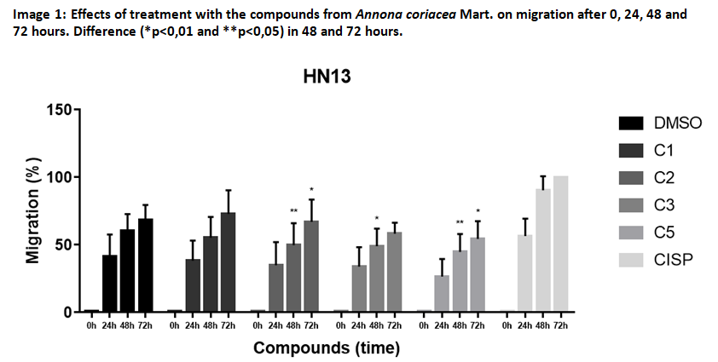
- BRAAKHUIS, B. J.; LEEMANS, C. R.; VISSER, O. Incidence and survival trends of head and neck squamous cell carcinoma in the Netherlands between 1989 and 2011. Oral Oncol, v. 50, n. 7, p. 670-5, 2014. ISSN 1879-0593.
- HOFFMANN, T. K. Systemic therapy strategies for head-neck carcinomas: current status. Tumordiagnostik und Therapie, v. 33, n. 6, p. 339, 2012. ISSN 0722-219.
- ITHARAT, A. et al. In vitro cytotoxic activity of Thai medicinal plants used traditionally to treat cancer. J Ethnopharmacol, v. 90, n. 1, p. 33-8, 2004. ISSN 0378-8741.
- SHIMIZU, S. et al. Autophagic cell death and cancer. Int J Mol Sci, v. 15, n. 2, p. 3145-53, 2014. ISSN 1422-0067.
Acknowledgment: Fapemig, CNPq,UFSJ.

Biography
Biochemistry student at Federal University of São João del-Rei, Campus Centro-Oeste Dona Lindu (UFSJ-CCO), Technician in Pharmacy by the institution Conceição Ferreira Nunes, Divinópolis/Mg and student of scientific initiation in the Laboratory of Experimental Pathology (Lapatex), UFSJ-CCO.
Email: coelhoalinem@gmail.com
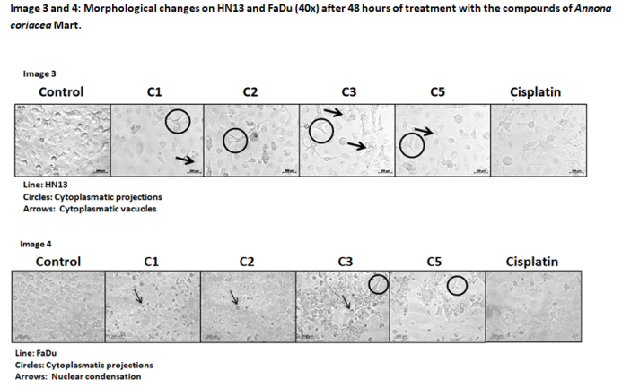

Notes/Comments:

