Preliminary evidence to show the apoptotic effects of extracellular factors of breast carcinoma upon HeLa survival
Himadri Patel, Devashree Jahagirdar, Nilesh Kumar Sharma*
Cancer and Translational Research Lab, Dr D. Y. Patil Biotechnology & Bioinformatics Institute, Dr D.Y. Patil Vidyapeeth, Pune 411033, Maharashtra, India.

Abstract

The tumor tissue microenvironment plays an important role in the development and regulation of normal and tumor or neoplastic cells. In essence, tumor microenvironment supports the cancer to achieve its characteristics of heterogeneous and complex diseases. Within the heterogeneous landscape of tumor microenvironment, several cellular and non-cellular factors have been reported to drive cancer development, invasion, metastasis and drug resistance debacles. Here, authors have attempted to understand the crosstalk between non-cellular components from breast carcinoma including extracellular factors of MCF-7 and triple negative breast cancer clinical tissue samples towards growth and survival of cervical cancer cell HeLa. In this paper, authors have selected breast carcinoma cell MCF-7 and clinical tissue samples as a source of non-cellular microenvironment factors. Further, these non-cellular components from breast cancer cells are evaluated for their growth and proliferation inhibitory role upon HeLa using growth, viability and apoptosis assays. The current findings lead us to suggest that the microenvironment secreted from MCF-7 and breast carcinoma tissue can play an interference role in growth and viability of HeLa during in vitro approaches. Here, preliminary data strongly indicate that non-cellular secreted components are able to bring apoptosis induced cell death of HeLa, which resulted into loss of cell viability. This observation is a novel of this kind, where cells and tissue samples from one carcinoma such as breast carcinoma could be implicated in the modulation of another carcinoma cell line HeLa for its growth and death process. However, this findings need to be tested in other cell lines and molecular mechanisms and detection of non-cellular microenvironment components. Current findings can be extended as a speculative proof of concept to support the observations about the rare co-occurrence of breast carcinoma and cervical carcinoma in a single individual. However, this hypothesis needs to be tested using 3-D tumor tissue culture model and clinical model.
Image
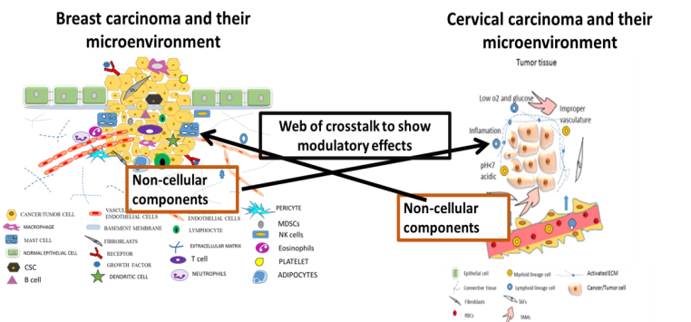
Figure 1: Proposed schematic model to illustrate web of crosstalk among carcinoma non-cellular microenvironment.
Recent Publications (minimum 5)
- Pritish Nilendu, Ajay Kumar, Azad Kumar, Pal JK, Sharma NK. (2017). Breast cancer stem cells as last soldiers eluding therapeutic burn: A hard nut to crack. International Journal of Cancer. DOI: 10.1002/ijc.30898. PUBMEDMID: 28722143.
- Devashree J, Shruti Purohit, Aayushi Jain, Sharma NK. (2016). Export of short RNAs: A bridge between breast carcinoma and their neighboring cells". Front. Oncol. | doi: 10.3389/fonc.2016.00147. PUBMED ID: 27379209.
- Bishop, J. Michael.The molecular genetics of cancer. Science. 1987, 235(4786):305-311.
- Jeffrey W. Pollard. Tumour-educated macrophages promote tumour progression and metastasis. Nature Reviews Cance.2004. 4. 71-78.
- Melissa R. Junttila1,& Frederic J. de Sauvage. Influence of tumour micro-environment heterogeneity on therapeutic response. Nature. 2013. 501, 346–354.

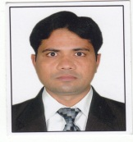Biography
Dr. Nilesh Kumar Sharma has completed Ph.D. from Indian Institute of Technology Roorkee, India in the year 2009 within Health Science specialization. Dr. Sharma completed his post doctoral research training for more than three years in DNA repair genetic and cancer biology at NIEHS, NIH, USA and Rutgers University, NJMS, NJ, USA. Since July 2016, Dr. Sharma is working as an Associate Professor at Dr. D. Y Patil Biotechnology & Bioinformatics, Dr. D. Y Patil, Vidyapeeth, Pune, India as a faculty and Principal Investigator in DST and DPU funded research project. Dr. Sharma has been credited with more than 25 research publications in indexed international Journals and two book chapters.
Email: Nilesh.sharma@dpu.edu.in

Full name: Dr. Nilesh Kumar Sharma
Contact number: +917219269540
ORCID ID: orcid.org/0000-0002-8774-3020
RESEARCHER ID: K-2540-2013
Scopus Author ID: 16307935500
Google Scholar ID: https://scholar.google.nl/citations?hl=en&user=BALQiIUAAAAJ
LinkedIn ID: https://in.linkedin.com/in/dr-nilesh-kumar-sharma2339b917

