PEP,FNDC5,C2C12,PGC1α pattern of genes expression during differentiation of mouse embryonic stem cells into heart cells in TABRIZ city IRAN
Shahin Asadi* ( student of Molecular Genetics )
Ali Nazirzadeh ( phd of BioTechnology )
Elham Ahmadi ( student Master of Medical BioTechnology )
Research Center for Stem Cell and Drug Applied Research Center, Tabriz University of Medical Sciences in modern biology.
Branch,Islamic Azad University,Tabriz,Iran.
Shahin.Asadi
*Author;Shahin Asadi-student of Molecular Genetics
Email;shahin.asadi1985@gmail.com
Tell;+989379923364

Abstract
FNDC5 gene with another protein called Xuemei Proxy (PEP) is a 209 amino acid protein coding. These genes mainly in heart tissue, skeletal muscle and brain expressed. This study aimed to clarify the pattern of expression of this gene in mouse embryonic cells Heart cells taken. The mouse embryonic stem cells as a model for cardiac differentiation induced by ascorbic acid used and the pattern of expression of PEP at certain stages of differentiation were analyzed by Real-Time PCR technique. The results show a dramatic increase in PEP gene expression in the adult cardiomyocytes. PEP increased expression of genes may have a role in later stages cardiogenesis is possible that further studies are needed to identify it.
Keywords: Protein proxy Xuemei, cardiac differentiation, embryonic stem cells and mice, Real-Time PCR.
Introduction
Fibronectin type III domain-containing protein 5, the precursor of irisin, is a protein that is encoded by the FNDC5 gene.^{[1]}
Fibronectin domain-containing protein 5 is a membrane protein comprising a short cytoplasmic domain, a transmembrane segment, and an ectodomain consisting of a ~100 kDa fibronectin type III (FNIII) domain. The ectodomain has been proposed to be cleaved to give a soluble peptide hormone named irisin. It has been proposed that irisin is secreted from muscle in response to exercise, and may mediate some beneficial effects of exercise in humans and the potential for generating weight loss and blocking diabetes has been suggested.^{[2][3][4][5][6][7][8]} while others have questioned these findings.^{[1][9][10][11]}
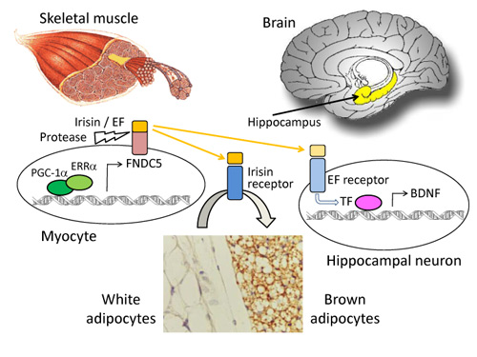

Discovery
FNDC5 was initially discovered during a genome search for fibronectin type III domains^{[12]} and also independently in a search for peroxisomal proteins.^{[1][13]} Irisin was found to be a cleaved version of FNDC5. The cleaved product has been called irisin, after the Greek messenger goddess Iris.^{[2]}
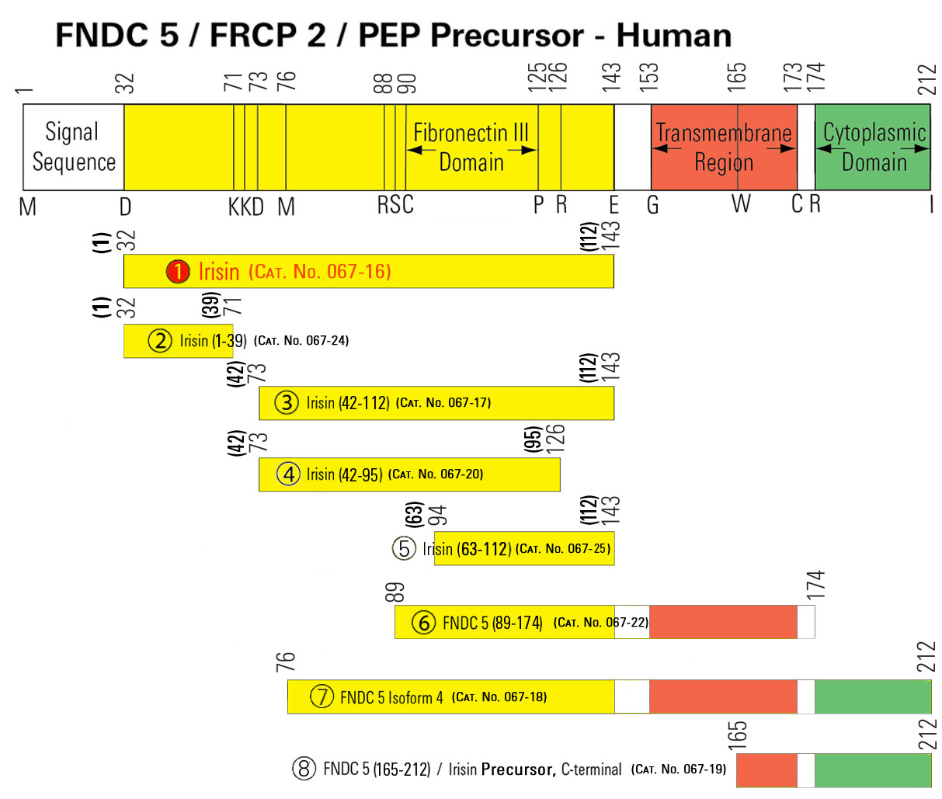

Biosynthesis and secretion
The FNDC5 gene encodes a prohormone, a single-pass type I membrane protein (human, 212 amino acids; mouse and rat, 209 amino acids) that is upregulated by muscular exercise and undergoes post-translational processing to generate irisin. The sequence of the protein includes a signal peptide, a single fibronectin type III domain, and a C-terminal hydrophobic domain that is anchored in the cell membrane. The production of irisin is similar to the shedding and release of other hormones and hormone-like polypeptides, such as epidermal growth factor and TGF alpha, from transmembrane precursors. After the N-terminal signal peptide is removed, the peptide is proteolytically cleaved from the C-terminal moiety, glycosylated, and released as a hormone of 112 amino acids (in human, amino acids 32-143 of the full-length protein; in mouse and rat, amino acids 29-140) that comprises most of the FNIII repeat region. The sequence of irisin, the cleaved and secreted portion of FNDC5, is highly conserved in mammals; the human and murine sequences are identical.^{[2]} However, the start codon of human FNDC5 is mutated to ATA, which causes it to be expressed at only 1% the level of other animals with the normal ATG start - though its circulation levels are still on par with other key humanhormones, such as insulin.^{[14]}
A difference in the nucleotide sequence of human FNDC5 from that of mouse Fndc5 creates a different initiation codon, potentially generating a protein that begins at methionine-76 (Met-76). A protein initiated at Met-76 would be missing the signal peptide and would be trapped in the cytoplasm. Via mass spectrometry, irisin has been found to circulate in humans in levels similar to other key hormones, such as insulin.^{[14]}

Function
Exercise causes increased expression in muscle of peroxisome proliferator-activated receptor gamma coactivator 1 alpha (PGC-1alpha), which is involved in adaptation to exercise. In mice, this causes production of the FNDC5 protein which is cleaved to give a new product irisin.^{[2][5]} Due to its production through a mechanism initiated by muscular contraction, irisin has been classified as a myokine.^{[15]}
Based on the findings that FNDC5 induces thermogenin expression in fat cells, overexpression of FNDC5 in the liver of mice prevents diet-induced weight gain, and FNDC5 mRNA levels are elevated in human muscle samples after exercise, it has been proposed that irisin promotes the conversion of white fat to brown fat in humans which would make it a health promoting hormone.^{[3][4]} However this proposal has been challenged^{[16]} since FNDC5 is upregulated only in highly active elderly humans.^{[9]}
In mice, irisin released from skeletal muscle during exercise also acts directly on bone by increasing cortical bone mineral density, bone perimeter and polar moment of inertia.[17][unreliable medical source]
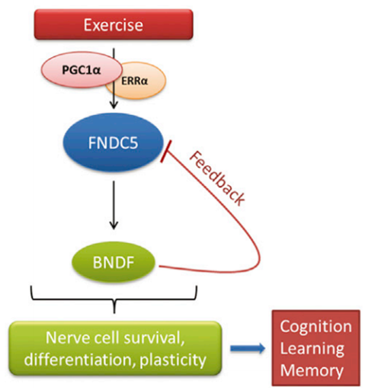
C2C12 is a mouse myoblast cell line. C2C12 cell line is a subclone produced in Helen Blau's Lab in Stanford of myoblasts that were originally obtained by Yaffe and Saxel at the Weizmann Institute of Science in Israel in 1977 through serial passage of myoblasts cultured from the thigh muscle of C3H mice after a crush injury. These cells are capable of differentiation. C2C12 cells are a useful tool to study the differentiation of myoblasts and osteoblasts, to express various proteins, and to explore mechanistic pathways.^{[1]}
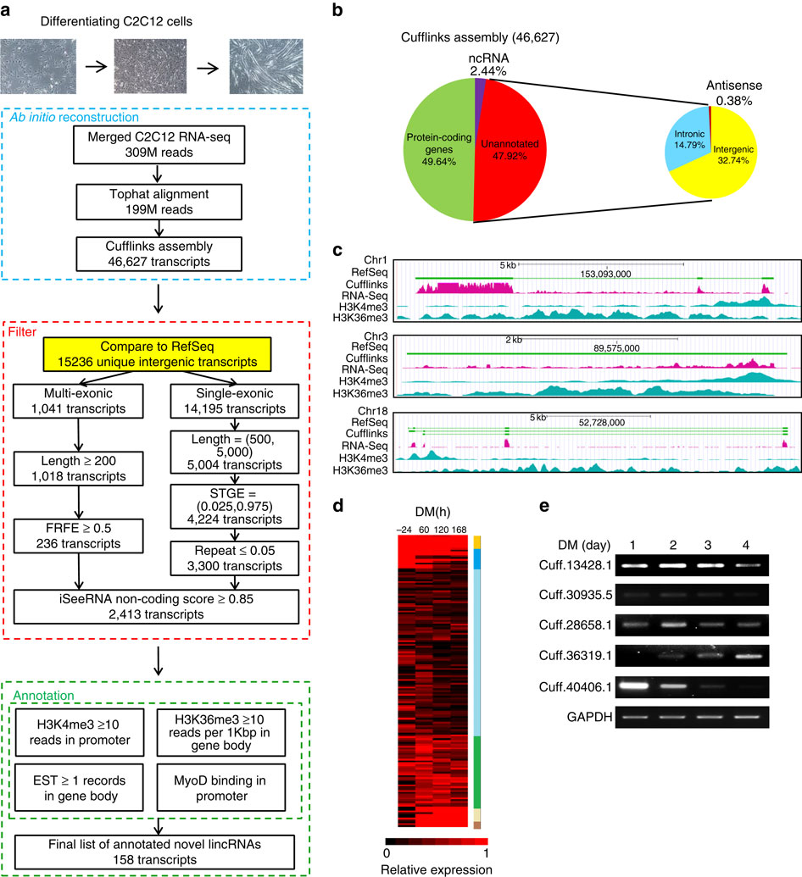
Xuemei proxy another protein called Fibronectin type III Domain 5 (FNDC5) is known at the receiver is 209 amino acids in rat cDNA cloning was done in 2002. Preliminary observations indicate that PEP gene expression gradually increases in heart tissue of mouse embryos and in adult mouse heart tissue reaches its maximum expression. Previous studies have also shown that the expression of this gene in C2C12 cells differentiated lineages Myoblasts to Myotub, doubled ¹. In recent studies by Bostrom and colleagues found that physical activity leads to an increase in muscle gene expression PGC1a PEP increased gene expression and secretion product called Irisin muscle cells into the blood. irisin Mayocain act as a protein-coding genes with increased expression in mitochondria Uncoupler cause fat cells to become brown fat tissue is white. As a result of increased thermogenesis or exothermic and releases energy in the form of heat ². Weight loss studies have shown that decreased expression of underlying genes underlying PEP aerobic activity is decreased in patients with myocardial infarction ⁴. Since a variety of cell lines derived from embryonic stem cells are able to differentiate embryonic germinal layer, This feature enables stem cells as a model to study embryonic development and how it can be used in a variety of cell lines. Thus, induction of differentiation of embryonic stem cells into heart cells in laboratory environments can be modeled process cardiogenes the fetus.
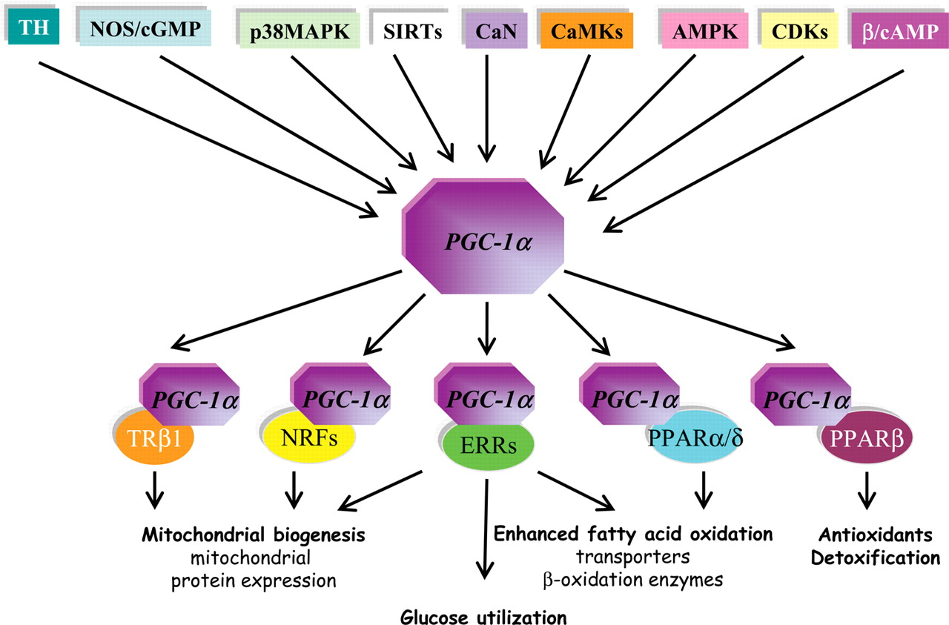

GW501516
GW501516 (also known as GW-501,516, GW1516, GSK-516 and on the black market as Endurobol^{[1]}) is a PPARδ receptor agonist that was invented in a collaboration between Ligand Pharmaceuticals and GlaxoSmithKline in the 1990s, was entered into clinical development as a drug candidate for metabolic diseases and cardiovascular diseases, and was abandoned in 2007 because animal testing showed that the drug caused cancer to develop rapidly in several organs.
In 2007 research was published showing that high doses of GW501516 given to mice dramatically improved their physical performance; the work was widely discussed in popular media, and led to a black market for the drug candidate and to its abuse by athletes as a doping agent. The World Anti-Doping Agency (WADA) developed a test for GW501516 and other related chemicals and added them to the prohibited list in 2009; it has issued additional warnings to athletes that GW501516 is not safe.

History
GW501516 was initially discovered during a research collaboration between GSK and Ligand Pharmaceuticals that began in 1992.^{[2]} The discovery of the compound was published in a 2001 issue of PNAS.^{[3]} Oliver et al. reported that they used "combinatorial chemistry and structure-based drug design" to develop it.^{[4]} One of the authors was the son of Leo Sternbach who discovered benzodiazepines in the 1960s.^{[5]}
R & D Focus Drug News reported that GSK began phase I trials of the compound for the treatment of hyperlipidemia in 2000^{[6]} followed by phase I/II in 2002.^{[7]} In 2003, Ligand Pharmaceuticals earned a $1 million payment as a result of GSK continuing phase I development.^{[8]}
By 2007, GW501516 had completed two phase II clinical studies and other studies relating to obesity, diabetes, dyslipidemia and cardiovascular disease,^{[9][10]} but GSK abandoned further development of the drug in 2007 for reasons which were not disclosed as the time.^{[11]} It later emerged that the drug was discontinued because animal testing showed that the drug caused cancer to develop rapidly in several organs.^{[12][13][14]}
Ronald M. Evans's laboratory purchased a sample of GW501516 and gave mice a much higher dose than had been used in GSK's experiments; they found that the compound dramatically increased the physical performance of the mice. The work was published in 2007 in Cell and was widely reported in the popular press including The New York Times and The Wall Street Journal.^{[15]}

Performance-enhancing drug
Concerns were raised prior to the 2008 Beijing Olympics that GW501516 could be used by athletes as an ergogenic performance-enhancing drug that was not currently controlled by regulations or detected by standard tests. One of the main researchers from the study on enhanced endurance consequently developed a urine test to detect the drug, and made it available to the International Olympic Committee. The World Anti-Doping Agency (WADA) developed a test for GW501516 and other related PPARδ modulators,^{[16]} and added such drugs to the prohibited list in 2009.^{[17]}
GW501516 has been promoted on bodybuilding and athletics websites^{[18]} and by 2011 had already been available for some time on the black market.^{[1][19]} In 2011 it was reported to cost $1000 for 10 g.^{[15]} In 2012, WADA recategorised GW501516 from a gene doping compound to a "hormone and metabolic modulator".^{[20]}
At the Vuelta Ciclista a Costa Rica in December 2012 four Costa Rican riders tested positive for GW501516. Three of them received two-year suspensions, while the fourth got 12 years as it was his second doping violation.^{[21][22][23]} In April 2013, Russian cyclicst Valery Kaykov was suspended by cycling's governing body UCI after having tested positive for GW501516. Kaykov's team RusVelo sacked him immediately^{[24]} and in May 2013, Venezuelan Miguel Ubeto was provisionally suspended by the Lampre team.^{[25]}
In 2013, WADA took the rare step of warning potential users of the compound of the possible health risks, stating that "clinical approval has not, and will not be given for this substance"; the New Scientist attributed the warning to the risks of the drug causing cancer.^{[18][26]}
On 25 February 2014 the 20 km race walk Olympic champion, World champion and World Record holder, Elena Lashmanova of Russia, tested positive for GW501516.^{[27][28]}

Mode of action
GW501516 is a selective agonist (activator) of the PPARδ receptor.^{[29]} It displays high affinity (K_{i} = 1 nM) and potency (EC₅₀ = 1 nM) for PPARδ with > 1000 fold selectivity over PPARα and PPARγ.^{[4]}
In rats, binding of GW501516 to PPARδ recruits the coactivator PGC-1α. The PPARδ/coactivator complex in turn upregulates the expression of proteins involved in energy expenditure.^{[30]} Furthermore, in rats treated with GW501516, increased fatty acid metabolism in skeletal muscle and protection against diet-induced obesity and type II diabetes was observed. In obese rhesus monkeys, GW501516 increased high-density lipoprotein (HDL) and lowered very-low-density lipoprotein (VLDL).^{[30]}

Acadesine
Acadesine (INN), also known as 5-aminoimidazole-4-carboxamide-1-β-D-ribofuranoside, AICA-riboside, and AICAR, is an AMP-activated protein kinase activator^{[1]} which is used for the treatment of acute lymphoblastic leukemia^{[2]} and may have applications in treating other disorders such as diabetes.^{[3]}
Acadesine is an adenosine regulating agent developed by PeriCor Therapeutics and licensed to Schering-Plough in 2007 for phase III studies. The drug is a potential first-in-class agent for prevention of reperfusion injury in CABG surgery. Schering began patient enrollment in phase III studies in May, 2009. The trial was terminated in late 2010 based on an interim futility analysis.^{[4][5]}

Chemistry
Reaction of 2-bromo tribenzoyl ribose with 1,2-diaminomaleionitrile results in the displacement of the anomeric halogen by one of the amino groups and the formation of the aminosugar largely as the β-anomer. Treatment of this product with methyl orthoformate in the presence of a base leads to the replacement of the alkoxy groups in orthoformate by the adjacent amines, resulting in the formation of the imidazole ring. Reaction with alkoxide then interestingly converts the nitrile nearest the sugar to an iminoester; the benzoyl groups are cleaved in the process. Hofmann rearrangement in the presence of a bromine and a base converts the iminoester to the corresponding primary amine. Basic hydrolysis then converts the remaining nitrile to an amide, affording acadesine.^{[6]}
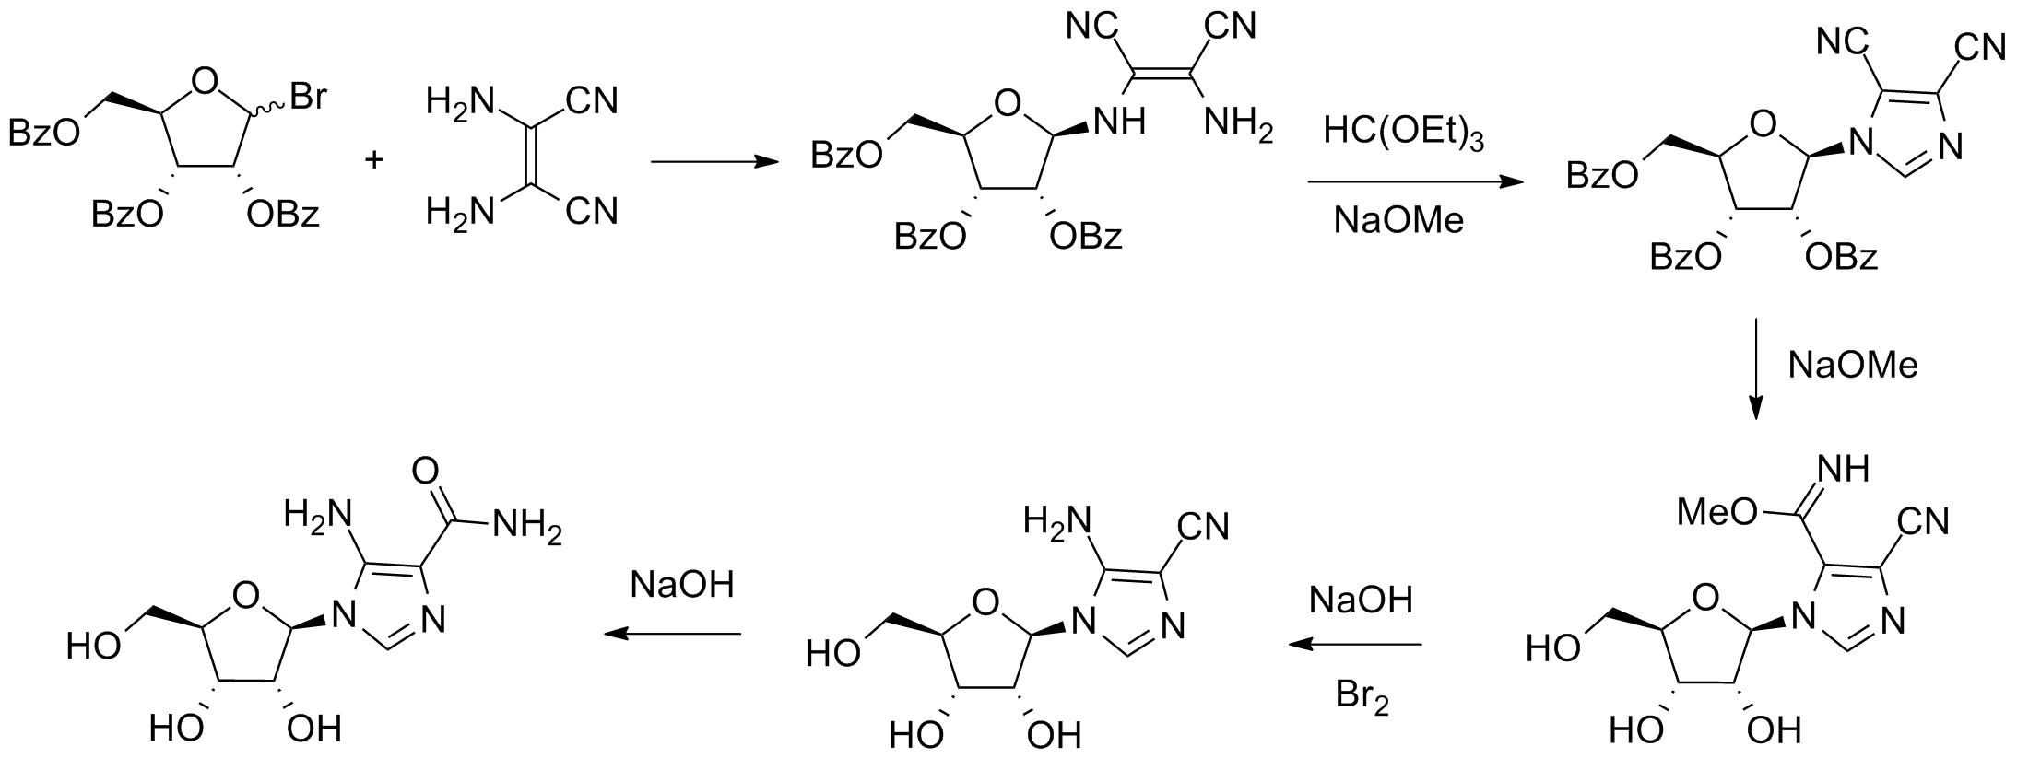

Pharmacology and use in doping
Acadesine acts as an AMP-activated protein kinase agonist.^{[7]} It stimulates glucose uptake and increases the activity of p38 mitogen-activated protein kinases α and β in skeletal muscle tissue,^{[8]} as well as suppressing apoptosis by reducing production of reactive oxygen compounds inside the cell.^{[9]}
In 2008, researchers at the Salk Institute discovered that acadesine injected in mice significantly improved their performance in endurance-type exercise, apparently by converting fast-twitch muscle fibers to the more energy-efficient, fat-burning, slow-twitch type. They also looked at the administration of GW 501516 (also called GW1516) in combination with acadesine. Given to mice that did not exercise, this combination activated 40% of the genes that were turned on when mice were given GW1516 and made to exercise. This result drew attention to the compound as a possible athletic endurance aid.^{[10]} One of the lead researchers from this study has developed a urine test to detect it and has made the test available to the International Olympic Committee, and the World Anti-Doping Agency (WADA) has added acadesine to the prohibited list from 2009 onwards.^{[11]} The British Medical Journal reported in 2009 that WADA had found evidence that acadesine was used by cyclists in the 2009 Tour de France.^{[12]}

Elafibranor
Elafibranor (GFT505) a experimental medication that is being studied and developed by Genfit for the treatment of cardiometabolic diseases including diabetes, insulin resistance, dyslipidemia, and non-alcoholic fatty liver disease (NAFLD).^{[2][3]}
Elafibranor is a dual PPARα/δ agonist.^{[4][5]}
Elafibranor is mainly focused on the treatment of NASH disease.^{[6]}

Clinical studies
Administered to over 800 patients and healthy volunteers to date, Elafibranor has demonstrated :
- beneficial properties for NASH :^{[7]}
- Improvement of insulin sensitivity and glucose homeostasis ^{[8]}
Phase 2b (GOLDEN) results were published online in GastroEnterology in February 2016 ^{[9]} and will be fully available in the paper version in May 2016.
As of February 2016 GFT505 has completed 8 clinical trials and a phase III is in progress.^{[10]}

Pre-clinical studies
Efficacy on histological NASH parameters (steatosis, inflammation, fibrosis) in animal disease models – anti-fibrotic activities ^{[11]}
The absence of safety concern has been confirmed in a full toxicological package up to 2-year carcinogenicity studies and cardiac studies (in mice).^{[12]}

MBX-8025
MBX-8025 is a PPARδ receptor agonist that is being investigated for drug use by Metabolex.^{[2][3]} According to a press release they are examining its potential use for the treatment of dyslipidemia, metabolic syndrome, type 2 diabetes, and non-alcoholic steatohepatitis. The compound, formerly known as RWJ-800025, was licensed from Janssen Pharmaceutica NV.^{[4]}

Telmisartan
Telmisartan (INN) /tɛlmɪˈsɑːrtən/ is an angiotensin II receptor antagonist (angiotensin receptor blocker, ARB) used in the management of hypertension. It was discovered by Boehringer Ingelheim and launched in 1999 as Micardis.^{[1]}

Administration
The usually effective dose telmisartan is 40–80 mg once daily. Some patients may already benefit at a daily dose of 20 mg. In cases where the target blood pressure is not achieved, telmisartan dose can be increased to a maximum of 80 mg once daily.^{[2]}

Contraindications
Telmisartan is contraindicated during pregnancy. Like other drugs affecting the renin-angiotensin system (RAS), telmisartan can cause birth defects, stillbirths, and neonatal deaths. It is not known whether the drug passes into the breast milk.^{[4]} Also it is contraindicated in bilateral renal artery stenosis in which it can cause renal failure.

Side effects
Side effects are similar to other angiotensin II receptor antagonists and include tachycardia and bradycardia (fast or slow heartbeat), hypotension (low blood pressure), edema (swelling of arms, legs, lips, tongue, or throat, the latter leading to breathing problems), and allergic reactions.^{[4]}

Mode of action
Telmisartan is an angiotensin II receptor blocker that shows high affinity for the angiotensin II receptor type 1 (AT₁), with a binding affinity 3000 times greater for AT₁ than AT₂. It has the longest half-life of any ARB (24 hours)^{[2][5]} and the largest volume of distribution among ARBs (500 liters).^{[6][7]}
In addition to blocking the RAs, telmisartan acts as a selective modulator of peroxisome proliferator-activated receptor gamma (PPAR-γ), a central regulator of insulin and glucose metabolism. It is believed that telmisartan’s dual mode of action may provide protective benefits against the vascular and renal damage caused by diabetes and cardiovascular disease (CVD).^{[5]}
Telmisartan's activity at the peroxisome proliferator-activated receptor delta (PPAR-δ) receptor has prompted speculation around its potential as a sport doping agent as an alternative to GW 501516.^{[8]} Telmisartan activates PPAR-δ receptors in several tissues.^{[9][10][11][12]}

Clinical trials

ONTARGET
The Ongoing Telmisartan Alone and in combination with Ramipril Global Endpoint Trial (ONTARGET) was one of the largest ARB clinical studies ever undertaken;^{[13]} 25,620 patients from 733 centres in 41 countries were randomised for 5.5 years of treatment of either telmisartan, the ACE inhibitor ramipril or a combination of the two. The study aimed to investigate the role of telmisartan in cardiovascular (CV) protection through the primary composite outcome of death from CV causes, myocardial infarction, stroke or hospilization for heart failure, in high CV risk patients.
The study showed telmisartan was as effective as ramipril but with lower rates of cough and angioedema, which led to fewer discontinuations. The combination group experienced similar efficacy, but with increased risk of hypotensive symptoms. Moreover, in a patient population selected to tolerate ACE inhibitors, telmisartan was shown to be better tolerated and associated with higher treatment compliance than ramipril.^{[14]}

TRANSCEND
As part of the ONTARGET study, patients who could not tolerate ACE inhibitors were randomly assigned to receive either telmisartan or placebo as part of the Telmisartan Randomized Assessment Study in ACE Intolerant Subjects with Cardiovascular Disease (TRANSCEND) study. An accompanying editorial comments: "Overall, data supporting use of angiotensin-receptor blockers to prevent vascular events in various cardiovascular groups, other than heart failure, are incomplete. TRANSCEND's results challenge the non-inferiority shown in ONTARGET and suggest no more than a modest effect, if any at all."^{[15]}

PRoFESS
The Prevention Regimen For Effectively Avoiding Second Strokes (PRoFESS) study investigated therapy with telmisartan initiated soon after an ischemic stroke and continued for 2.5 years. This treatment did not significantly lower the rate of recurrent stroke, major cardiovascular events, or diabetes.^{[16]}

GW501516
GW501516 (also known as GW-501,516, GW1516, GSK-516 and on the black market as Endurobol^{[1]}) is a PPARδ receptor agonist that was invented in a collaboration between Ligand Pharmaceuticals and GlaxoSmithKline in the 1990s, was entered into clinical development as a drug candidate for metabolic diseases and cardiovascular diseases, and was abandoned in 2007 because animal testing showed that the drug caused cancer to develop rapidly in several organs.
In 2007 research was published showing that high doses of GW501516 given to mice dramatically improved their physical performance; the work was widely discussed in popular media, and led to a black market for the drug candidate and to its abuse by athletes as a doping agent. The World Anti-Doping Agency (WADA) developed a test for GW501516 and other related chemicals and added them to the prohibited list in 2009; it has issued additional warnings to athletes that GW501516 is not safe.

History
GW501516 was initially discovered during a research collaboration between GSK and Ligand Pharmaceuticals that began in 1992.^{[2]} The discovery of the compound was published in a 2001 issue of PNAS.^{[3]} Oliver et al. reported that they used "combinatorial chemistry and structure-based drug design" to develop it.^{[4]} One of the authors was the son of Leo Sternbach who discovered benzodiazepines in the 1960s.^{[5]}
R & D Focus Drug News reported that GSK began phase I trials of the compound for the treatment of hyperlipidemia in 2000^{[6]} followed by phase I/II in 2002.^{[7]} In 2003, Ligand Pharmaceuticals earned a $1 million payment as a result of GSK continuing phase I development.^{[8]}
By 2007, GW501516 had completed two phase II clinical studies and other studies relating to obesity, diabetes, dyslipidemia and cardiovascular disease,^{[9][10]} but GSK abandoned further development of the drug in 2007 for reasons which were not disclosed as the time.^{[11]} It later emerged that the drug was discontinued because animal testing showed that the drug caused cancer to develop rapidly in several organs.^{[12][13][14]}
Ronald M. Evans's laboratory purchased a sample of GW501516 and gave mice a much higher dose than had been used in GSK's experiments; they found that the compound dramatically increased the physical performance of the mice. The work was published in 2007 in Cell and was widely reported in the popular press including The New York Times and The Wall Street Journal.^{[15]}

Performance-enhancing drug
Concerns were raised prior to the 2008 Beijing Olympics that GW501516 could be used by athletes as an ergogenic performance-enhancing drug that was not currently controlled by regulations or detected by standard tests. One of the main researchers from the study on enhanced endurance consequently developed a urine test to detect the drug, and made it available to the International Olympic Committee. The World Anti-Doping Agency (WADA) developed a test for GW501516 and other related PPARδ modulators,^{[16]} and added such drugs to the prohibited list in 2009.^{[17]}
GW501516 has been promoted on bodybuilding and athletics websites^{[18]} and by 2011 had already been available for some time on the black market.^{[1][19]} In 2011 it was reported to cost $1000 for 10 g.^{[15]} In 2012, WADA recategorised GW501516 from a gene doping compound to a "hormone and metabolic modulator".^{[20]}
At the Vuelta Ciclista a Costa Rica in December 2012 four Costa Rican riders tested positive for GW501516. Three of them received two-year suspensions, while the fourth got 12 years as it was his second doping violation.^{[21][22][23]} In April 2013, Russian cyclicst Valery Kaykov was suspended by cycling's governing body UCI after having tested positive for GW501516. Kaykov's team RusVelo sacked him immediately^{[24]} and in May 2013, Venezuelan Miguel Ubeto was provisionally suspended by the Lampre team.^{[25]}
In 2013, WADA took the rare step of warning potential users of the compound of the possible health risks, stating that "clinical approval has not, and will not be given for this substance"; the New Scientist attributed the warning to the risks of the drug causing cancer.^{[18][26]}
On 25 February 2014 the 20 km race walk Olympic champion, World champion and World Record holder, Elena Lashmanova of Russia, tested positive for GW501516.^{[27][28]}

Mode of action
GW501516 is a selective agonist (activator) of the PPARδ receptor.^{[29]} It displays high affinity (K_{i} = 1 nM) and potency (EC₅₀ = 1 nM) for PPARδ with > 1000 fold selectivity over PPARα and PPARγ.^{[4]}
In rats, binding of GW501516 to PPARδ recruits the coactivator PGC-1α. The PPARδ/coactivator complex in turn upregulates the expression of proteins involved in energy expenditure.^{[30]} Furthermore, in rats treated with GW501516, increased fatty acid metabolism in skeletal muscle and protection against diet-induced obesity and type II diabetes was observed. In obese rhesus monkeys, GW501516 increased high-density lipoprotein (HDL) and lowered very-low-density lipoprotein (VLDL).^{[30]}

Peroxisome proliferator-activated receptor
In the field of molecular biology, the peroxisome proliferator-activated receptors (PPARs) are a group of nuclear receptor proteins that function as transcription factors regulating the expression of genes.^{[1]} PPARs play essential roles in the regulation of cellular differentiation, development, and metabolism (carbohydrate, lipid, protein), and tumorigenesis^{[2]} of higher organisms.^{[3][4]}

Nomenclature and tissue distribution
Three types of PPARs have been identified: alpha, gamma, and delta (beta):^{[3]}
- α (alpha) - expressed in liver, kidney, heart, muscle, adipose tissue, and others^{[5]}
- β/δ (beta/delta) - expressed in many tissues but markedly in brain, adipose tissue, and skin
- γ (gamma) - although transcribed by the same gene, this PPAR through alternative splicing is expressed in three forms:
  - γ1 - expressed in virtually all tissues, including heart, muscle, colon, kidney, pancreas, and spleen
  - γ2 - expressed mainly in adipose tissue (30 amino acids longer)
  - γ3 - expressed in macrophages, large intestine, white adipose tissue.

History
PPARs were originally identified in Xenopus frogs as receptors that induce the proliferation of peroxisomes in cells.^{[6]} The first PPAR (PPARα) was discovered during the search of a molecular target for a group of agents then referred to as peroxisome proliferators, as they increased peroxisomal numbers in rodent liver tissue, apart from improving insulin sensitivity.^{[7]} These agents, pharmacologically related to the fibrates were discovered in the early 1980s. When it turned out that PPARs played a much more versatile role in biology, the agents were in turn termed PPAR ligands. The best-known PPAR ligands are the thiazolidinediones; see below for more details.
After PPARδ (delta) was identified in humans in 1992,^{[8]} it turned out to be closely related to the PPARβ (beta) previously described during the same year in other animals (Xenopus). The name PPARδ is generally used in the US, whereas the use of the PPARβ denomination has remained in Europe where this receptor was initially discovered in Xenopus.

Physiological function
All PPARs heterodimerize with the retinoid X receptor (RXR) and bind to specific regions on the DNA of target genes. These DNA sequences are termed PPREs (peroxisome proliferator hormone response elements). The DNA consensus sequence is AGGTCANAGGTCA, with N being any nucleotide. In general, this sequence occurs in the promotor region of a gene, and, when the PPAR binds its ligand, transcription of target genes is increased or decreased, depending on the gene. The RXR also forms a heterodimer with a number of other receptors (e.g., vitamin D and thyroid hormone).
The function of PPARs is modified by the precise shape of their ligand-binding domain (see below) induced by ligand binding and by a number of coactivator and corepressor proteins, the presence of which can stimulate or inhibit receptor function, respectively.^{[9]}
Endogenous ligands for the PPARs include free fatty acids and eicosanoids. PPARγ is activated by PGJ₂ (a prostaglandin) and certain members of the 5-HETE family of arachidonic acid metabolites including 5-oxo-15(S)-HETE and 5-oxo-ETE.^{[10]} In contrast, PPARα is activated by leukotriene B₄. Certain members of the 15-Hydroxyicosatetraenoic acid family of arachidonic acid metabolites, including 15(S)-HETE, 15(R)-HETE, and 15-HpETE activate to varying degrees PPAR alpha, beta/delta, and gamma.^{[11]} PPARγ activation by agonist RS5444 may inhibit anaplastic thyroid cancer growth.^{[12]} See^{[13]} for a review and critique of the roles of PPAR gamma in cancer.
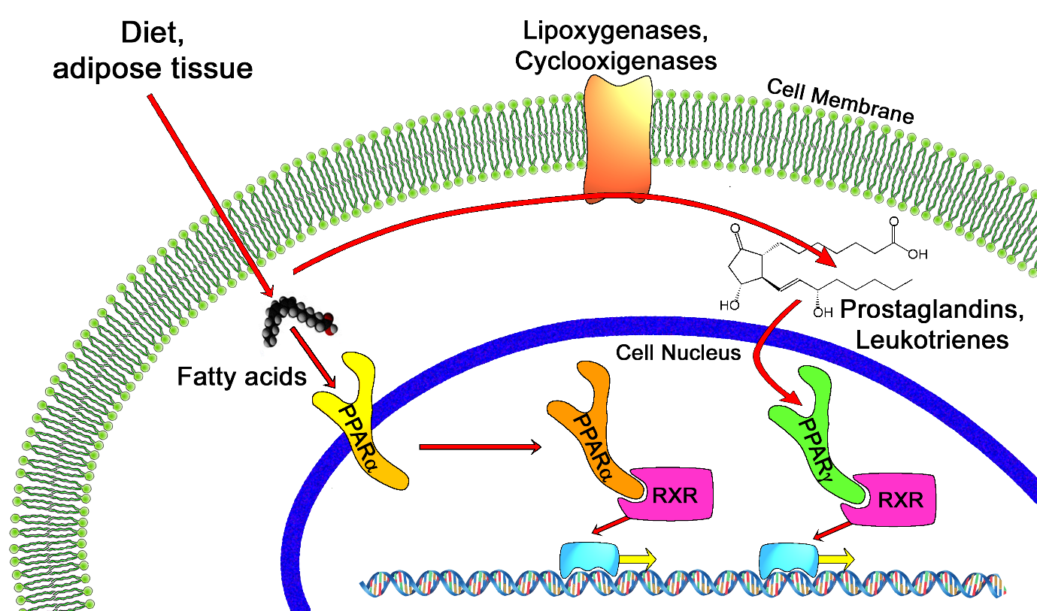

Genetics
The three main forms are transcribed from different genes:
- PPARα - chromosome 22q12-13.1 (OMIM 170998)
- PPARβ/δ - chromosome 6p21.2-21.1 (OMIM 600409)
- PPARγ - chromosome 3p25 (OMIM 601487).
Hereditary disorders of all PPARs have been described, generally leading to a loss in function and concomitant lipodystrophy, insulin resistance, and/or acanthosis nigricans.^{[14]} Of PPARγ, a gain-of-function mutation has been described and studied (Pro12Ala) which decreased the risk of insulin resistance; it is quite prevalent (allele frequency 0.03 - 0.12 in some populations).^{[15]} In contrast, pro115gln is associated with obesity. Some other polymorphisms have high incidence in populations with elevated body mass indexes.

Structure
Like other nuclear receptors, PPARs are modular in structure and contain the following functional domains:
- (A/B) N-terminal region
- (C) DBD (DNA-binding domain)
- (D) flexible hinge region
- (E) LBD (ligand binding domain)
- (F) C-terminal region
The DBD contains two zinc finger motifs, which bind to specific sequences of DNA known as hormone response elements when the receptor is activated. The LBD has an extensive secondary structure consisting of 13 alpha helices and a beta sheet.^{[16]} Natural and synthetic ligands bind to the LBD, either activating or repressing the receptor.

Pharmacology and PPAR modulators
Main article: PPAR modulator
PPARα and PPARγ are the molecular targets of a number of marketed drugs. For instance the hypolipidemic fibrates activate PPARα, and the anti diabetic thiazolidinediones activate PPARγ. The synthetic chemical perfluorooctanoic acid activates PPARα while the synthetic perfluorononanoic acid activates both PPARα and PPARγ. Berberine activates PPARγ, as well as other natural compounds from different chemical classes.^{[17][18]}

Materials and Methods
Cultured embryonic stem cells:
In the study of embryonic stem cells line embryo B1 CBL576 derived from mice were used. Number 3 × 10⁵ stem cell culture flasks on gelatinization were previously covered by feeder cells were cultured. Environment consisting of: Knockout DMEM (Gibco), 15% serum (ES-FCS, Gibco), mercaptoethanol (Sigma), 2 mM L-glutamine (Gibco), non-essential amino acids, penicillin and streptomycin, LIF (Chemicon ), respectively. Embryonic stem cells are cultured with 5% carbon dioxide, 95% humidity and 37 ° C and kept growing.

Development and differentiation of embryoid bodies in cardiomyocytes:
In an effort to evaluate the PAP gene expression pattern during differentiation into cardiac cells, mouse embryonic stem cells in culture induced by ascorbic acid adhesive was used as a model cardiogenesis. Thus, after the isolation of embryonic stem cells from fibroblasts to produce embryoid bodies hanging drop method, μL20 droplets containing 8 × 10² cells per drop in K-DMEM Gibco, 10829-018 acid containing 15% ES-FCS ascorbic (Sigma, A4403) to a final concentration 10⁻⁴M inside the bacterial culture dishes containing sterile distilled water for 2 days at 37 ° C and 5% carbon dioxide were cultured. Then on the seventh day 24 embryoid bodies in containers that have been coated with 1% gelatin medium without LIF and stem cells Ascorbic acid at 37 ° C and 5% carbon dioxide were cultured. After 5 to 7 days cardiomyocyte beating the bodies were formed.

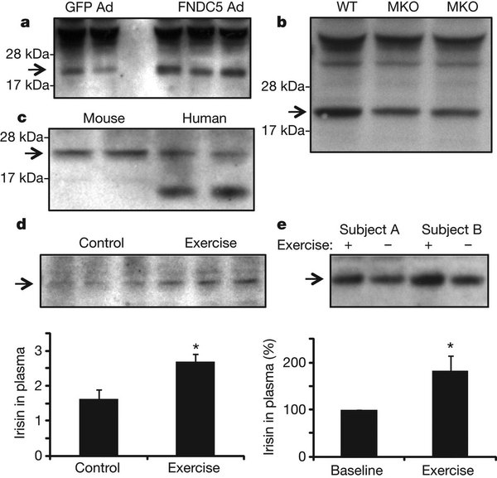
Schematic 1: pattern gang FNDC5 gene in mouse and human cells.

Rate analysis:
On days 12 and 14 after initiation of differentiation of embryonic bodies pulsating tests were counted using phase contrast microscopy. To assess the frequency of the pulse rate per minute was calculated. This experiment was repeated 3 times and the results were presented to the deviation from the mean. Real-Time PCR techniques for the assessment of specific gene expression PEP and cardiac markers were used. To isolate RNA from the RNase Mini Kit Qiagen kits were used. Before use, duplication, to eliminate genomic DNA contamination, RNA samples with DNase I (Fermentas) were treated for 30 min at 37 ° C. The EDTA samples were incubated for 5 min at 60 ° C to inactivate the DNase. MMLV reverse transcriptase enzyme and random Hexamer and 1 mg of RNA sample was used. For Real-Time PCR reaction mixture contained 25 ng of cDNA sample and 10 ml of Rotor-Gene SYBR Green was 30 micromoles of each primer pair. Expression of target genes (Table 1) Glacier aldehyde 3-phosphate dehydrogenase gene expression levels were compared.

Gene name | Variety of cell lines
Rex1,Nanog | Stem Cells
Brachyury | Mesodermal cells
Gata4,Nkx2.5 | Cardiac precursor cells
aMHC | Adult cardiac cells
Table 1: marker genes for each of the cardiac differentiation of various cell lines examined and pattern gang C2C12 gene in mouse and human cells.
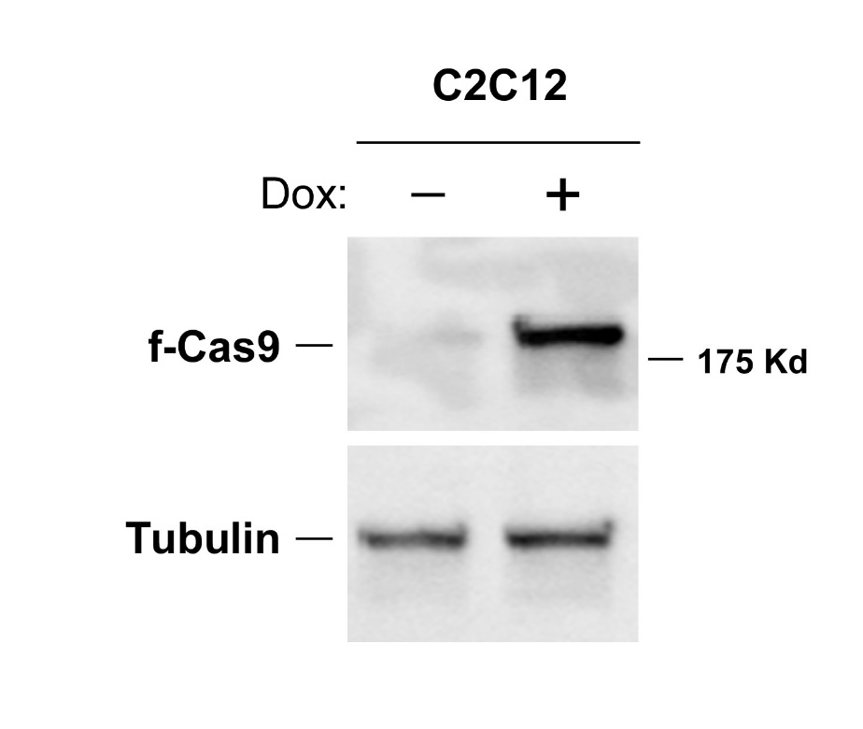
Results
If the text was in the process of cardiac differentiation in mouse embryonic stem cells in 4 stages including mouse embryonic stem cells, embryonic bodies on the second day, the seventh day, cardiomyocytes mature EBs (pulsating bodies) were investigated. The results showed that after 7 days induced by ascorbic acid, effectively cardiomyocytes embryoid bodies differentiated mononuclear weighted with polecat have continued to beat spontaneously scattered colonies, expanded and cardiomyocytes throbbing in several areas 14 created.
Accession No | AT | Reveres Primer(5’-3’) | Forward Primer(5’-3’) | Gene
NM-027402.6 | 60 | CCGATGATATGAG | GACAGTAGAGAA | PEP
NM-008087.4 | 60 | TGAAGTCGCAGG | TGCCGCCTGGAG | GAPDH
NM-009557.1 | 59 | AGCCATCTTCCTCA | CCAGTCCAGAAT | Rex1
NM-028012.8 | 53 | CAATGGATGCTGG | TGAGCTATAAGC | Nanog
Nm-009408.3 | 55 | GGAGAACCAGAA | GCTCATCGGAAC | Brachyury
NM-008700.4 | 4 | AGGGTGGGTGTG | TTAGGAGAAGGG | Nkx5
NM-005404.7 | 62 | TGGGTGTGAAATG | GGAGAAGGGCGA | Gata4
NM-00116417.2 | 59 | CGAACATGTGGTT | CAGAGGAGAAGG | aMHC
Table 2: Primers used for analysis of target gene expression by Real-Time PCR.
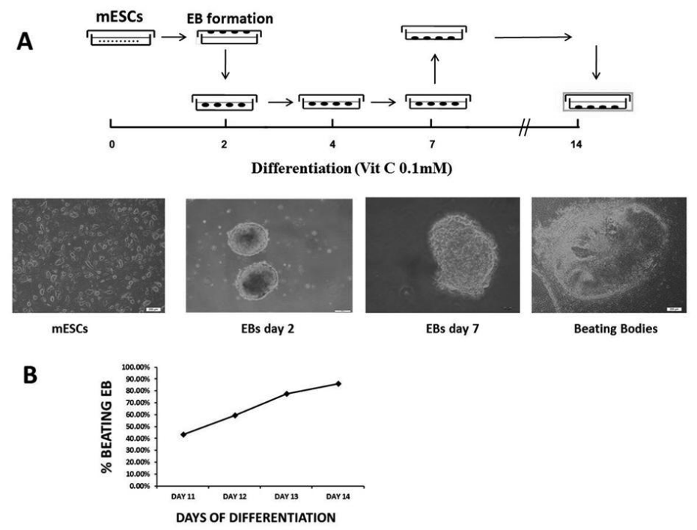
Schematic 2: Stages of cardiac differentiation and cell morphology in 4 stages: stem cells, embryonic bodies, two-day, seven-day-old EBs and beating EBs cardiomyocytes mature and Analysis: Number of beating embryoid bodies from the eleventh to the fourteenth day is displayed.

In this study, about 80% of EBs differentiated into cardiomyocytes, which was confirmed by counting the number of objects in the beating.

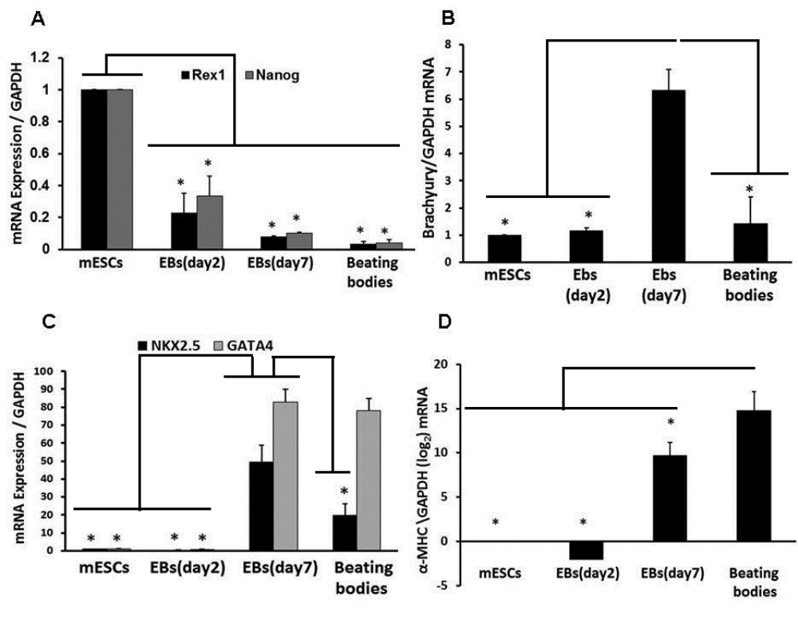
Schematic 3: The pattern of gene expression during the differentiation into cardiac cells. Rex1 expression analysis and Nango (stem cell marker genes), Brachioury (mesodermal cell marker gene), Nkx2.5 and Gata4 (genetic marker for heart precursor cells) and MHC (adult cardiac cell marker gene).

Discussion

Research studies show that followed the stem cells of mouse retinoic acid induced neural cells, the gene expression pattern shows an increase. It was found that the expression of cardiomyocyte clearly increases. Due to the accumulation of EBs and the importance of ascorbic acid and ascorbic acid concentration in the study of gene expression in EBs PEP cases that require further investigation.

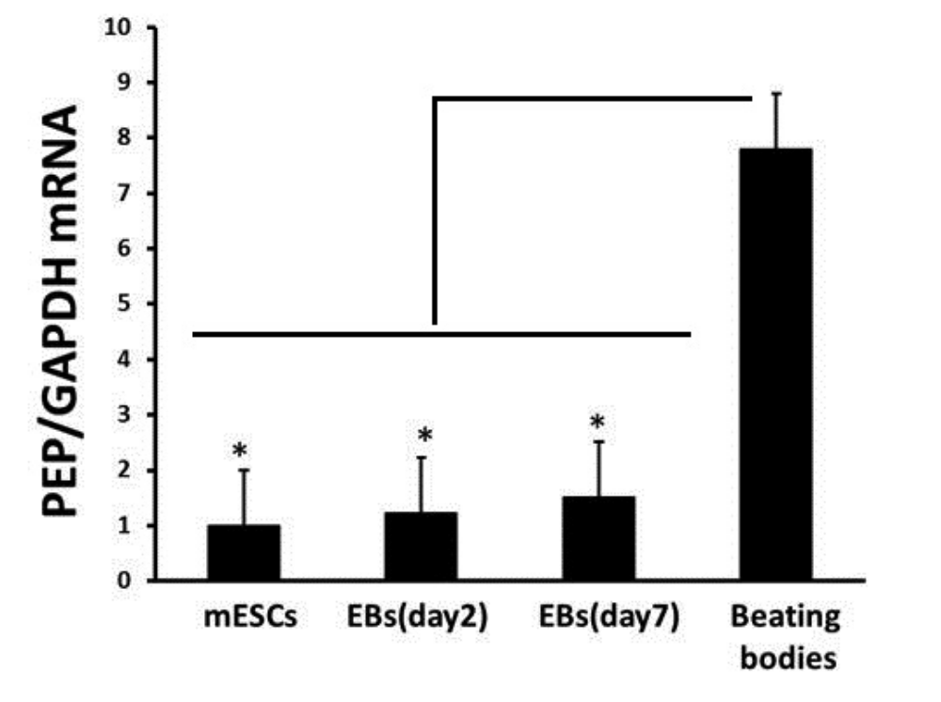
Schematic 4: PEP gene expression pattern during the process of differentiation into cardiac cells.
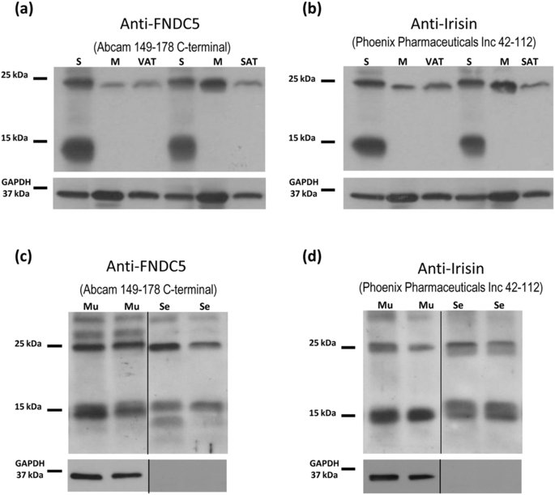

Schematic 5: pattern gang anti-FNDC5 and anti-irisi gene in mouse and human cells.

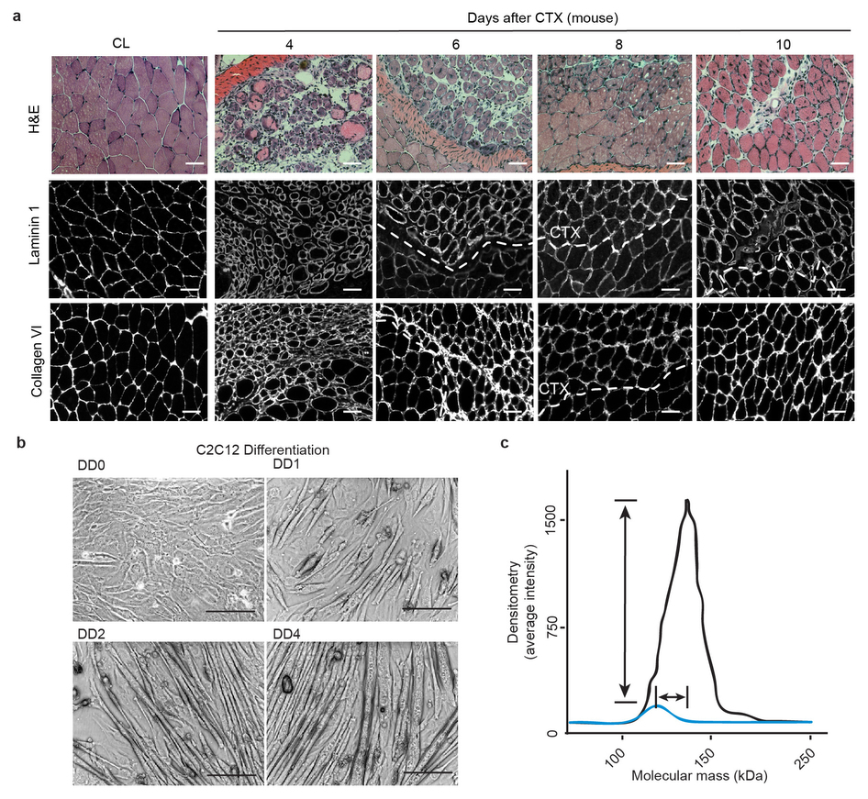

Schematic 6: The pattern of gene gang C2C12 mouse cells.

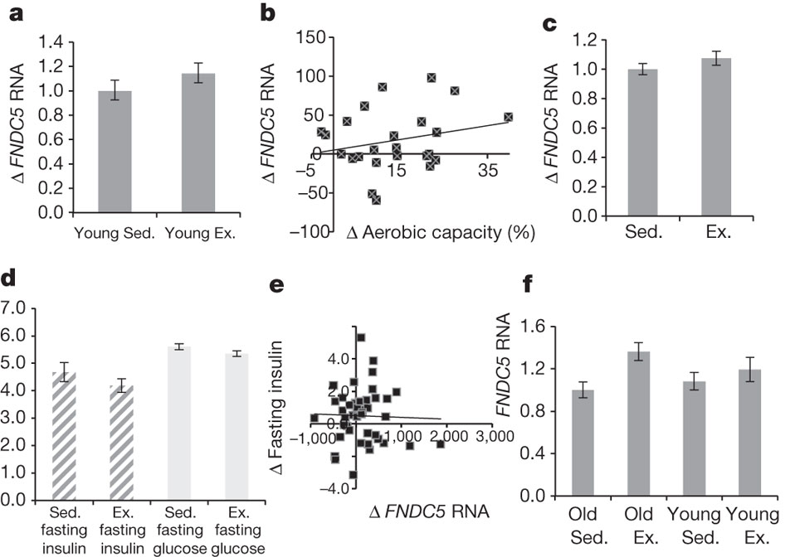
Schematic 7: a comparative diagram FNDC5 RNA in cells from young and old mice.

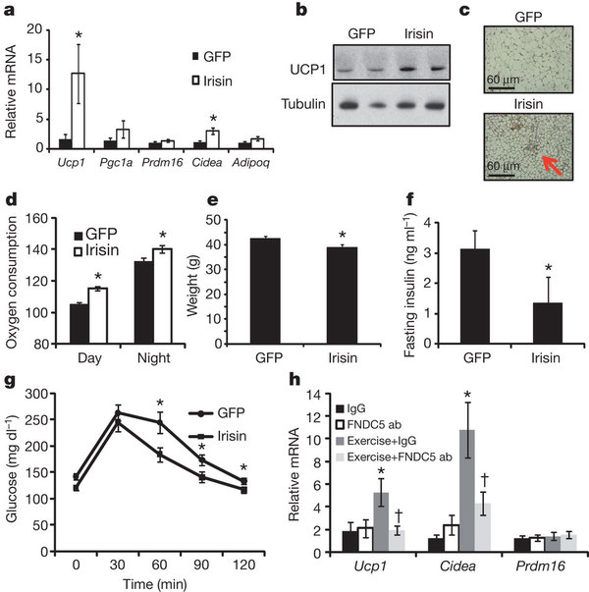
Schematic 8: diagram comparing and IRISIN FNDC5 RNA in mouse cells by oxygen uptake during the day and night.

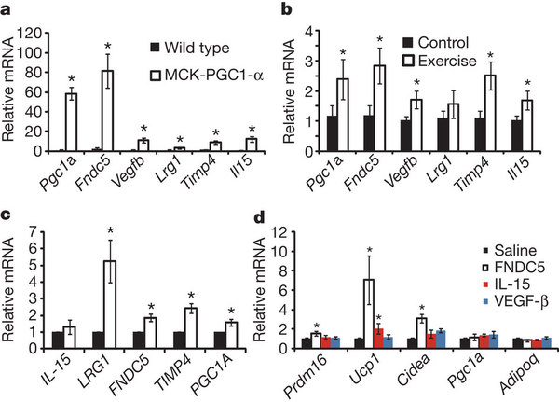
Schematic 9: diagram comparing and PGC1A FNDC5 RNA in the cells of mice created by genetic mutation and control mouse cells.

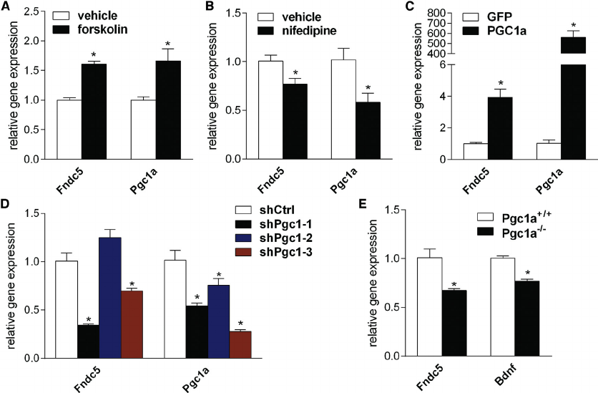
Schematic 10: diagram comparing the genes FNDC5 and PGC1A in mouse cells by the expression and activity in drug response.

References;
- Wolfgang Kühnel (1 January 2003). Color atlas of cytology, histology, and microscopic anatomy. Thieme. pp. 172–. ISBN 978-3-13-562404-4. Retrieved 18 April 2010.
- Julian Seifter; Austin Ratner; David Sloane (1 October 2005). Concepts in medical physiology. Lippincott Williams & Wilkins. pp. 201–. ISBN 978-0-7817-4489-8. Retrieved 18 April 2010.
- Severs, Nicholas. "The Cardiac Muscle Cell". Retrieved 2012.
- Sampayo-Reyes A, Narro-Juárez A, Saíd-Fernández S, et al. (2006). "Effect of clofibric acid on desmin and vimentin contents in rat cardiomyocytes". Int. J. Toxicol. 25 (5): 403–8. doi:10.1080/10915810600846989. PMID 16940012.
- Anatomy and Physiology of the Heart". Retrieved 2012.
- American Heart Association: How the Heart Works". Retrieved 2012.
- Klabunde, Richard. "Cardiovascular Physiology= Cardiac muscle Concept". Retrieved 2012.
- Bergmann, O.; Bhardwaj, R. D., Bernard, S., Zdunek, S., Barnabe-Heider, F., Walsh, S., Zupicich, J., Alkass, K., Buchholz, B. A., Druid, H., Jovinge, S., Frisen, J. (3 April 2009). "Evidence for cardiomyocyte renewal in humans". Science 324 (5923): 98–102. doi:10.1126/science.1164680. PMC 2991140. PMID 19342590.
- Göktepe, S; Abilez, OJ, Parker, KK, Kuhl, E (2010-08-07). "A multiscale model for eccentric and concentric cardiac growth through sarcomerogenesis". Journal of Theoretical Biology 265 (3): 433–42. doi:10.1016/j.jtbi.2010.04.023. PMID 20447409.
- Trapani S, Linss J, Goldenberg S, Fischer H, Craievich AF, Oliva G (November 2001). "Crystal structure of the dimeric phosphoenolpyruvate carboxykinase (PEPCK) from Trypanosoma cruzi at 2 A resolution". Journal of Molecular Biology 313 (5): 1059–72. doi:10.1006/jmbi.2001.5093. PMID 11700062.
- Chakravarty K, Cassuto H, Reshef L, Hanson RW (2005). "Factors that control the tissue-specific transcription of the gene for phosphoenolpyruvate carboxykinase-C". Critical reviews in biochemistry and molecular biology 40 (3): 129–54. doi:10.1080/10409230590935479. PMID 15917397.
- Christopher JT, Holtum JAM (1996). "Patterns of carbon partitioning in leaves of Crassulacean acid metabolism species during deacidification". Plant Physiol. 112 (1): 393–399. doi:10.1104/pp.112.1.393. PMC 157961. PMID 12226397.
- Voznesenskaya E.V., Franceschi V.R., Chuong S.D., Edwards G.E. (2006). "Functional characterization of phosphoenolpyruvate carboxykinase-type C4 leaf anatomy: immuno-cytochemical and ultrastructural analyses". Annals of Botany 98 (1): 77–91. doi:10.1093/aob/mcl096.
- Chen ZH, Walker RP, Técsi LI, Lea PJ, Leegood RC (May 2004). "Phosphoenolpyruvate carboxykinase in cucumber plants is increased both by ammonium and by acidification, and is present in the phloem". Planta 219 (1): 48–58. doi:10.1007/s00425-004-1220-y. PMID 14991407.
- Esterbauer H, Oberkofler H, Krempler F, Patsch W (Feb 2000). "Human peroxisome proliferator activated receptor gamma coactivator 1 (PPARGC1) gene: cDNA sequence, genomic organization, chromosomal localization, and tissue expression". Genomics 62 (1): 98–102.
- Pollard KS, Salama SR, Lambert N, Lambot MA, Coppens S, Pedersen JS, Katzman S, King B, Onodera C, Siepel A, Kern AD, Dehay C, Igel H, Ares M, Vanderhaeghen P, Haussler D (September 2006). "An RNA gene expressed during cortical development evolved rapidly in humans". Nature 443 (7108): 167–72.
- Liang H, Ward WF (December 2006). "PGC-1alpha: a key regulator of energy metabolism". Adv Physiol Educ 30 (4): 145–51.
- Summermatter S, Thurnheer R, Santos G, Mosca B, Baum O, Treves S, Hoppeler H, Zorzato F, Handschin C (January 2012). "Remodeling of calcium handling in skeletal muscle through PGC-1α: impact on force, fatigability, and fiber type". Am. J. Physiol., Cell Physiol. 302 (1): C88–99.
- Valero T (2014). "Mitochondrial biogenesis: pharmacological approaches". Curr. Pharm. Des. 20 (35): 5507–9. PMID 24606795. Mitochondrial biogenesis is therefore defined as the process via which cells increase their individual mitochondrial mass [3]. ... This work reviews different strategies to enhance mitochondrial bioenergetics in order to ameliorate the neurodegenerative process, with an emphasis on clinical trials reports that indicate their potential. Among them creatine, Coenzyme Q10 and mitochondrial targeted antioxidants/peptides are reported to have the most remarkable effects in clinical trials.
- Zheng B, Liao Z, Locascio JJ, Lesniak KA, Roderick SS, Watt ML, Eklund AC, Zhang-James Y, Kim PD, Hauser MA, Grünblatt E, Moran LB, Mandel SA, Riederer P, Miller RM, Federoff HJ, Wüllner U, Papapetropoulos S, Youdim MB, Cantuti-Castelvetri I, Young AB, Vance JM, Davis RL, Hedreen JC, Adler CH, Beach TG, Graeber MB, Middleton FA, Rochet JC, Scherzer CR (October 2010).

