Galactose-N-acetyl-galactosamine (Gal-GalNAc): A carbohydrate marker for simple mass screening test for cancer
AbulKalam M. Shamsuddin
University of Maryland School of Medicine, and IP-6 Research, Inc. Baltimore, MD, USA

Abstract (300 word limit)
Statement of the Problem: Early detection, hence prevention is our best strategy to combat the global scourge cancer. Current technologies for mass screening are inaccurate and/or prohibitively expensive, hence not readily acceptable by the public. Described is a simple, rapid, inexpensive and accurate method for mass screening of cancers and precancerous of the lung, colon and breast. Methodology & Theoretical Orientation Comparative and correlative studies of the pathology and pathogenesis of colon cancer in animal models and human disease have resulted in conceptualization of ‘field effect’ theory in carcinogenesis, and identification of the marker D-galactose-β [1→3]-N-acetyl-D-galactosamine (Gal-GalNAc) expressed early during carcinogenesis. This assimilated body of knowledge has resulted in development of a simple rectal mucus test for colon cancer screening which is also adapted for screening other epithelial cancers and precancers expressing Gal-GalNAc in the tissues as well as their secretions in the bronchus, nipple fluid, prostate etc. Gal-GalNAc in these secretions is detected by enzymatic oxidation by galactose oxidase (10 minutes) followed by color reaction with Schiff’s basic fuchsin (1 minute). Findings: Studies done worldwide have shown > 90% sensitivity and specificity for colorectal and lung cancers. Conclusion & Significance: The high sensitivity and specificity as well as the cost-effectiveness of this test makes it a great tool in our strategies for early detection, hence control of colon and lung cancers. Similar expression of this marker in cancers of breast, prostate etc. through ‘field effect’ makes it potentially useful for their screening as well. Because of its high accuracy (as opposed to fecal occult blood tests for colon cancer) and cost-effectiveness (compared to mammography and chest X-ray for breast and lung cancers respectively) it would reduce the number of unnecessary colonoscopies, chest X-rays, mammography and other expensive, cumbersome and/or unsafe procedures, thereby decreasing the total national health-care cost.
.

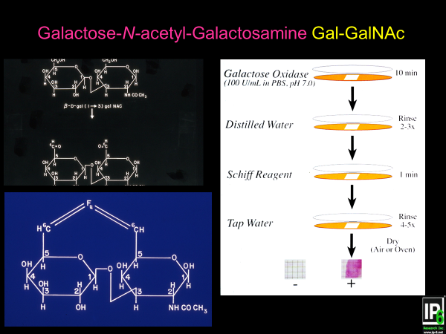

Figure 1: Gal-GalNac is oxidized at C6 positions by galactose oxidase to yield 2 vicinyl aldehydes which is reacted with Schiff’s basic fuchsin to yield magenta color, negative sample is without color (right panel).

Relevant Publications
1.Shamsuddin et al (1995) Common expression of the tumor marker D-galactose-ß-[1→3]-N acetyl-D-galactosamine by different adenocarcinomas: Evidence of field-effect phenomenon. Cancer Research 55: 149-152.
2.Zhou DY (1993) Comparison of Shams' test for rectal mucus to an immunological test for fecal occult blood in large intestinal carcinoma screening. Analysis of a check-up of 6480 asymptomatic subjects. Chin Med J. 106:739-42
3.Li X (1995) [T-antigen test of sputum – a new simple method for the screening of lung cancer] Zhonghua Jie He He Hu Xi Za Zhi 18:285-6
4.Chagpar A et al (2004): Prospective evaluation of a novel approach for the use of quantitative galactose oxidase-Schiff reaction in ductal fluid. Cancer 100:2549-2554.
5. Vucenik I et al (2001) Usefulness of galactose oxidase -Schiff test in rectal mucus for screening of colorectal malignancy. Anticancer Research 21:1247-1255.

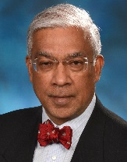
 here
Biography (150 word limit)
AbulKalam M. Shamsuddin is Professor of Pathology at the University of Maryland School of Medicine. He received his medical degree from University of Dhaka. His PhD dissertation on colon carcinogenesis at the University of Maryland led to the development of a simple test for mass screening of cancers of the colon, lungs and breast. He is also the pioneering scientist to show the anti-cancer property of inositol and inositol hexaphosphate (IP₆) - natural constituents of cereals and legumes (www.ip-6.net). He holds several patents on the cancer screening test and IP₆+Inositol, and published numerous peer-reviewed papers, book chapters and books.
Email: Shams@som.umaryland.edu Research@ip-6.net
Notes/Comments:
Keynote speech only.

