The fluctuations in homocysteine level caused by various combinations of folic acid cycle genes SNP alleles as a factor in the course of pregnancy violation
Andrei V. Ivanov
University Hospital of Saint-Petersburg State University, Russia

Abstract
Female reproductive system disorders are the classic example of the multifactorial diseases. One of its violation factors including habitual miscarriage and pre-eclampsia is the of pathological alleles of single nucleotide polymorphisms (SNP) of the folic acid cycle genes presence in the genome. The realizing mechanism for this genetic predisposition is homocysteine level increasing in the blood named hyperhomocysteinemia. However, the lack of direct correlation between the genotype of the four most clinically significant SNPs and the blood homocysteine level detected is in some contradiction with the literature data. This study presenting an attempt to find the relationship between the genotype for the four SNPs of the three folate cycle genes - C677T and A1298C of the MTHFR gene, A2756G of the MTR gene and the A66G of the MTRR gene and the homocysteine level in the blood of women with impaired pregnancy. In total there were 131 patients, European population, reproductive age, residents of the North-West region of Russia.
As a result no direct correlation was found between homocysteine level and folic acid cycle genotype in patients and control group. But it was found a statistically significant interlation between the presence of pathological alleles of the studied SNP and the mean square deviation (σ) of the homocysteine level fluctuations over time. For the polymorphism C677T of the MTHFR gene σ of the homocysteine blood level fluctuation is increased up to four times in women with a homozygous pathological state TT compared with the normal homozygotes CC (Figure 1). The clinical importance of monitoring the homocysteine blood level has been shown especially for women with folate cycle genes pathological alleles presence.that would help this recognition.

Image

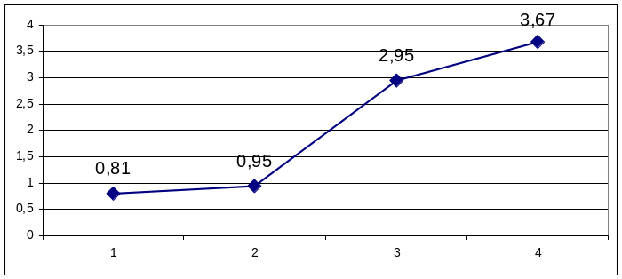
Figure 1. Dependence of the homocysteine level mean square deviation (σ) during the monitoring period (6-15 months) from the genotype of the tested SNP in folic acid cycle genes.
On the abscissa axis: Group No.:
- Normal homozygous in C677T of MTHFR gene (24 persons),
2. Normal homozygous and heterozygous in any of SNP tested (18 persons),
3. Pathologic homozygous in any of SNP tested (25 persons),
- Pathologic homozygous in C677T of MTHFR gene (8 persons).
On the ordinate axis: homocysteine level mean square deviation (σ).


University Hospital of
Saint-Petersburg State University
Biography

Andrei Ivanov is a Head of Department of Human Genetics. PhD in Cell Biology. Specialization in Clinical laboratory diagnostics. One of the most productive research is the influence of genetic part of multifactorial diseases such as female reproductive system disorders, irritable bowel syndrome, metabolic syndrome. Another parts of interest are metabolomics (especially steroid profiling), cell therapy of diabetic foot syndrome, biobanking. Considers his main task to be the introduction of the results of biological research into broad medical practice.
Email: anivanov@omrb.pnpi.spb.ru

