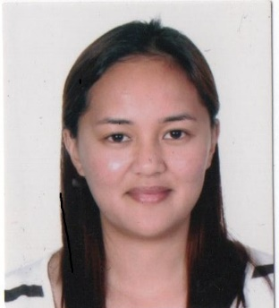

Title: Merkel Cell Carcinoma in an 82-year-old Filipino Male: A Case Report and Literature Review
Name: Hydelene B. Dominguez, MD
SLU-HOSPITAL of the SACRED Heart, Baguio City, Philippines

Merkel cell carcinoma (MCC) is an uncommon, highly aggressive skin malignancy that develops usually in sun-exposed areas, most common on the head and neck area (55%). MCC is mainly a malignancy of UV-exposed and fair-skinned elderly Caucasians. We report the case of an 82-year-old Filipino male who presented with progressive left leg swelling with multiple nodules of varying sizes. The nodules were excised and pathologic diagnosis revealed MCC. The patient underwent chemotherapy however expired due to acute respiratory failure type 1 secondary to acute kidney injury as a complication of tumor lysis syndrome. MCC carries a poor prognosis hence early detection is warranted and vital for patient’s survival.

Biography

Hydelene Dominguez has completed Doctor of Medicine at the age of 24 years old from School of Medicine, Saint Louis University, Baguio City, Philippines. She is presently a third year resident physician of the Department of Internal Medicine at SLU-Hospital of the Sacred Heart, Baguio City, Philippines.

Presenting author details
Full name: Hydelene Beray Dominguez
Contact number: +63-998-5622278
Twitter account: none
Linked In account: none
Session name/ number:
Category: (Oral presentation)

