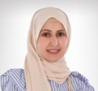
Breastfeeding challenges for mothers in Kuwait
Maryam AlAli BS, Chicc Mama Clinc, Kuwait

Abstract:

Breastfeeding is very important in every single society around the world, it has many health advantages for both mother and baby. It reduces child mortality and has health benefits that extend into adulthood. It also contributes to the health and well being of mothers, reduces breast and ovarian cancer and helps spacing children. Encouraging mothers to breastfeed and supporting them is very important to help them breastfeed for longer periods.

Breastfeeding awareness has recently started in Kuwait, breastfeeding rate in Kuwait and GCC are still low comparing to other societies such as Canada, as a Breastfeeding Specialist that has my own office and very active in social media spreading the awareness and the importance of breastfeeding. I conducted study where recorded 40 participants. The main reason that’s making them to give up is the society itself (family and friends, mainly) not the real breastfeeding challenges! the second reason is the baby attached to them most of the time as many families in Kuwait are dependent on nannies to take care of kids.

Image
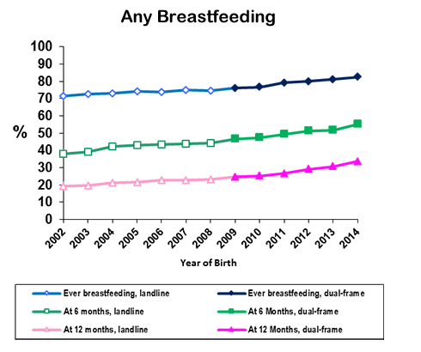
Percent of U.S Children who were Breastfed
Recent Publications:
- AAP Section on Breastfeeding. Breastfeeding and the Use of Human Milk. Pediatrics. 2012;129(3):e827-841. 2011-3552. Accessed November 1, 2017.
- World Health Organization Breastfeeding website. Accessed November 1, 2017.
- Odom EC, Li R, Scanlon KS, Perrine CG, Grummer-Strawn L. Reasons for Earlier than Desired Cessation of Breastfeeding. Pediatrics. 2013;131(3):e726–732. Accessed November 1, 2017.
- Sriraman NK, Kellams A. Breastfeeding: What are the Barriers? Why Women Struggle to Achieve Their Goals. J Womens Health (Larchmt). 2016;25(7):714-22. Accessed November 1, 2017.
- Perrine CG, Galuska DA, Dohack JL, et al. Vital Signs: Improvements in Maternity Care Policies and Practices That Support Breastfeeding — United States, 2007–2013—United States, 2007-2013. MMWR Morb Mortal Wkly Rep. 2015;64(39):1112–1117. Accessed November 1, 2017.

Biography:
Maryam AlAli has completed breastfeeding specialist training 2017; Took lactation educator and counselling training from Texas 2014.
Email: proudkuwaitimom@gmail.com

