Female obesity, alpha lipoic acid supplementation and infertility in women.
Mariam Abdo de Luis, Universidad Isabel I (Spain)
Dr. Gina Llado-Jordan PhD, Universidad Isabel I (Spain)

Abstract (300 word limit)
Introduction: Currently, both obesity and infertility are related to oxidative stress (OE). The increase in free radicals can affect the ovules and the sperm maturation. Alpha Lipoic Acid (ALA) is an indispensable cofactor, which is involved in the Krebs Cycle, in tissue repair and in regeneration processes.
So, can ALA supplementation regulate the metabolic syndrome as an antioxidant in obese people? Can ALA be a benefit for obese and infertile women?
Objectives: the aim of the Project was to evaluate, through works carried out by other authors, the role of obesity and ALA supplementation in female infertility.
Methodology: a literature review was carried out. The study was done from December 2018 to April 2019. The search was carried out in Pubmed database in advanced mode. The MeSH descriptors used were the following: "Female infertility", "obesity", "oxidative stress", "thioctic acid" and "insulin resistance". The Boolean operator used was “AND”. The search strategy and the final selection of studies included in this review, are represented in the following flow chart (Figure 1). The study was done with 21 papers. Due to the variability in the papers’ methodology, it was not possible to carry out a meta-analysis.
Results: several studies (from 2013 to 2018), reveal that overweight and obesity are related with the infertility. As well, EO and ALA supplementation are related too.
Conclusions: For a higher success rate in a future pregnancy, even in those where it is necessary to do fertility treatments; it is necessary to quantify, as a previous step, the woman’s weight and the couple’s oxidative damage. In relation to ALA supplementation, although possible benefits have been found in its use, it would be essential to do new clinical studies with representative samples. Thus the works where better results are collected, are those in which interventions are prolonged over time, highlighting improvements weight loss.
Image
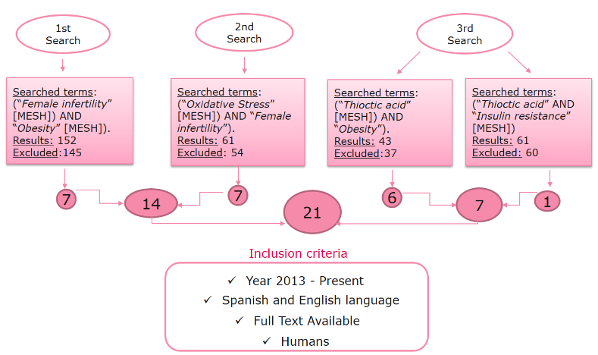

Figure 1: Methodology. From Female obesity, alpha lipoic acid supplementation and infertility in women. TFG, by Abdo et al, 2013.
Recent Publications (minimum 5)
- Kucukgoncu S, Zhou E, Lucas KB, Tek C. Alpha-lipoic acid (ALA) as a supplementation for weight loss: results from a meta-analysis of randomized controlled trials. Obes Rev. 2017;18(5):p.594-601.
- Silvestris E, de Pergola G, Rosania R, Loverro G. Obesity as disruptor of the female fertility. Reprod Biol Endocrinol. 2018;16(1):p. 22.
- Akbari M, Ostadmohammadi V, Lankarani KB, Tabrizi R, Kolahdooz F, Reza Khatibi S, et al. The effects of alpha-lipoic acid supplementation on glucose control and lipid profiles among patients with metabolic diseases: A systematic review and meta-analysis of randomized controlled trials. Metabolism. 2018;87:p. 56-69.
- Namazi N, Larijani B, Azadbakht L. Alpha-lipoic acid supplement in obesity treatment: A systematic review and meta-analysis of clinical trials. Clin Nutr. 2018;37(2):p. 419-28.

Biography (150 word limit)
Mariam Abdo de Luis completed her degree in pharmacy in Universidad Europea de Madrid, Spain and her degree in Nutrition and Dietetics in Universidad Isabel I. She works in the he parmaceutic medicine industry in Spain. She has completed also 1 MBA related to health sciences. Her main line of research is Pharmacy and Nutrition.

Email: gina.llado@ui1.es

