ANTIPROLIFRATIVE ACTIVITY OF ANNONA MURICATA EXTRACT ON TRIPLE NEGATIVE BREAST CANCER CELLS
Heba K. Alshaeri^{1,2}, Moudi M. Alasmari^{1,4}, Zuhair S. Natto³, & Alejandro Pino-Figueroa¹

¹Department of Pharmaceutical Sciences, MCPHS University, Boston, MA, United States
²Department of Pharmaceutical Sciences, Fakeeh College for Medical Sciences, Jeddah, Saudi Arabia.
³Department of Dental Public Health, School of Dentistry, King Abdulaziz University, Jeddah, Saudi Arabia
⁴College of Medicine, King Saud bin Abdulaziz University for health Sciences University, Jeddah, Saudi Arabia.

Statement of the Problem: Triple negative breast cancer (TNBC) cells are a subtype of breast cancer that lack of estrogen receptors (ERs), progesterone receptors (PRs) and human epidermal growth factor receptor 2 (HER2). This type of breast cancer has poor prognosis and accounts for 15–20% of newly diagnosed breast cancer (BC) cases. Annona muricata is a tropical plant and has been used as a folk medicine to treat several diseases such as malaria, inflammation, diabetes and recently it was known to have anticancer activity on various cancer types. However, the underlying molecular mechanisms remain to be explored. Research Question/Hypothesis: We hypothesize that Annona muricata ethyl acetate (AMEA) extract and the isolated compounds will reduce cell proliferation and produce cell death by the induction of apoptosis. Moreover, AMEA or its active ingredients will interfere with the function of EGFR signaling activity in the TNBC cell line. Research Design/Methodology: The effect of AMEA and F4 on the cell viability of BT-20 breast cancer cell line was analyzed by MTS assay. We measured caspase-3/ 7 activity and cytochrome c release as a marker of apoptosis. Also, the protein expression of Bax and Bcl-2 was determined using western blot. To investigate further of AMEA and F4 anti-cancer effect we measured cyclin D1 and EGFR signaling and its downstream proteins AKT, MAPK and NF-κB p65 protein expression by western blot analysis. Results: The AMEA showed significant decrease on BT-20 cell viability. Furthermore, AMEA and F4 produced anti-proliferative effect via inhibiting the EGFR phosphorylation and the phosphorylation of its downstream signaling proteins including AKT and MAPK. These effects were accompanied with down-regulation of cyclin D1 production resulting in cell cycle arrest at G1/S phase. Moreover, this compound decreased significantly NF-κB p65 protein expression in the nuclear fraction, therefore, inhibiting its activation and preventing the induction of cell survival. Our data indicated that neither AMEA nor F4 had significant effect on apoptosis biomarkers when tested on Bcl-2, Bax, cytochrome c and caspase 3/7 activities. Conclusion of the Investigation: These findings provide a scientific basis for the molecular mechanism of action of Annona muricata extract and its active fraction F4 in the treatment of TNBC. It has been demonstrated the anti-proliferative effect via EGFR-mediated signaling pathways which includes AKT/MAPK/NF-κB pathways and cyclin D1 inhibition.

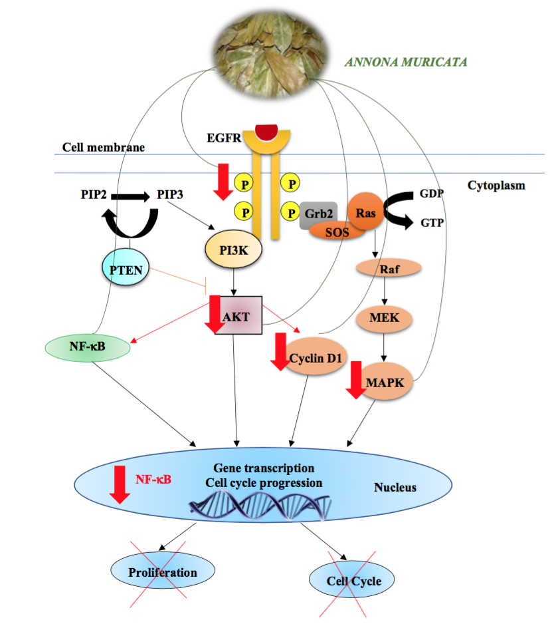A diagram shows the anti- proliferative mechanism of action of A.muricata extract on TNBC.

Recent Publications:

1- Zorofchian Moghadamtousi S, Karimian H, Rouhollahi E, et al. Annona muricata leaves induce G1 cell cycle arrest and apoptosis through mitochondria-mediated pathway in human HCT-116 and HT-29 colon cancer cells. J Ethnopharmacol. 2014;156:277-289.

2- Torres M, Rachagani S, Purohit V, et al. Graviola: a novel promising natural-derived drug that inhibits tumorigenicity and metastasis of pancreatic cancer cells in vitro and in vivo through altering cell metabolism. Cancer Lett. 2012;323(1):29-40.

3- Dai Y, Hogan S, Schmelz E, et al. Selective growth inhibition of human breast cancer cells by graviola fruit extract in vitro and in vivo involving downregulation of EGFR expression. Nutr Cancer. 2011;63(5):795-801.

4- Kim JY, Dao TTP, Song K, et al. Annona muricata Leaf Extract Triggered Intrinsic Apoptotic Pathway to Attenuate Cancerous Features of Triple Negative Breast Cancer MDA-MB-231 Cells. Evid Based Complement Alternat Med. 2018;7972916. Published 2018 Jul 17.

5- Abdul Wahab SM, Jantan I, Haque MA, Arshad L. Exploring the Leaves of Annona muricata L. as a Source of Potential Anti-inflammatory and Anticancer Agents. Front Pharmacol. 2018;9:661. Published 2018 Jun 20.

Biography:
Heba Alshaeri was received a PharmD degree at King Abdulaziz University, Saudi Arabia and a MPH degree at Loma Linda University, USA in 2013. During this time she published two manuscripts and made a number of presentations at scientific meetings. Since 2013 she joined MCPHS university for doctoral program in pharmacology and she completed her PhD degree on May, 2018. She is a member of the American Society for Pharmacology and Experimental Therapeutics and the American Association of Pharmaceutical Scientists. She is a highly motivated scientist who has demonstrated an unquenchable thirst for knowledge in areas related to her research on phytochemicals extracted from botanical sources on triple-negative breast cancer cells. Her ability to develop hypotheses for testing, designing experiments and conducting these, along with analyzing and interpreting the results is remarkable. She operates at the highest ethical level, is open to criticism and works well in a team setting.

Emails: halshaeri@llu.edu

pharmd_heba@yahoo.com

