Breast cancer screening: how can we improve women's information?

P. Rosado Varela¹, JM Baena Cañada¹, A. Quílez Cutillas¹, M. González-Guerrero¹, E. Benítez-Rodríguez².
¹Medical Oncology Service, Puerta del Mar University Hospital, Cádiz, Spain.
²Population Cancer Registry, Provincial Office of Health, Cádiz, Spain.

Abstract (300 word limit)
BACKGROUND: Women usually accept the invitation to participate in breast cancer screening but they tends to overestimate the benefit of screening programs or doesn´t have an idea of their risk / benefit balance, possibly because most people have little experience in quantifying absolute risk reduction associated with any medical intervention. Under ideal conditions, primary care physician, public health service documentation and and other information resources should be helpful tools to quantify the benefits of this type of intervention.
METHODS: A randomized controlled clinical trial of 434 women aged between 45 and 69 years was conducted in a Mammography Screening Program Centre in a local Health District in Cádiz (Spain). Women were asked if they had consulted the following sources of information and how often they had done so: friends and family, experts (primary care physician, pharmacist), the media (television, radio, press), healthcare services or institutions (Andalusian Health Service, Ministry of Health, insurance companies, consumer and self-help association, pamphlets and information), books and online healthcare and medical websites.

RESULTS: Almost none of the participants in the study has received information about the mammographic screening program for breast cancer from their pharmacist, insurance companies or consumer associations. Family and friends, television, press and SAS documentation are the main sources of information.


Image
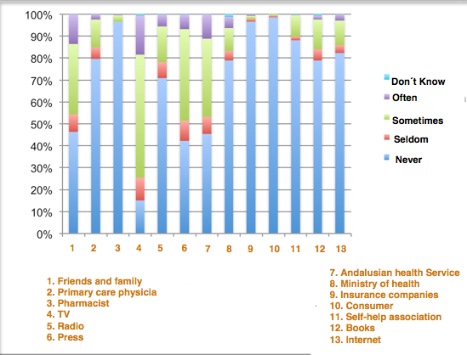

Figure 1: Information sources
Recent Publications (minimum 5) (If not leave as blank)
- Queiro Verdes T, Cerdá Mota T, España Fernández S. Información a usuarias sobre el cribado de cáncer en la mujer: Evaluación de la situación actual y establecimiento de estándares de información basada en la evidencia: Información a usuarias sobre el cribado de cáncer de mama. Plan de Calidad para el Sistema Nacional de Salud del Ministerio de Sanidad y Política Social. Axencia de Avaliación de Tecnoloxías Sanitarias de Galicia; 2007. Informes de Evaluación de Tecnologías Sanitarias: avalia-t Nº. 2007/05-1
- Geller BM, Zapka J, Hofvind SS, Scharpantgen A, Giordano L, et al. Communicating with women about mammography. J Cancer Educ 2007; 22:25-31.
- Moulton B, Collins PA, Burns-Cox N, Coulter A. From informed consent to informed request: do we need a new gold standard?. J R Soc Med 2013; 106:391-394.
4. GfK-Nürnberg e.V., Frank R. Health in Europe. European Consumer Study 2007 [in German]. Nuremberg, Germany: GfK-Nürnberg; 2007.
5. Gigerenzer G, Mata J, Frank R. Public Knowledge of Benefits of Breast and Prostate Cancer Screening in Europe. J Natl Cancer Inst 2009; 101:1216-1220.

Biography (150 word limit): During my training as an oncologist I have developed a doctorate on the perception of women in the mammographic cancer screening program. The results of the research show that their level of knowledge is low and that most participants do not make a true informed decision about their participation in the test. Currently I continue working in the same line of research from the perspective of qualitative research.

Full Name: Petra Rosado Varela
Email: petra.rosado.sspa@juntadeandalucia.es
Category: e-Poster:

