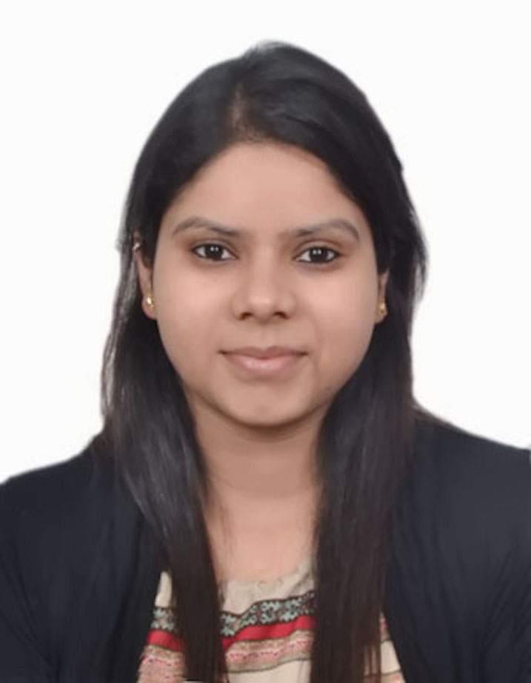

TITLE: To compare the efficacy of intramyometrial vasopressin plus rectal misoprostol with intramyometrial vasopressin alone to decrease blood loss during laparoscopic myomectomy: A Randomised Clinical Trial

Sonal Srivastava
All India Institute of Medical Sciences, New Delhi, India

Uterine leiomyomas are the most common benign tumors of the uterus in women of reproductive age group, with a cumulative incidence of 70%.
Myomectomy is the gold standard surgical treatment for symptomatic women wishing to retain their fertility. A major problem that myomectomy poses is excessive blood loss from the increased uterine vasculature. A number of pharmacological interventions have been used to decrease the blood loss during myomectomy, with signiﬁcant reductions seen in misoprostol, vasopressin, bupivacaine plus epinephrine and tranexamic acid treated patients. In India, no studies have been conducted to compare the efficacy of different combination regimens to control hemorrhage during laparoscopic myomectomy. Thus, we proposed to investigate in our trial, the efficacy of a single preoperative dose of per-rectal misoprostol along with intramyometrial vasopressin over intramyometrial vasopressin alone.
It was a prospective, randomized, controlled clinical trial conducted at the department of Obstetrics and Gynaecology, AIIMS, New Delhi from January 2014 to June 2016.
Thirty women received 600µg rectal misoprostol 30 minutes pre-surgery followed by intramyometrial vasopressin intraoperatively (group I) and thirty women received intramyometrial vasopressin alone (group II).
The mean blood loss in group I was significantly less than in group II (139.0 ml vs 206.0 ml). The mean drop in haemoglobin in the misoprostol group was also significantly less than the control group (0.6 gm% vs 1.8 gm%). The detailed result will be discussed at the conference.

Bibliography
Dr Sonal Srivastava Garg completed her MBBS in 2011 from Government Medical College and Hospital, Chandigarh. She did her MD in Obstetrics and Gynaecology from the prestigious All India Institute of Medical Sciences (AIIMS), New Delhi and finished in 2016. She also holds a degree of Diplomate of National Board (DNB) in the same field. She is currently pursuing a fellowship in gynaecological oncology from the renowned Gujarat Cancer Research Institute in Ahmedabad and has avid interest in academics and as well as research projects.

Presenting author details
Full name: Dr Sonal Srivastava Garg
Contact number: +91-9968722166
Twitter account: --
Linked In account: --
Session name/ number:
Category: (Oral presentation/ Poster presentation): Oral presentation

