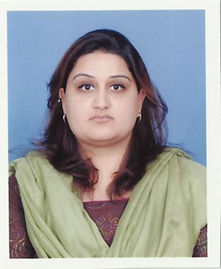
Depression, Resilience and Body Image Among Young Unmarried and Married Women with Breast Cancer

Dr. Rabia Iftikhar & Rabail Zahid
Clinical Psychology Unit
Department of Psychology
Government College University, Lahore.
The aim of the present study was to find out and compare the levels of depression, resilience and body image in married and unmarried breast cancer patients. A sample of 60 breast cancer patients was recruited; 30 of which were married and 30 were unmarried. Three questionnaires were administered on them, namely the Siddiqui Shah depression Scale (Siddiqui& Shah, 1992), the Indigenous Resilience Scale (Mahmood & Naz, 2008) and the Body Image and Relationships Scale (Hormes et. al., 2008). Results of the study revealed that unmarried women were more depressed than married women and married women were more resilient as compared to unmarried women. No difference was found in the body image of both the groups. It was concluded that unmarried breast cancer patients are more vulnerable and more in need of immediate psychological intervention as compared to married patients. The results of the present study will help the practitioners identify which patients are more likely to be suffering from depression as a result of their illness and the factors that help them deal with it better; such as social support. It will also determine the direction of pre and post counseling services that should be given for the patient’s psychological well-being.
Biography
Dr. Rabia Iftikhar has completed her PhD from Government College University Lahore, Pakistan. She is a Consultant Clinical Psychologist and Practitioner. She has published several papers on different mental health issue in reputed journals. She has worked with many NGO’s dealing with women issues in Pakistan.

Presenting author details
Full name: Dr. Rabia Iftikhar
Contact number: 092 323 4004540
Linked In account: rubail1983
Session name/ number:
Category: Oral presentation

