Reproductive and Sexual Health: Empowerment of the Community Good Life Promoters in the uptake of Long Acting Reversible Contraceptive services among rural women
Kenneth Kahiigwa Ruyonga, BA (Social Sciences), Uganda

Abstract (300 word limit)
Statement of the Problem: Unmet need remains highest among women throughout Uganda, and highest mainly among rural women. Rural women have an average of 7.1 children in contrast to an urban average of 4.4 children, and are far less likely to use modern contraception (37% as compared to 15%). Women in poorer households have on average almost twice the number of children than those women in higher wealth quintiles (8 as compared to 4.3). 86% of women state that they have at least one serious problem in accessing health care including a lack of money for treatment (65%) and distance to service points (55%). 36% of the rural women share their fear of side effects as a reason for not using modern contraceptives resulting to low perception towards modern family planning methods.
Methodology & Theoretical Orientation: Community based Good Life promoters (GLPs) was identified and trained on the modern family planning method and in the counseling of side effects. Overtime, the community dialogues sessions were held within the villages to create demand and change the perception of the women on modern family planning. The GLPs were equipped with counseling charts, and talking points. Gradually, more women were referred to the private clinic for services using the referral slips. This referral aided more engagement of the women with the service provider at the clinic and this increased the number of users of the modern family planning methods. The quality of counseling sessions provided by the GLPs and health workers had an influence in the perception of the rural women towards modern family planning methods which stems from the behavioral change theory of perceived barriers and benefit (Abdelaziz, 2014).
Findings: The number of women referred to the clinic and received services increased from 20% (period Jan- June 2017) to 45% (July-Dec 2017). More new users of modern family planning were received at the clinic based on the referrals provided by the GLPs.
Conclusion & Significance: Perception of rural women towards family planning can only be influenced by quality counseling sessions, and the presence of individuals who can console and help them make informed decision when faced with any method challenges.
Recommendations: More training of community Good Life promoters to increase access to information and address possible challenges associated with the use of modern family planning methods.

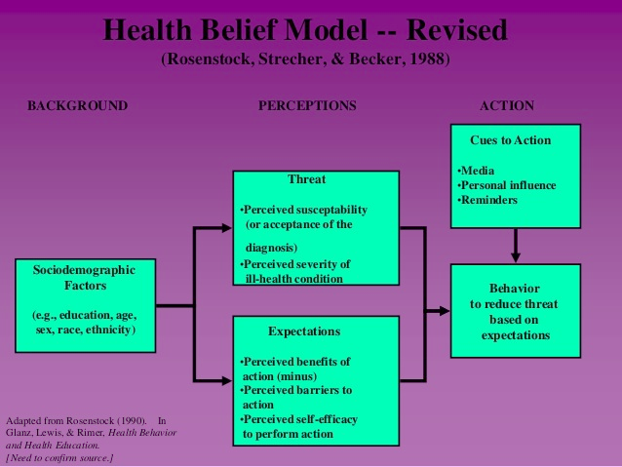
Recent Publications
- Shelley Megquier (2014) Reproductive Transitions: Unmet Need for Family Planning. Retrieved from http://www.prb.org/pdf14/uganda-unmet-need-contraception.pdf
- Dr. Abdelaziz M. Elfaki, Theories of Behavioral Change (2014) Retrieved from: https://www.slideshare.net/UDDent/theories-of-behaviour-change


Biography

Kenneth Kahiigwa Ruyonga is a social behavioral change communication officer employed by Uganda Health Marketing Group under the USAID/Uganda Social Marketing Activity project that works with community structures to address the hindrances to the uptake of modern family planning among the rural poor communities. Uganda Health Marketing Group one of the leading social marketing organizations in Uganda, has a vision to deliver quality and affordable health products and services to Ugandans through the social marketing franchises. As an expert in communication, Kenneth has discovered that the more the rural women have access to information the higher their chances of utilizing the services and this can only be strengthened through the continuous community engagements through dialogues.
Full Name: Kenneth Kahiigwa Ruyonga
Email: kruyonga@uhmg.org
Contact no: +256 789 035 507
LinkedIn account:
Twitter account:
Session name/ number:
Category: Poster
Date of Birth: 28th October 1978

