Cesarean Scar Pregnancy: “A Rarity No More?”
A Report of 2 Cases.
Dr.D.A.Reyes, FEUNRMF, Philippines

ABSTRACT

Cesarean scar pregnancy is the rarest form of ectopic pregnancy. In the Philippines, little is known about its incidence and occurrence. However, increasing rates worldwide is now being documented and is closely being related to the increasing cesarean section rates. This paper reports two cases of cesarean scar pregnancy who both presented with vaginal bleeding. The first case is a Gravida 6 Para 5 (5005), while the second case is a Gravida 3 Para 2 (2002), who were diagnosed early by ultrasonography but managed differently. The first case was managed by hysterectomy, on the other hand, the second case was managed conservatively by laparoscopic excision of the cesarean scar pregnancy. Close follow up with serial beta-hCG monitoring was done for the second case until normalization of its level. This paper intends to raise awareness of the increasing incidence of cesarean scar pregnancy, its pathophysiology, different options in the diagnosis and management. Recommendations were made to decrease the incidence of cesarean section, thereby, lowering the occurrence of cesarean scar pregnancy.
The incidence of cesarean scar pregnancy has increased due to early and accurate diagnosis by ultrasonography. Several factors would tend to affect its management, identifying these factors would tailor fit the management according to the needs of the patient.

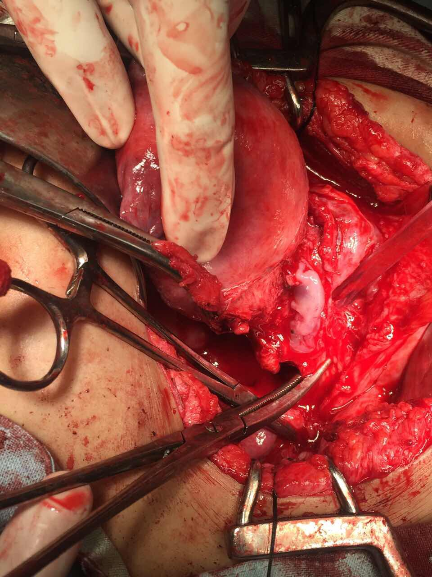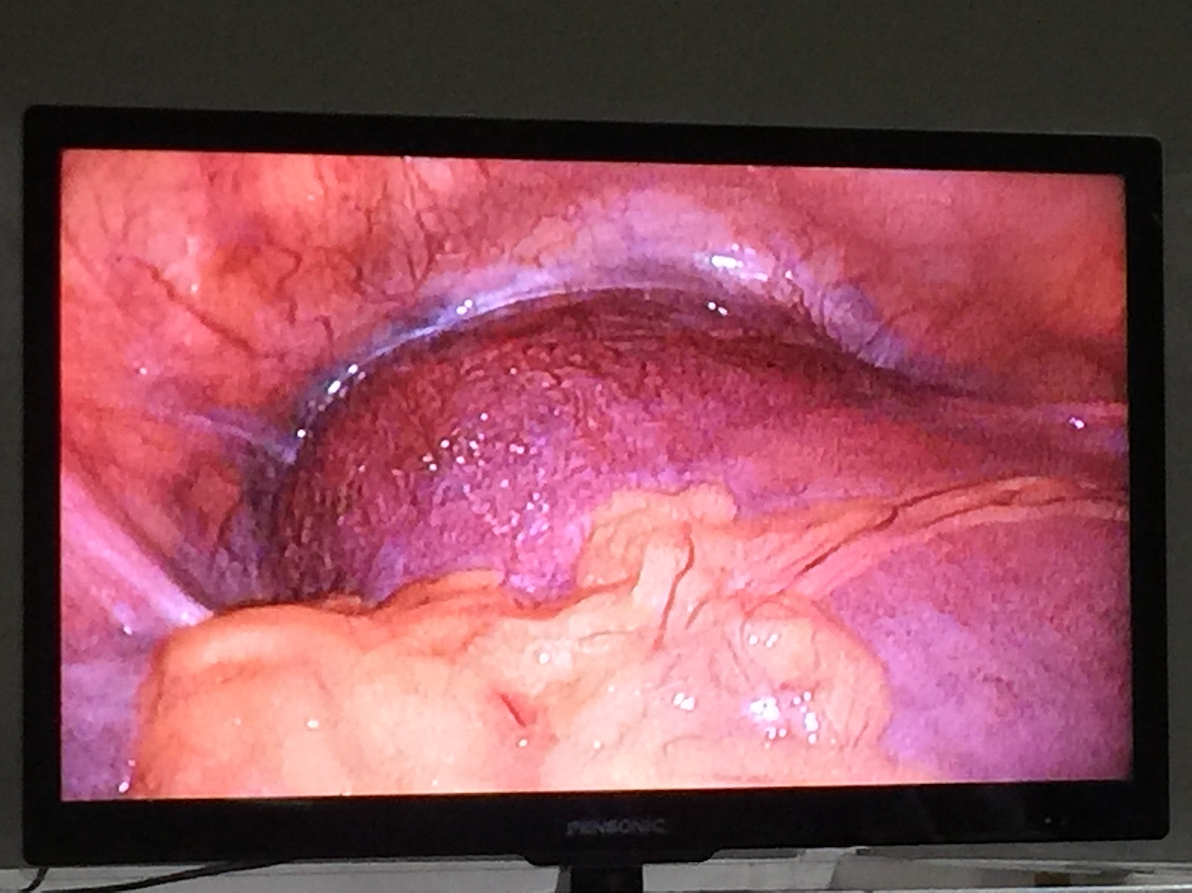

Figure 3.1

A highly vascular mass at the serosal surface was noted approximately measuring 3.0 x 2.0 x 6.0 cm.
Conceptus noted to be implanted anterior to the myometrium, with a thin membrane separating from the urinary bladder.

 Biography
Dr. Denise Elaine A. Reyes received the Doctor of Medicine degree in Far Eastern University- Dr. Nicanor Reyes Medical Foundation, Philippines. She graduated with the honor of cum laude and is currently having her Obstetrics and Gynecology residency training on the same institute. She is a strong advocate of women’s health and aims to help achieve the World Health Organization’s fifth millenium developmental goal which is to improve maternal health.
Email: deniseahyongreyesmd@yahoo.com

