Impact of Action II Petite Lady Laser Machine in the Treatment of Urinary Incontinence and Sexual Dysfunction Female
Dr. Najwa alfarra , Dr. Waleed altaweel

Abstract
1. Introduction
Urinary incontinence & sexual Dysfunction is very common among female. It causes social or hygienic problem. Urinary incontinence is the uncontrolled leakage of urine. This condition affects about a third of the female population and is more common in women than in men (Gaspar, Addamo & Brandi, 2011). The Petite Lady treatment is a non-invasive way that is aimed at awakening a woman’s sensuality by tightening up their vaginal canal. Moreover, the method reduces urinary incontinence problem. A lot of people view it as an alternative to the traditional surgical methods that are seen to have side effects. Since there are variations in the impact of the treatment methods, the area needs a lot of research.
2. Objective
The objective of the study was to evaluate the impact of the Action II lady laser machine in the treatment of sexual dysfunction and urinary incontinence in females.
3. Methods:
Will assist 30 women, aged 25-55 years old with sexual dysfunction in stress incontinence confirmed by patient history and urodynamic study. We will evaluate the impact of Action 11 Petite Lady Laser Machine in the treatment of urinary incontinence and female sexual dysfunction confirmed by using the Female Sexual Function Index (FSFI) Arabic validate version by (Anis , et al. 2011), measuring vaginal muscle power by using PFX2, and bladder diary. These questions were answered by the patient before we commenced the treatment and after 10 weeks of completing the treatment. The muscle power were measured before and after the treatment, it was conducting at the physical therapy department. Furthermore, the survey included a participant information sheet outlining the nature of the study. The study took a place at King Faisal Specialist Hospital and research center.
Main Outcome Measures:
In the voiding diary the women reported that the urinary frequency, episodes of urgency and urine leakage during sneezing, coughing, and laughing dramatically improved by 85%. The domain scores of the FSFI, including desire, arousal, lubrication, orgasm, satisfaction, and pain, were calculated and showed huge improvement in mean score increased by more than 3 points at all subjects after completed the treatment by 90%. The muscle power of the pelvic floor improved in all cases the mean of muscle power before the treatment was 2/5 after the treatment became 3+-4/5. The treatment protocol was 4 sessions at 2 weekly intervals for the first three sessions, then one month interval between the third and fourth session, with 2940nm Er: YAG via 90 degree scanning scope.
Results:
All the subjects successfully completed the study with no adverse events. Significant improvement in vaginal wall relaxation was seen in all subjects at 2 months and half post treatment based on the PFX2values, on the partners input for vaginal tightening 83%, for sexual satisfaction as assessed by the subjects themselves (90%) and bladder diary showed decrease in leakage during coughing, sneezing and laughing by 85% see figure 1. The preliminary results confirm that laser treatment is an effective, safe and comfortable treatment option for symptoms relief in patients with SUI and sexual dysfunction.
Figure1: showed the difference at coughing, sneezing, laughing, SD, Urge, and Pad before and after the treatment.
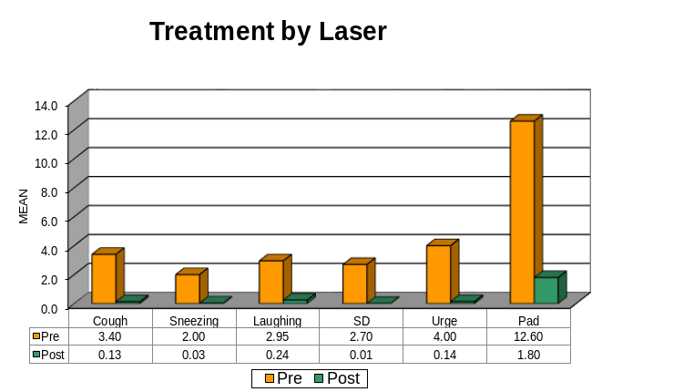
Key Words: Er: YAG laser, non-ablative laser treatment, collagen remodelling, stress incontinence. Female sexual dysfunction.

