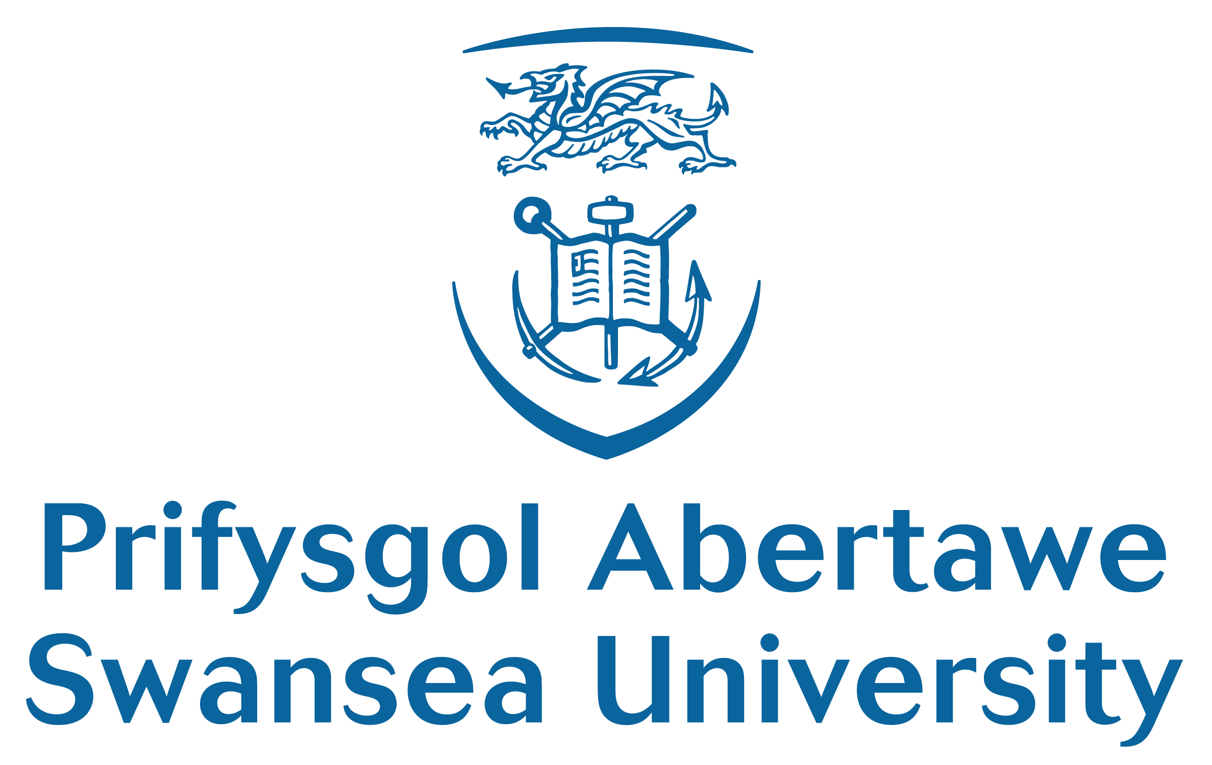

Development and feasibility test of a novel evidence-based and theory-based co-designed intervention to support Saudi women with breast cancer

Alaa Alanazi

College of Human and Health Sciences, Swansea University, UK

Introduction

Breast cancer is the most commonly diagnosed cancer in Saudi women. The cancer and treatment can produce many different psychosocial issues and physical symptoms. Different studies reported a low overall quality of life among Saudi women with breast cancer. There is evidence that self-management support (SMS) interventions delivered by nurses have the potential to help reduce these symptoms and enhance the quality of life. In Saudi Arabia, the provision of SMS is unknown and therefore, this study aims to develop and test the feasibility of an intervention to support Saudi women with breast cancer.

Methodology

This study is guided by Medical Research Council (MRC) framework for developing and evaluating complex interventions which involve a systematic multistage process. Stage one involved an evidence synthesis by conducting a systematic literature review and qualitative in-depth interviews using a purposive sampling with 23 Saudi women newly diagnosed with breast cancer in three hospitals to understand their needs and concerns. Ethical approval and consents were taken and the theoretical saturation of data were achieved. The digitally-recorded data and field notes were transcribed, organized using MAXQDA software and analysed using a thematic analysis. Stage two included developing a self-management programme by applying a theory and evidence to identify effective components to support patients alongside consultations with health care professionals and patients. Stage three will include a training workshop for nurses to ensure fidelity who will implement intervention on patients using a pre- and post-intervention study to evaluate its feasibility, acceptability, and potential impact using mixed method.

Result:

The literature and qualitative study showed that those women have physical, psychosocial, practical, and informational needs. The theory of social learning and self-confidence developed by Bandura has been applied and the literature shows that components such as: group-based intervention, education, goal setting, action plans, and navigating health system and resources are effective to support patients successfully. The rest of stages will be conducted soon.

Conclusion:

Saudi women with breast cancer experience challenges to manage disease and treatment-related symptoms. It is anticipated that delivering self-management intervention will help to enhance quality of life.

Biography

Alaa is a PhD student at the College of Human and Health Sciences in Swansea University, UK. She is working as a lecturer in the department of Medical Surgical Nursing in Princess Nourah University in Saudi Arabia.

