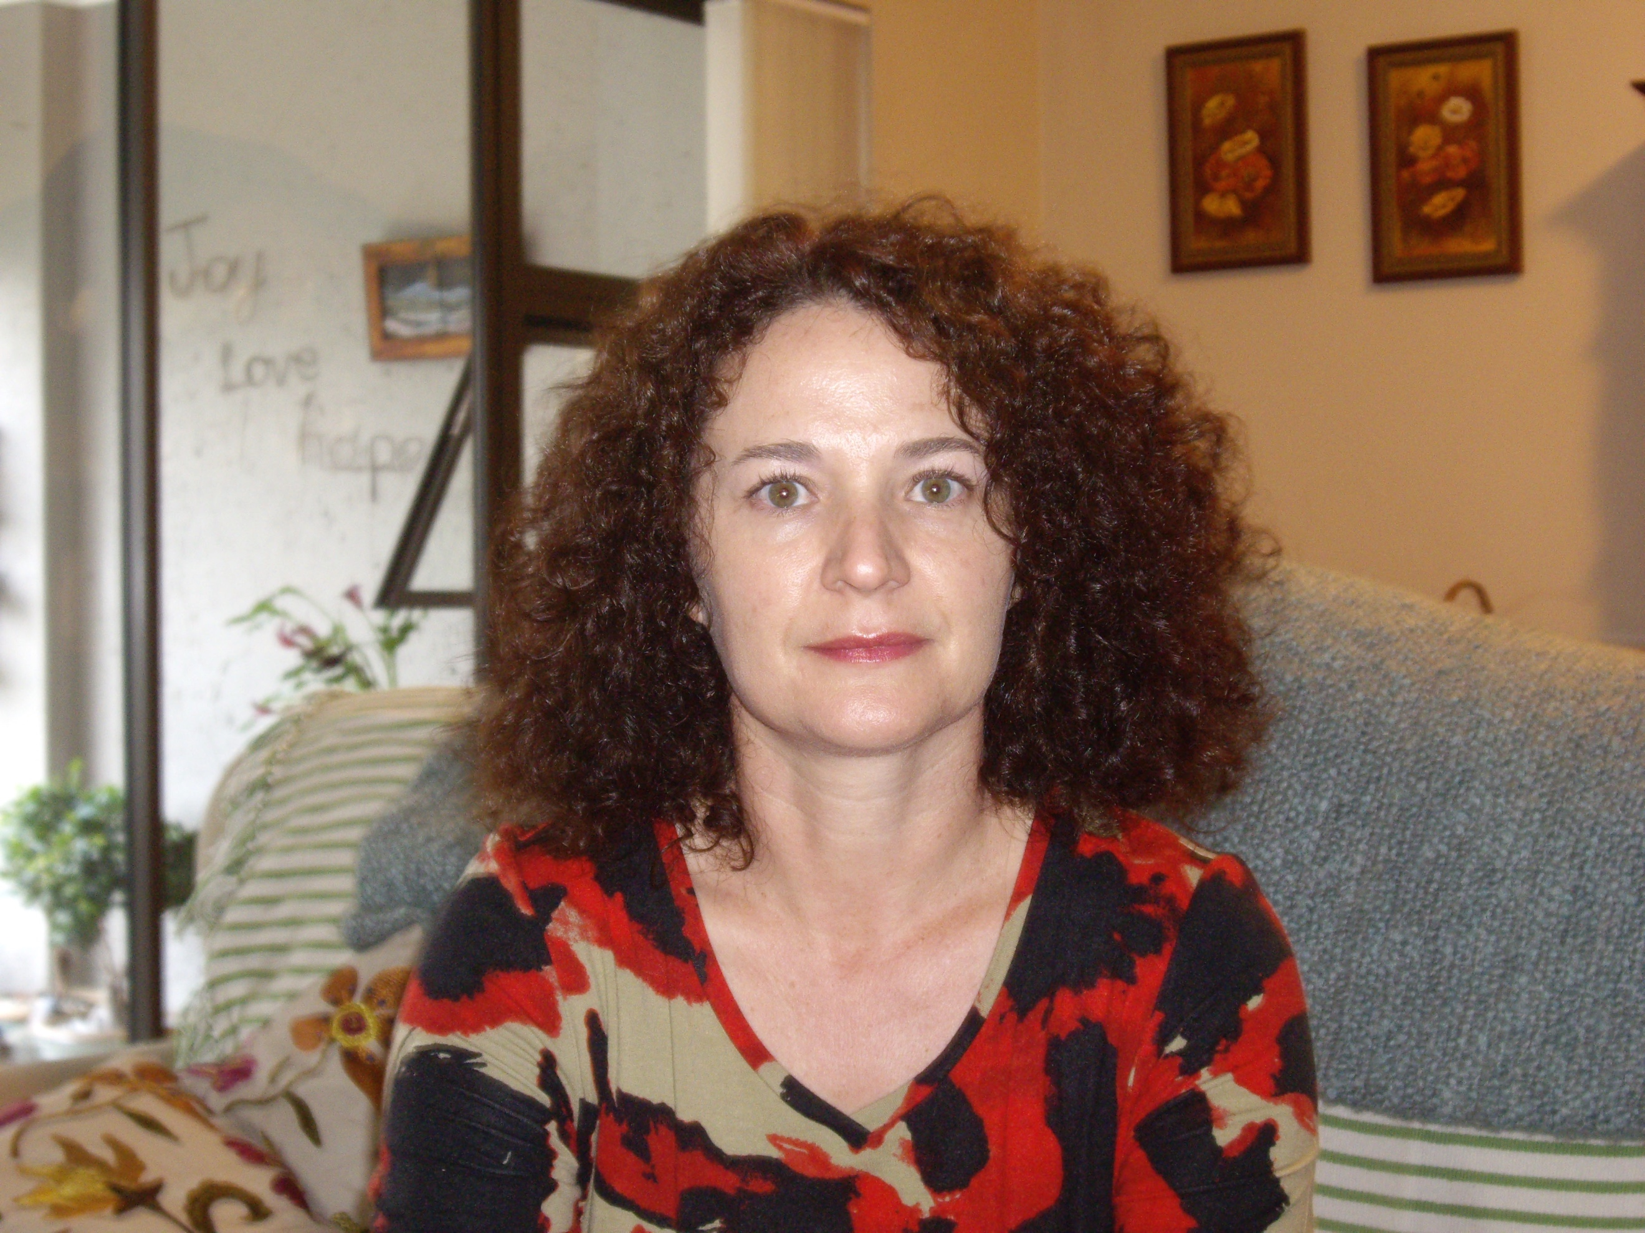
Anthropometric profiles of Grade 4 learners from low-income settings in South Africa
Sandra Pretorius^{1,2}, Natalia Neophytou¹ & Estelle. D. Watson¹
¹Centre for Exercise Science and Sports Medicine, School of Therapeutic Sciences, Faculty of Health Sciences, University of the Witwatersrand, ² INMED SA Partnerships for Children
Communities in low-to-middle income countries undergoing rapid urbanisation as well as nutrition transition are particularly at risk for associated health issues such as overweight and obesity. South Africa has the double-burden of both under- and overnutrition, and therefore is some uncertainty as to where to direct healthcare interventions. Therefore, providing anthropometric data in vulnerable populations like early childhood is much needed. This observational study assessed height, weight, head circumference and age-adjusted BMI in 1785 Grade 4 (9.5 ± 0.7 years old) learners from 12 schools in two different areas in South Africa. Overall, the results of this study found a higher prevalence of overnutrition (>95th percentile for age-adjusted BMI) than undernutrition (<15th percentile for age-adjusted BMI), 27.3% versus 12.4% respectively. Although the boys were significantly older and taller than the girls in this sample, there were no significant sex differences between boys and girls for BMI (19.9 kg/m² ±6.0 vs 20kg/m² ±5.8, p=0.59). Significant differences were found between peri-urban and urban areas for undernutrition (16.1% versus 9.5%, p<0.001) and overnutrition (9.7% versus 41.2%, p<0.001). South African children living in urban areas are particularly vulnerable to high rates of overweight and obesity. Therefore, interventions to address malnutrition in South African are much needed, but this study has shown the need for them to be area and context specific.
Biography
Sandra Pretorius completed her PhD in the Faculty of Health Sciences, University of the Witwatersrand, Johannesburg, South Africa in 2016 and is currently enrolled as a postdoctoral fellow at the Centre for Exercise Science and Sports Medicine, University of the Witwatersrand, South Africa and has 12 publications. She is also a registered dietician and currently manages an intervention project, ‘INMED SA Health in Action Program’ that focuses on improving the health of children in low-resource environments in South Africa through the promotion of healthy nutrition, physical activity and food gardens.
Presenting author details
Full name: Sandra Pretorius
Contact number: +27(0) 82 908 6814
Linked In account: https://www.linkedin.com/in/sandra-pretorius-7124ab50
Session name/ number: Nutrition & Health in Women, Children & adolescent girls
Category: (Oral presentation/ Poster presentation): Oral presentation

