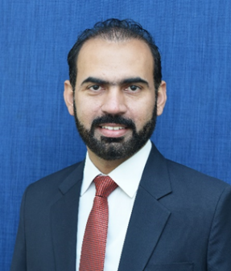

Prevalence of anaemia and associated risk factors among pregnant women in Lahore, Pakistan
Azmat Ullah¹ , Muhammad Sohaib^{1 ,} Farhan Saeed² , Sanaullah Iqbal¹
¹Department of Food Science and Human Nutrition, University of Veterinary and Animal Sciences, Lahore, 54000, Pakistan
²Institute of Home and Food Science, Government College University, Faisalabad, 38000, Pakistan
Abstract:
Maternal anaemia is one of the common problem related to pregnancy, especially in the developing countries like Pakistan. In this context, the present study carried out to determine risk factors associated with maternal anaemia prevalent among women of different age groups visiting different hospitals in Lahore. Current study was a cross sectional design involving 390 pregnant women. Data related to demographic area, maternal age, gestational age/period, educational and income level, as well as socioeconomic status of all the participants were collected. Also, hemoglobin level of the maternal pregnant women was estimated for assessment of maternal anaemia. Findings indicated 42.3% pregnant females had normal blood hemoglobin level and 57.7% were reported to be anemic (34.4 % mild & 23.3% moderate anemic). The education (p=0.01), occupation (p=0.03), income (p=0.001) living area (p=0.028) and house members (p=0.04), were significantly associated with maternal anaemia. Results of binary logistic regression analysis showed that income was an independent risk factors for maternal anaemia. These results further proposed prompt need of awareness and education regarding anaemia and also develop strategies to combat related consequences to mothers and families with special emphasis on understand the importance of care during pregnancy.
Keywords: Pregnant women, Prevalence, associated factors, maternal anaemia, Pakistan

Biography

Dr. Azmat Ullah Khan is working as Assistant Professor in the Department of Food Science and Human Nutrition, Faculty of Bio-Sciences, University of Veterinary and Animal Sciences, Lahore–Pakistan since October 30, 2014. He is coordinator of M.Phil. Food and Nutrition program. He published 13 papers in reputed journals.

Presenting author details
Name: Dr. Azmat Ullah Khan
Organization: University of Veterinary and Animal Sciences, Lahore
Current position: Assistant Professor
Email: azmat.khan@uvas.edu.pk
Address: Food Safety Lab, Room#106, Quality operation laboratories, University of Veterinary and Animal Sciences, Lahore
Tel: 00923457877348
Category: (Oral presentation)

